**Bonjour et Bonne Annee**

**from Zeste French Tours**

**A review of the 2015 Tours in pictures:**

**The Camargue in May 2015**:

At the Pont du Gard, the flamingoes of the Camargue, Collioure, Cathar castle Peyrpertuse, hat buying at Nimes and Carcassonne.

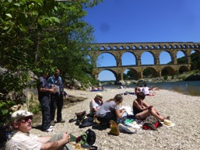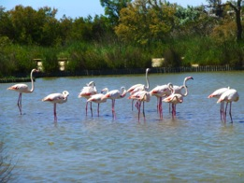

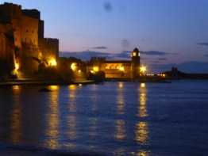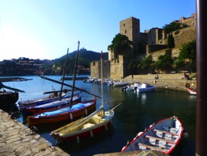

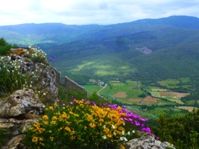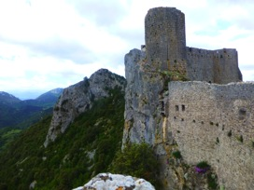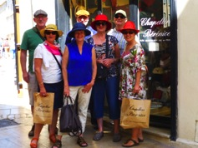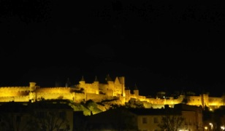

**Brittany in June 2015**:

The Paris Opera, fire twirling at the Notre Dame,at Monet’s garden, Brittany beach to ourselves, Honfleur, near Roscoff, Carnac, Mont St Michel.

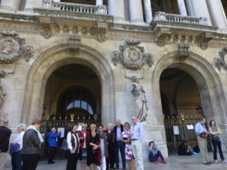 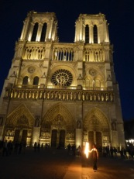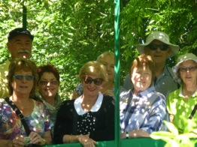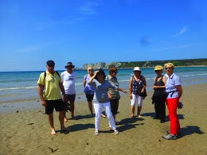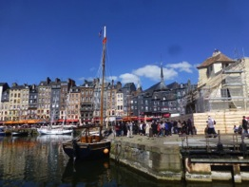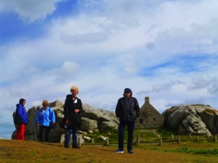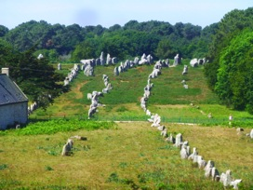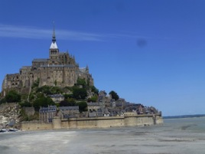

**The Dordogne In June/July 2015:**

Fete de la Musique in Bordeaux, Bordeaux, St Emilion, on the Dordogne, our chambre d’hote at Chateauroux, cooling off in the Dordogne, dinner in Sarlat.

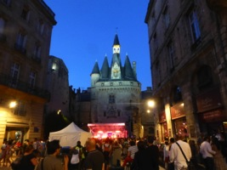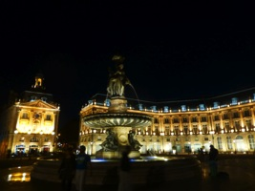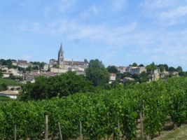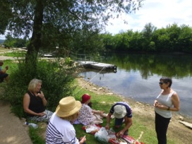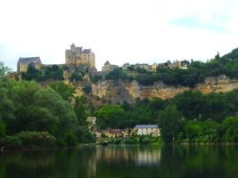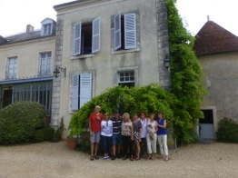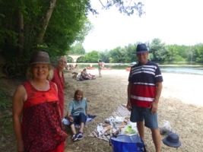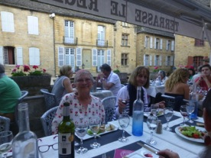

**Brittany in September 2015:**

Lunch at Honfleur, Mont St Michel, St Malo, Oysters at Cancale, walking around Ile de Batz, Giverny, Picnic at the beach neat Concarneau, and near Camaret sur Mer, Camaret, Graham at the beach near Roscoff, Pointe du Raz.

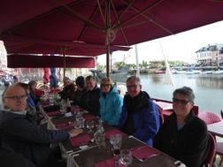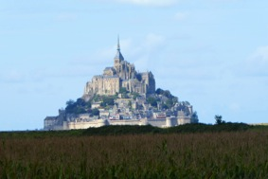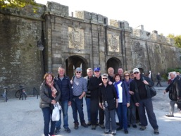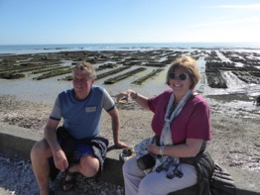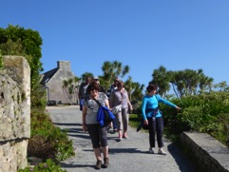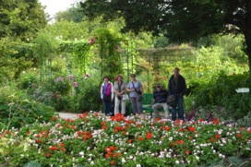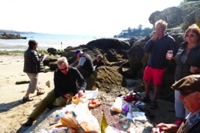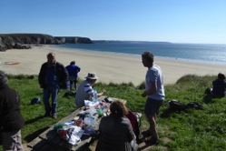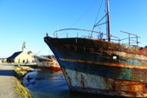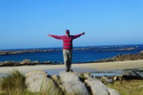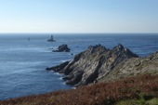

**Pottery Tour in September 2015:**

At the pottery of Eric Desplanches, Moustiers Ste Marie, Aperitifs at Lake Ste Croix, on the boat at Cassis, Cassis, dinner at Cassis, Pottery market at Cassis, beach day Cassis, on the top of world overlooking Cassis, Chateau la Coste, our masterpieces at Jean Marc Plantier’s studio, with Uwe Krause in his studio at Goult, with Olivia and Denis on top of their studio at Oppede le Vieux, our chambre d’hote at Buoux, Roussillon, Uzes market, Pont du Gard, lunch with Maryse Tavernier and Clude Wolfe at their studio, potters market at Lyon, La Fabrique, gallery near Montelimar, watching Yves Gaget demonstrating in his studio.

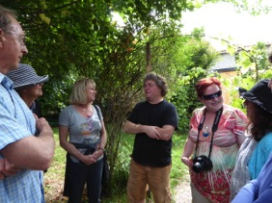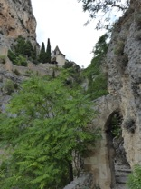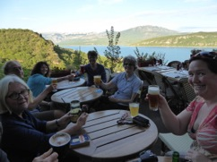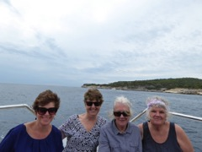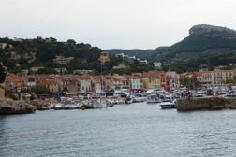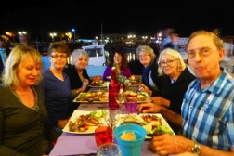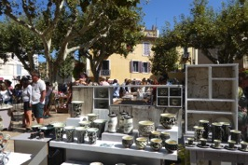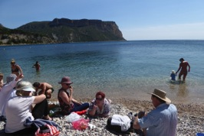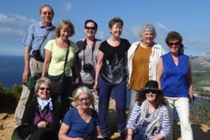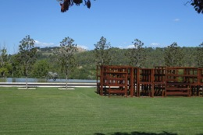

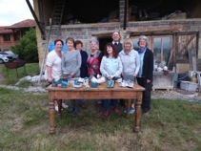

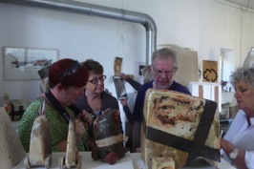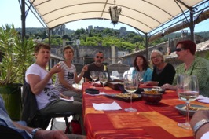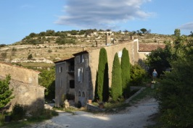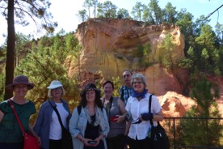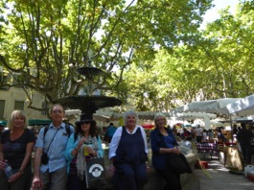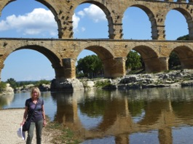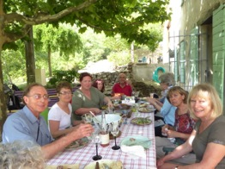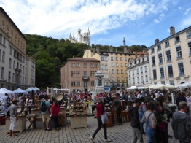

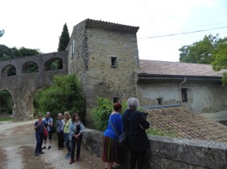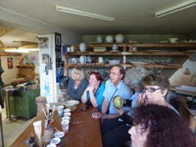

**Paris in September at Atelier d’Art de France, rue Daumesnil, Exhibition Terres Australes:**

Ceramic exhibition with French and Australian artists:

France: Christian Faillat, Yves Gaget, Brigitte Long, Jean Marc Plantier and Maryse Tavernier

Australia: Jane Annois, Rob Barron, Angela Nagel, Chris and Mary Lou Pittard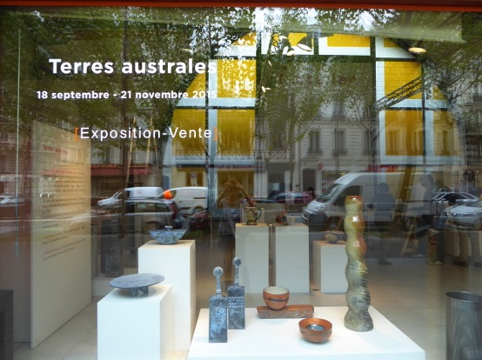

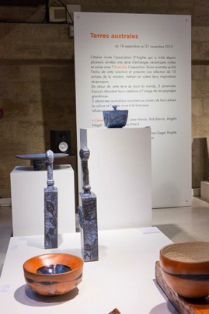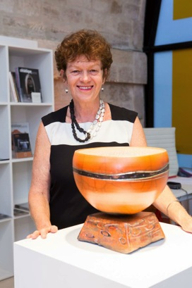

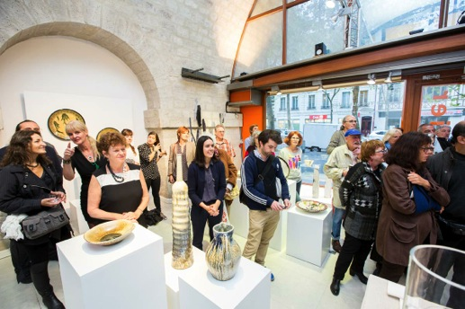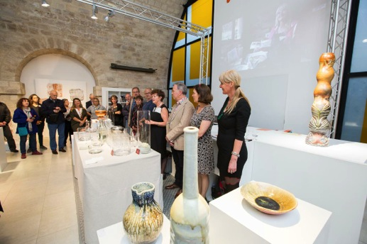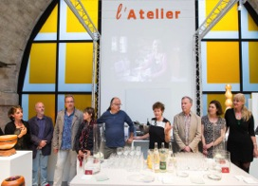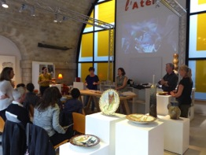

**Now it is time to look forward to 2016 and yes even 2017.**

**Here is the list of tours:**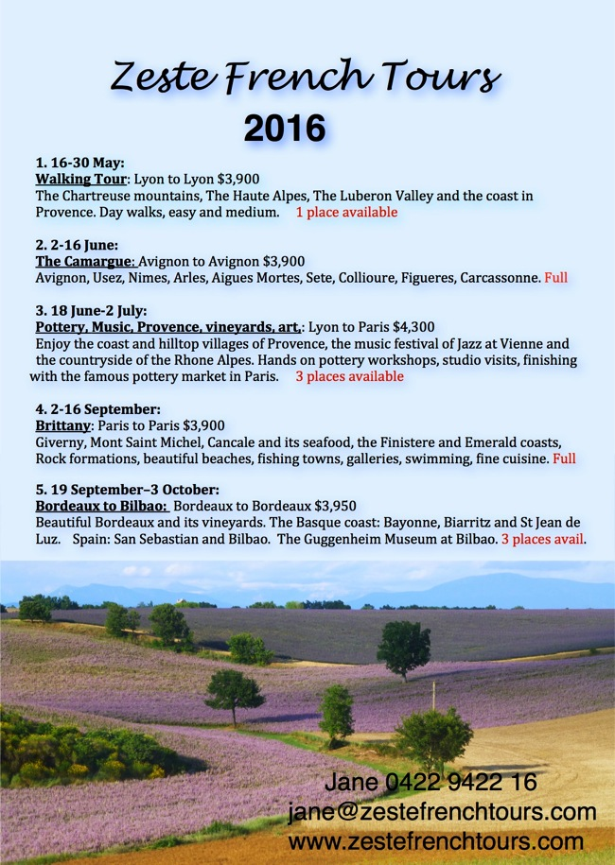

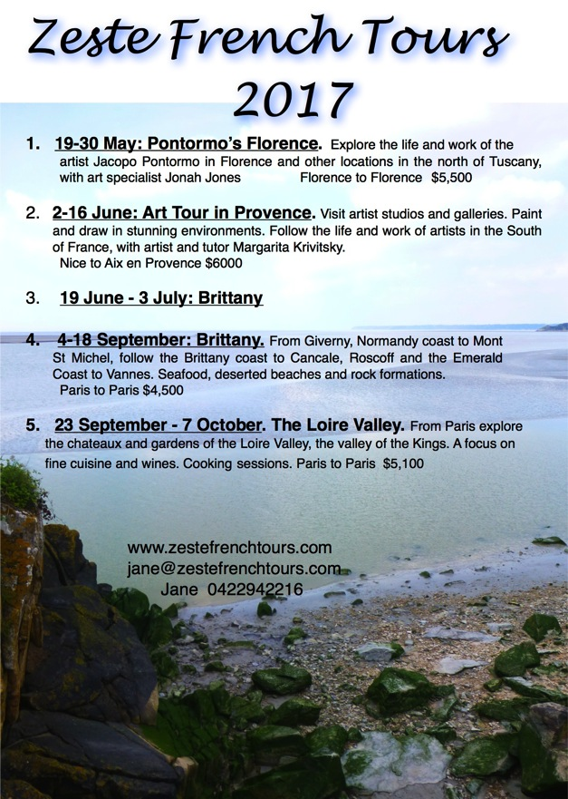

**To find out more about any of the tours please ring me on 0422942216 or look at the website** [**www.zestefrenchtours.com**](http://www.zestefrenchtours.com)**.**

**To make a booking /enquiries email: jane@zestefrenchtours.com**