Zeste French Tours
A Walking tour in France
In the Rhone Alpes, Provence and Hautes Alpes.
17-31 May 2018 Lyon to Lyon 4,200

Beginning in the Chartreuse Mountains with views to Mont Blanc and hidden valleys, then south to the Luberon Valley in Provence, with walks to hill top villages and spectacular countryside, past Mont Sainte Victoire near Aix en Provence, to stay in beautiful Cassis where we walk through the National Park to the Calanques on the Mediterranean. Return via Gap to spend three days in the Hautes Alpes. Stay in comfortable accommodation and enjoy fine cuisine. Easy and medium difficulty walks. Four different regions of France, four different landscapes and experiences.

Day 1: Thursday 17 May [St Pierre d’Entremont – 3nights]
Meet at Lyon airport, at about 11am. Drive towards the Chartreuse Mountains, to stay at our chambre d’hote at St Pierre d’Entremont for 3 nights. This will be our base for walks in the Chartreuse Mountains: Ancienne Ecole du Villard 73670 Saint-Pierre-d'Entremont, France Phone:+33 4 79 26 22 30
[Nathalie 0033 630 83 06 77]
The Chartreuse Monastery
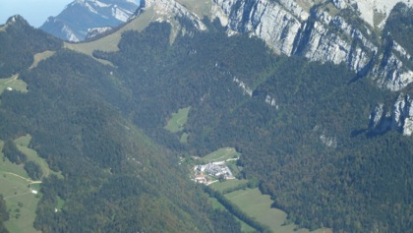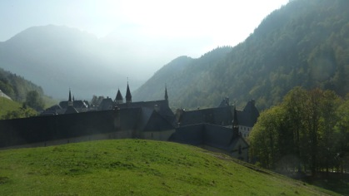

After lunch at Cremieu, at L'Armoire a Cuillers 33 4 74 27 18 61, spend the afternoon with a walk to the Chartreuse Monastery. A tour of the Monastery museum. Dinner in the village at Hotel Restaurant le Relais du Grand Som (0)4 79 26 25 50 dinner included.

Day 2: Friday 18 May [St Pierre d’Entremont]
A walk to la Cirque de Saint Meme. Picnic lunch.
From St Pierre d’Entremont walk through the forest, following the river to St Meme. Take the forest walk to see the waterfall, walk back through the villages on the way.
Dinner: La Flambee. 04 79 65 85 01 perronsophie@aol.com traditional fondue
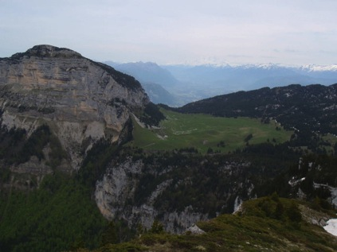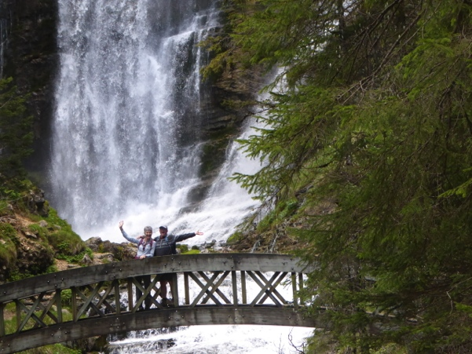

Day 3: Saturday 19 May [St Pierre d’Entremont]
A walk with a local guide, a more challenging walk, discovering local flora and fauna to Le Petit Som. Dinner at our chambre d’hote .
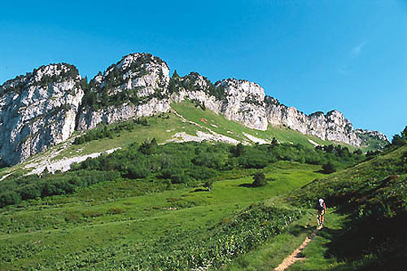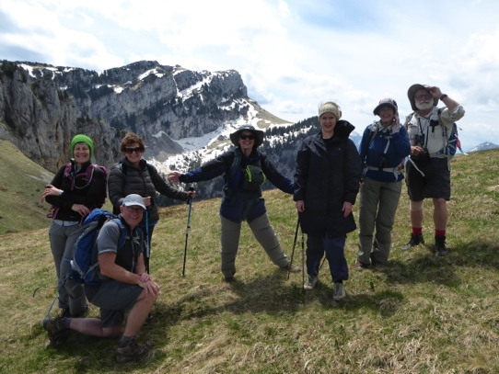

Day 4: Sunday 20 May [Dieulefit -1 night].
Drive to Dieulefit for the biannual Potters’ Exhibition in the gardens. Meet the potters, see the exhibitions of 30 potters, both local and from around France, with international guest artists. A town rich with galleries, medieval quarter, and ceramics. Stay the night at Dieulefit. Dinner included. Pentecost weekend.

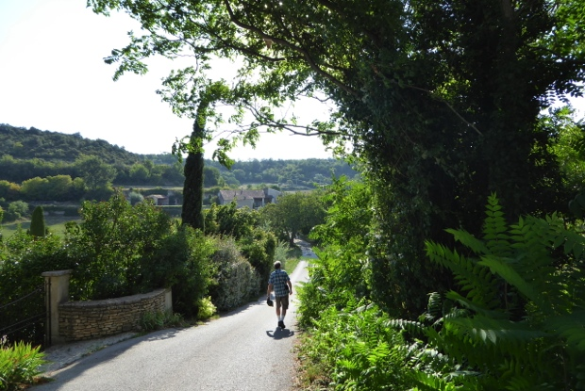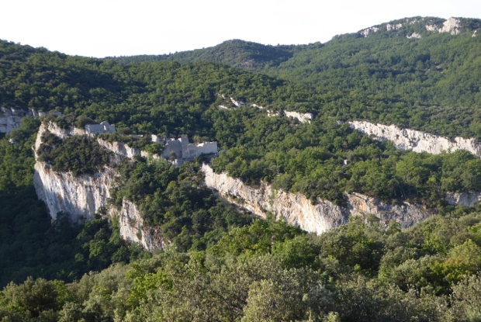

Day 5: Monday 21 May [Buoux in the Luberon Valley, Provence -3 nights]
Drive to the wine region near Vaison la Romaine. Visit Vaison and nearby villages. Arrive Buoux mid afternoon. Several choices to be made amongst the group for walks from this area. Late afternoon visit to Saignon. Dinner at “Au Comptoir de Balthazar”, Saignon 33 4 90 04 63 55. Dinner included.

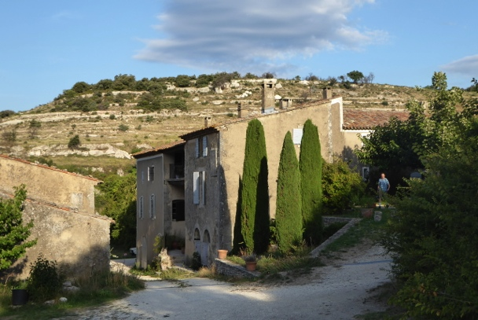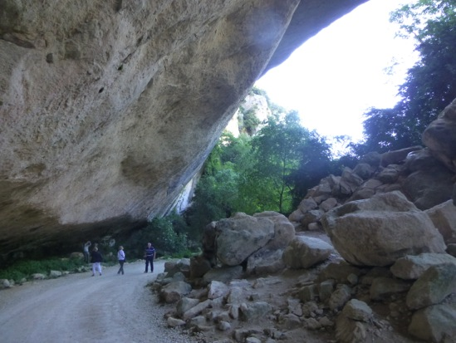
Our chambre d’hote at Buoux Buoux

Day 6: Tuesday 22 May [Buoux]
Walk from Buoux – a day walk to explore the old fortress, through the gorges and valley near our chambre d’hote, the Aiguebrun Mountains, nearby villages. Climb to the top of the fortress. Stunning countryside. Lavender in bloom. Swim if hot at our chambre d’hote. Stay in the chambre d’hote at Buoux “La Grande Bastide”.
Dinner Auberge de la Loube, Buoux. Phone:+33 4 90 74 19 58
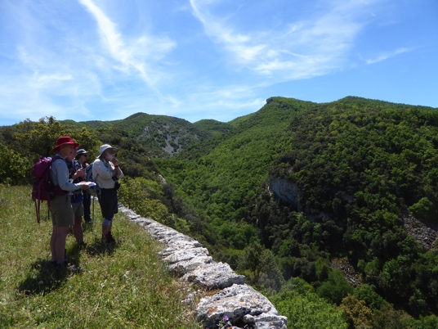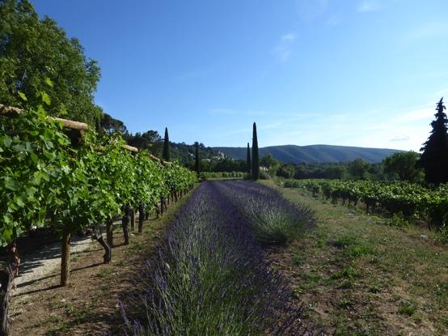

Day 7: Wed 23 May [Buoux, Luberon Valley]
Walk from Bonnieux to Lacoste and back, through the cedar forest and vineyards. Lunch at Lacoste and visit the chateau of the Marquis de Sade.
Dinner at Bonnieux.
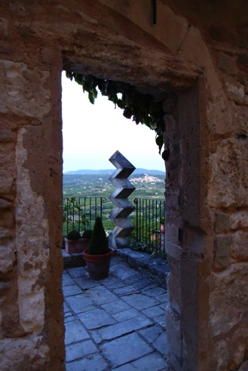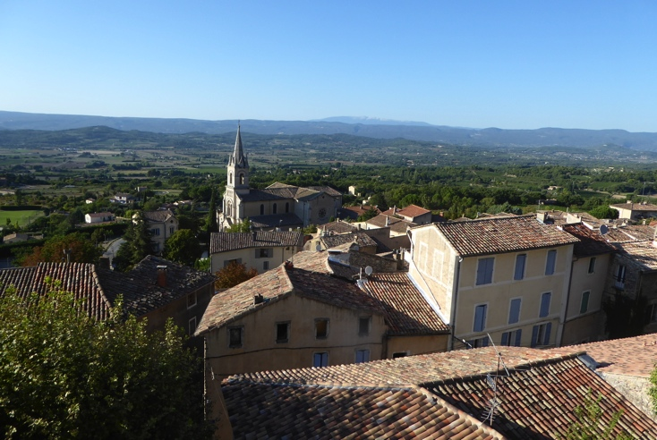
Lacoste looking through to Bonnieux Bonnieux

Day 8: Thursday 24 May [Cassis – 3 nights]
Drive to Chateau la Coste. Visit and walk through the internationally renowned sculpture park, 2 hours. Lunch at the fine restaurant and winery at Chateau la Coste. 04 42 61 92 92
Drive to Cassis [1hr]. Stay in our house near the national park. Dinner included.
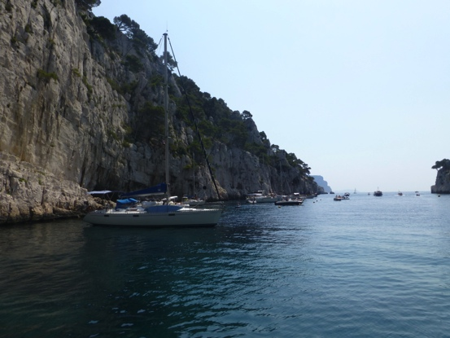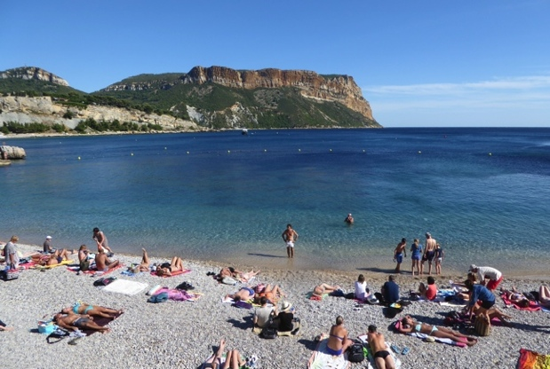 Cassis

Day 9: Friday 25 May [Cassis]
Walk to the Calanques: A day walk through the national park to the turquoise inlets for a swim and return.
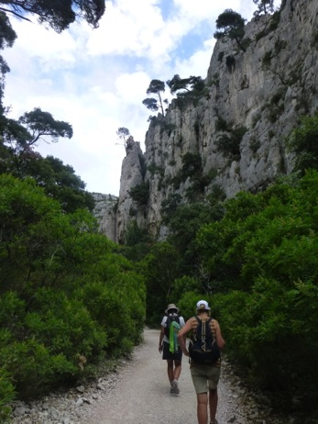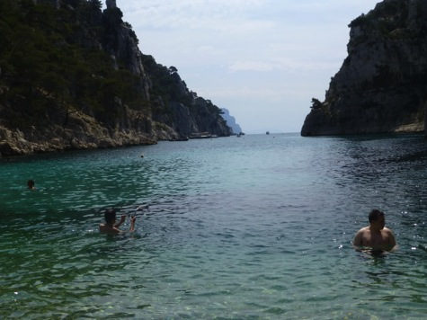
Day 10: Saturday 26 May [Cassis]
Boat trip to the Calanques in the morning. Relax an afternoon to walk/ swim/sleep/explore- your choice. Drive to the top of La Route des Cretes for spectacular views.

Day 11: Sunday 27 May [Gap – 3 nights]
On the way to Gap, drive through and visit Sisteron and its citadelle.
Stay at Maison d’hote la Rotonde des Granes a la Batie Neuve 12kms from Gap.
From Gap there is a wide choice of walks: to Lake Serre Poncon, Dinner included at the chambre d’hote, prepared by our host Bertrand Ferre.
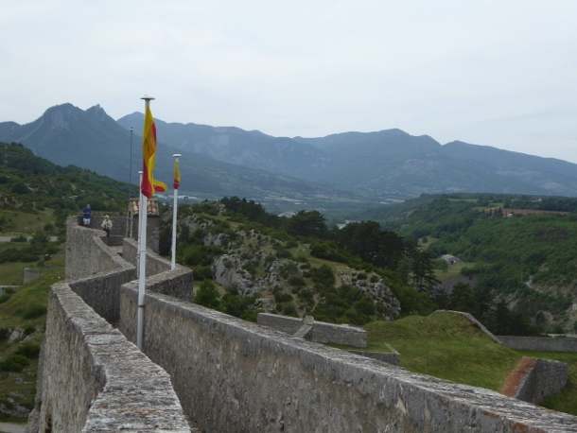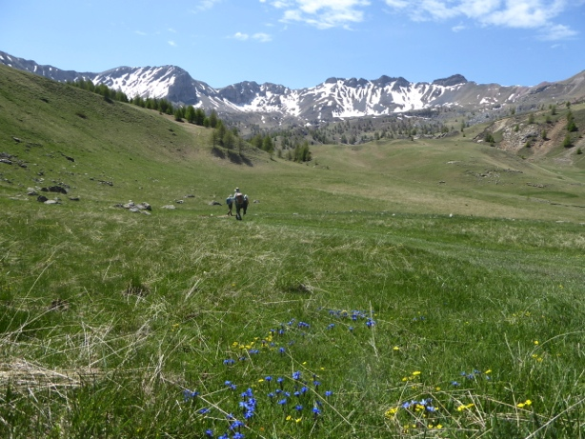
Sisteron citadelle Heading towards the top of le Pic Morgan

Day 12 Monday 28 May [Gap]
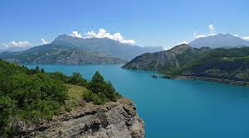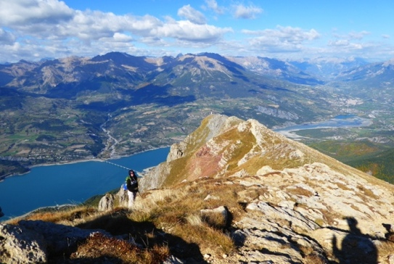
Lake Serre Poncon

A full day walk to Pic de Morgan, the mountain with 360o views overlooking the lake. Restaurant le Bouchon. 4 Rue de la Placette,Gap +33 4 92 46 02 43

Day 13: Tuesday 29 May [Gap]
Drive around the lake to visit the ‘demoiselles coiffees’ and other points of interest. A walk from near our chambre d’hote to the mountain range in the afternoon. Enjoy local market produce for dinner at our chambre d’hote.
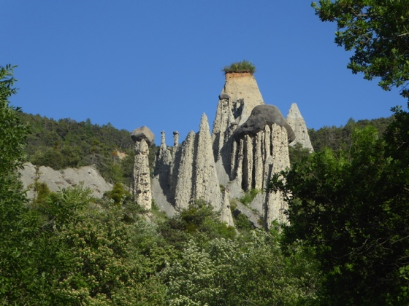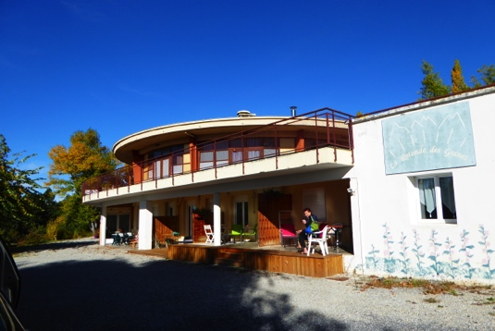
les Demoiselles Coiffees Our chambre d’hote

Day 14: Wednesday 30 May [La Cote St Andre- 1 night]
Visit the local market in the morning at Gap. Drive back to la Cote St Andre via La Route Napoleon. Stop at many places where Napoleon travelled. Visit the village of Corps on the way. Stay at la Cote St Andre at La Villa Jeannette. Dinner included.

Day 15: Thursday 31 May
Back to Lyon airport at about midday.

Included:
- Accommodation 14 nights-all gites and chambre d’hotes and hotels.
- All breakfasts
- 6 Dinners
- All travel in France in bus.
- Boat trips
- Entry fees to museums, galleries, places of interest
- Interpreting.
- Max 8 people on the tour.

Not included:
- Airfares
- Travel insurance
- Walking equipment
- Other meals
- Further details of the walks will be sent closer the date.

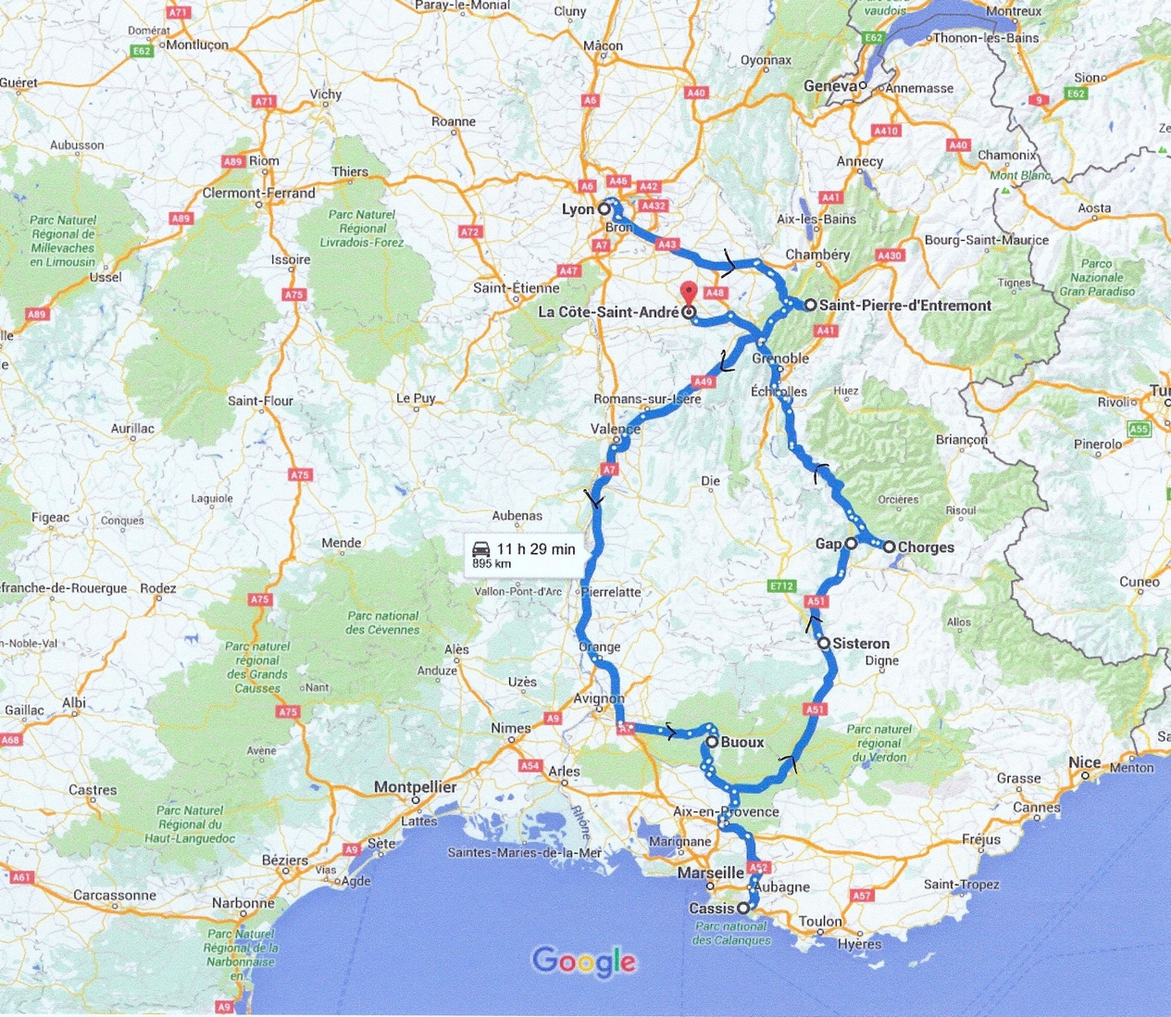

Suggestions for French Films:
- Belle et Sebastian
- Jean de Florette
- Manon des Sources.

