ZESTE FRENCH TOURS www.zestefrenchtours.com
The Loire Valley
Sat 23 September – Sat 7 October 2017: 14 nights, 15 days
Paris to Paris, $4,900
The tour will be a mix of tastes, colour, chateaux, gardens, galleries, food and wine indulgence, all through one of the most beautiful regions of France: the Valley of the Kings
Day 1: Saturday 23 September [Sancerre]
Saturday 23 -30 September at “Les Barrats” 12 kms west of Sancerre
Many of us will be in Paris the night before the trip starts. Dinner together on 22 September. Meet up in the morning at your hotel or point to be arranged.
Travel south to Fontainebleau [1 hour] where we visit the chateau and have lunch. In the afternoon drive to Sancerre [1 ½ hours]. Stay at ‘Les Barrats’, a gite near Sancerre. www.lesbarrats.com. This will be our home for a week.
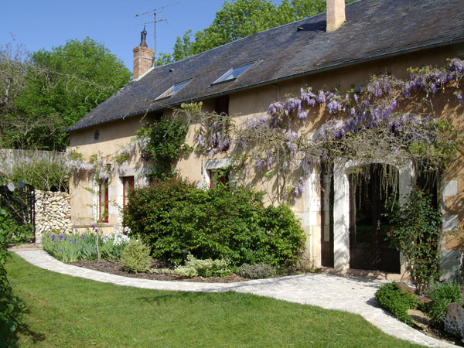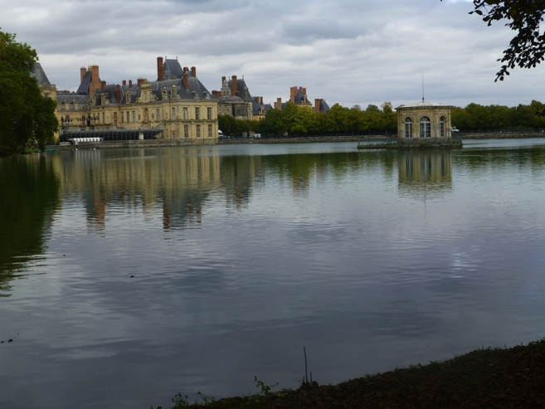
Les Barrats – our farmhouse Fontainebleau
Day 2: Sunday 24 September [Sancerre]
Our first week will be spent discovering the wine growing area of Sancerre and surrounds. We will visit local markets, fromageries, vineyards, villages, galleries and chateaux.
We are near the town of Sens-Beaujeu where we will have our local bakery for our croissants and bread for the morning. We are are 1km along a walking track to the goat farm and fresh goats cheese. Walks to nearby chateaux.

Sun am: Visit one of the Sancerre vineyards. Lunch at Sancerre overlooking the vineyards, with the famous Sancerre Sauvignon.
Afternoon visit to Nancay to visit le galerie Capazza. http://www.galerie-capazza.com [Open weekends 2.30-7pm]

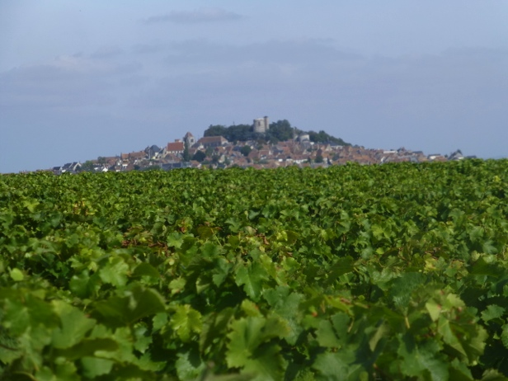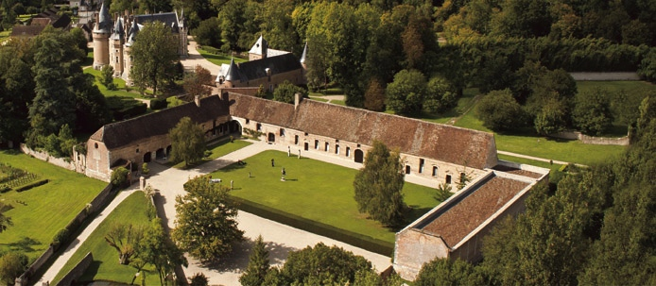
Sancerre Galerie Capazza, Nancay

Day 3: Monday 25 September [Sancerre]

Visit Henrichemont and la Borne to visit the local galleries, artists and potters.
Visit la cathedrale de Jean Linard

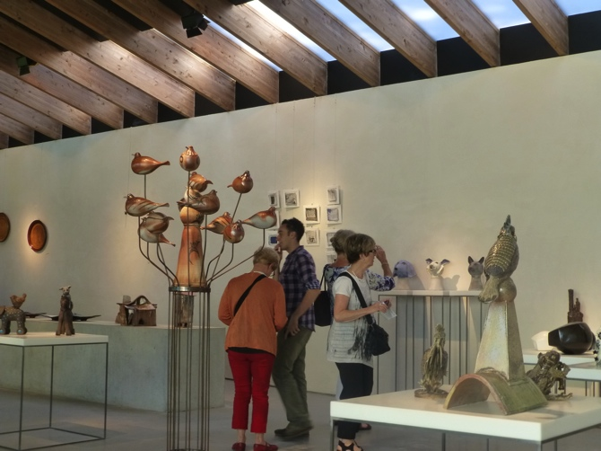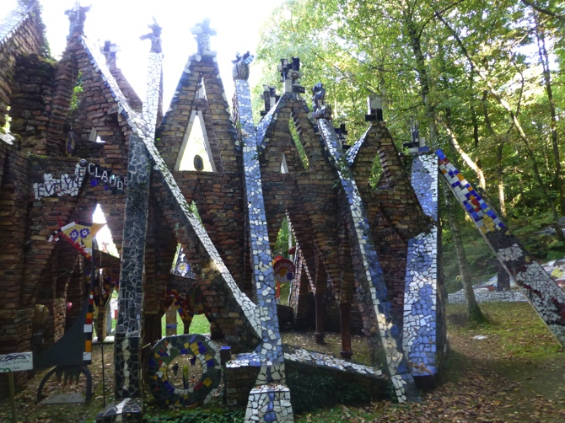
Contemporary ceramic gallery La Borne La Cathedrale de Jean Linard

Explore local area and small villages.

Day 4: Tuesday 26 September [Sancerre]
Guedelon:
At Guedelon a team of fifty people have taken on an extraordinary feat: to build a castle using the same techniques and materials used in the Middle Ages.

The wood, stone, earth, sand and clay needed for the castle's construction are all to be found here, in this abandoned quarry. Watched by thousands of visitors, all the trades associated with castle-building - quarrymen, stonemasons, woodcutters, carpenters, blacksmiths, tile makers, basket makers, rope makers, carters and their horses - are all working together to complete the castle.
And late afternoon visit to Ratilly: a chateau of artists [if time]

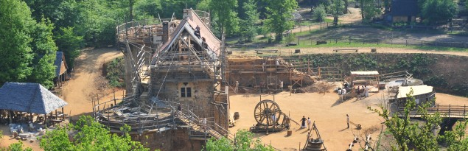
Guedelon

Day 5: Wednesday 27 September [Sancerre]
Market day at Henrichemont, in the morming.
Visit le Chateau de la Verrerie / La Chapelle d’Angillon
Cooking at home with our local food from market.

Day 6: Thursday 28 September [Sancerre] Bourges

A day visiting Bourges and surrounding villages: Visit the medieval town and cathedral at Bourges; The illuminations of Bourges in the evening.
Have coffee at Les Forestines de Bourges: the legendary French patisserie.
The Palais Jacques Coeur; (http://palais-jacques-coeur.monuments-nationaux.fr/en/);
Spend the afternoon at Les Marais gardens – a complex system of garden beds and canals.

A walk through Bourges in the evening for its sound and light show through the historic quarter: “ This magical event will bathe the most beautiful buildings of the town in light, images, music and emotion.”
Dinner in Bourges.

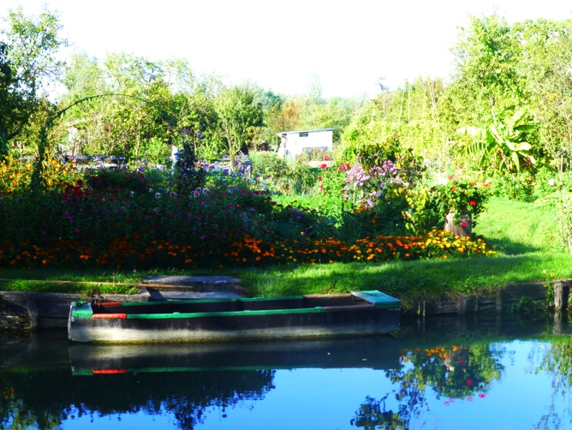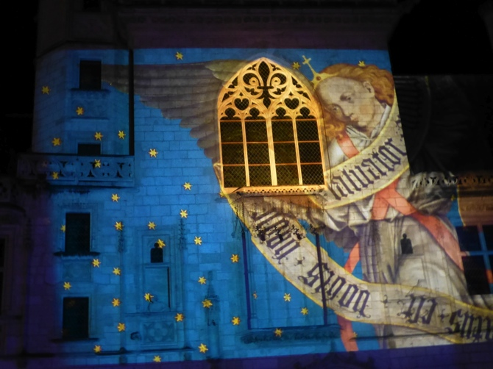
Le Marais at Bourges Illuminations, Bourges
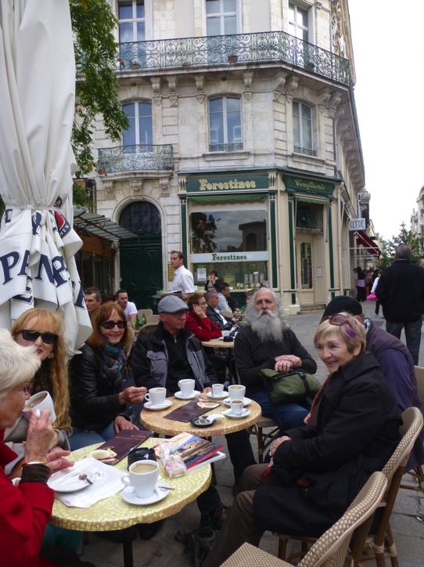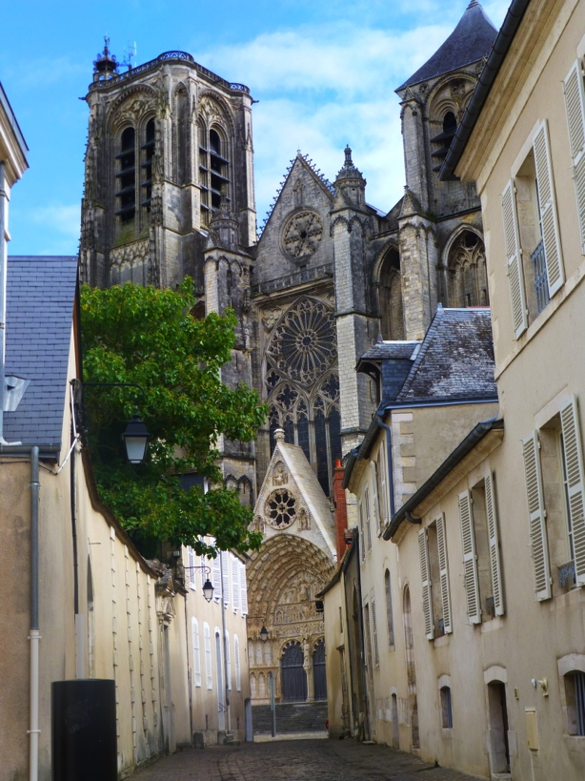
At Bourges enjoying forestines Cathedral at Bourges
Day 7: Friday 29 September [Sancerre]
Visit local chateaux and small villages. Time in the morning to relax, choose your activities. There is a pool!
Afternoon at La Borne, visit studios, wineries at Bue.
Dinner at “Chez les Filles” at La Borne

Day 8: Saturday 30 September [Montrichard - 3 nights]
Leave ‘Les Barrats’ and head towards Montrichard, near Chenonceaux.

Beginning of Les Chateaux de la Loire Vallée
Drive from Sancerre, visiting the Chateau of Valencay on the way in the morning, lunch at the “Orangerie at the chateau. Drive on to Montrichard where we visit La Cave des Roches at Bourre near Montrichard in the afternoon. La Cave Champignonniere. Underground caves where rock was used to build the chateaux of the Loire now extensive series of tunnels growing variety of mushrooms and underground town.
Dinner at the manor house: La Maison Carre, with our wonderful hostess Evelyne Filoziat. [included] www.maison-carre.com

Day 9: Sunday 1 October [Montrichard] Chateau of Amboise and Clos Luce.
Wander the famous market of Amboise along the Loire River. Visit the chateau of Amboise, the home of Francois 1, and ‘le Clos Luce’ where Leonardo di Vinci lived and died, with examples of di Vinci’s inventions and beautiful gardens. Explore Amboise. Restaurant in the evening.
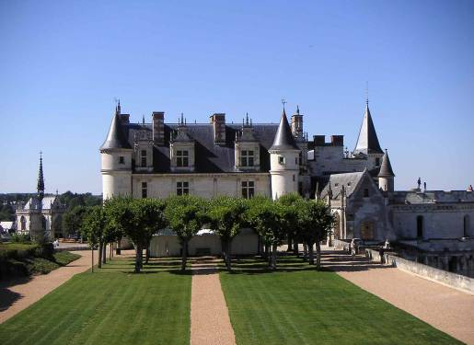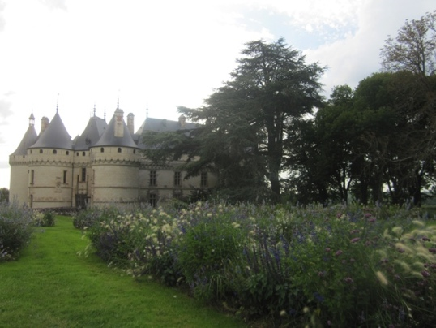
Amboise Chaumont sur Loire

Day 10: Monday 2 October [Montrichard] Chateau de Chenonceau
Am: Visit the Chateau of Chenonceau
Lunch at ‘L’Orangerie” at Chenonceau. 00 33 (0)2 47 23 91 97
An afternoon visit to Chateau de Chaumont sur Loire and its extensive gardens and international garden festival.
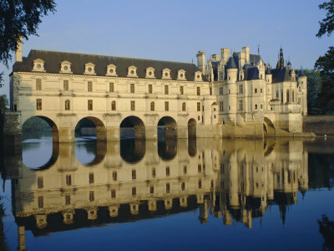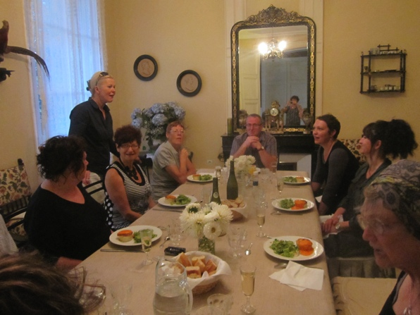
Chateau Chenonceau Dinner at Maison Carre

Day 11: Tuesday 3 October [Turquant– 3 nights]
Continue west towards Saumur, visit Chateaux Villandry, famous for its gardens, and Azay le Rideau. Stay at Turquant near Chinon at Le Balcon Bleu. http://lebalconbleuturquant.free.fr
2 rue de Martyrs, Turquant ph: 02 41381031
Dinner at L’helianthe restaurant Turquant, a gourmet restaurant in the limestone hillside.
restaurantlhelianthe@orange.fr Ph: 02 41 51 22 28 www.restaurant-helianthe.fr

Day 12: Wednesday 4 October [Turquant] Abbey Royale de Fontevraud
Market day in Fontevraud [morning].
Visit the Abbaye Royale de Fontevraud, where Richard the Lionheart, Eleanor of Aquitaine and Henry II of England are buried.
www.abbaye-fontevraud.com
49590 Fontevraud l’Abbaye +33241517352 10h - 17h30

Visit local artists and artisans of Fontevraud.
Call in to a local vineyard on the way home, for a wine tasting before preparing dinner together.

Day 13: Thursday 5 October [Turquant]
Saumur
Visit troglodyte caves in the region with underground sculptures, mushrooms and wine cellars.
Visit Angers and its chateau.

Restaurant at Candes St Martin: Auberge de La Route d'Or
Réservation par téléphone uniquement : 02 47 95 81 10

Day 14: 6 October: Vouvray and Chateau de Cheverny [Cheverny]
Visit the wineries of Vouvray and its famous sparkling wines. Take a tour through the caves/cellars. Then on to the Chateau of Cheverny.
Stay the night at Cheverny at a chambre d’hote. Walk around the illuminated chateau of Chambord at night, before dinner. Listen to the sounds of the deer.
It is mating time!

Day 15: Saturday 7 October [Paris]
am Visit Chateau Chambord known for its extravagant towers and double helix staircase.
Return to Paris. [2hr drive] Arrive in Paris early afternoon. We will arrange drop off points in Paris on an individual basis.
Visits to vineyards, fromageries and markets will be made regularly and according to our stamina at the time. As a small group we have the luxury of flexibility, and can be as busy or as relaxed as you wish to be.
Costs: $4,900
Bookings and Enquiries:
Jane Annois Zeste French Tours
Ph: 03 98442337 / 0422942216
jane@zestefrenchtours
www.zestefrenchtours.com
14 nights/15 days, Includes:
Transport Paris to Paris
Accommodation bed and breakfast
7 dinners
All entries to chateaux and museums
Max 8 people
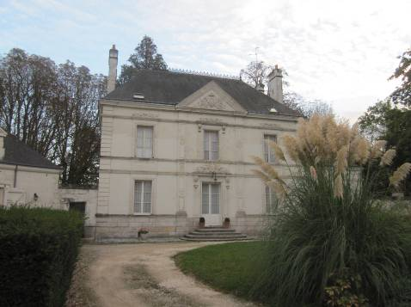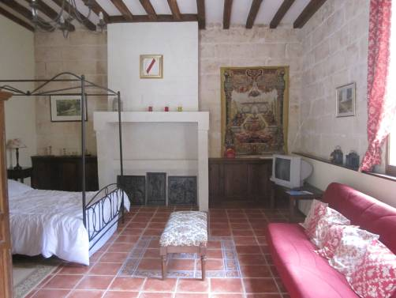
Our house at Montrichard One of our bedrooms at Montrichard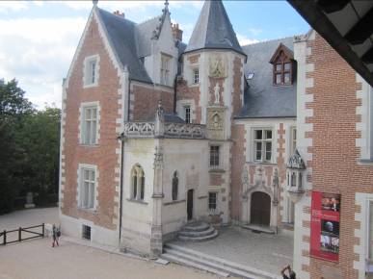 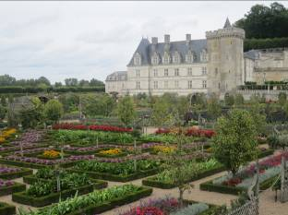
Leonardo di Vinci’s house Villandry Chateau

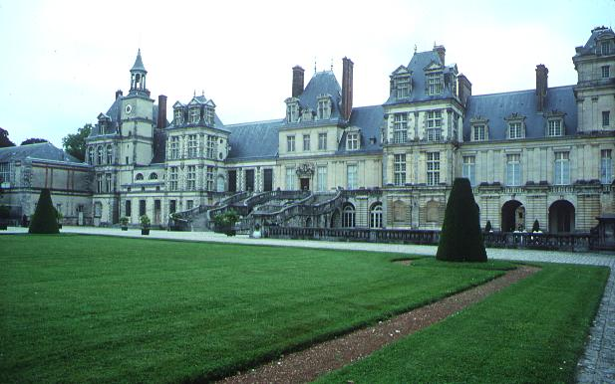 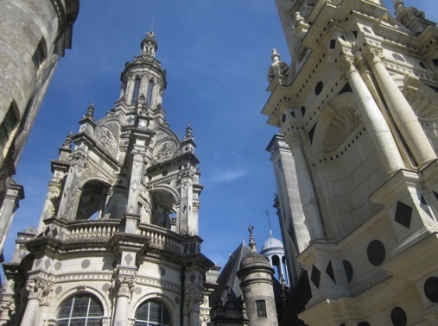 Fontainbleau Chambord

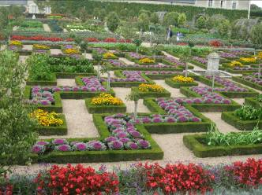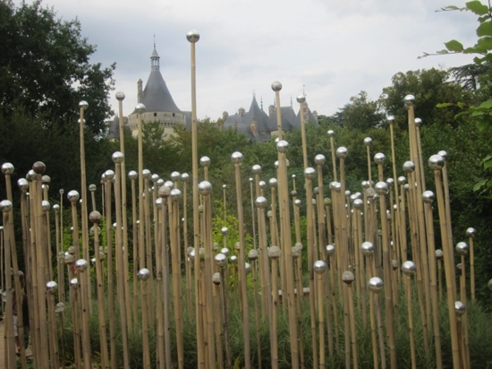
Villandry Chaumont sur Loire garden festival

