Zeste French Tours
The Dordogne
24 June – 7 July 2015 [13 nights, 14 days]

Bordeaux to Paris $3,800 www.zestefrenchtours.com

Discover the region of medieval chateaux along the beautiful Dordogne River. Known for its prehistoric cave paintings, panoramic views of idyllic countryside, its “bastide’ villages built during the Hundred Years War and fine food and wines. Immerse Yourself in this magnificent region of France.

Wednesday 24 June [Bordeaux]
Meet at point to be decided: airport/train station.
Take luggage to hotel and then explore galleries and streets of Bordeaux.
Many galleries to choose from:
CAPC musée d'art contemporain de Bordeaux
Regional collection of contemporary art: http://www.frac-aquitaine.net
Private collection: http://www.institut-bernard-magrez.com
Le Musée de la Création Franche [the mecca for outsider out or art brut]
[Dinner in Bordeaux included]
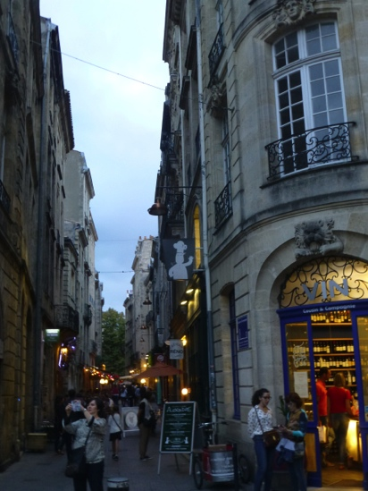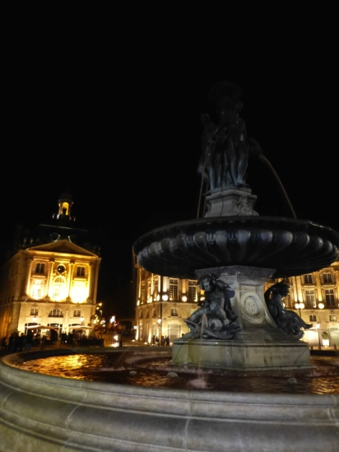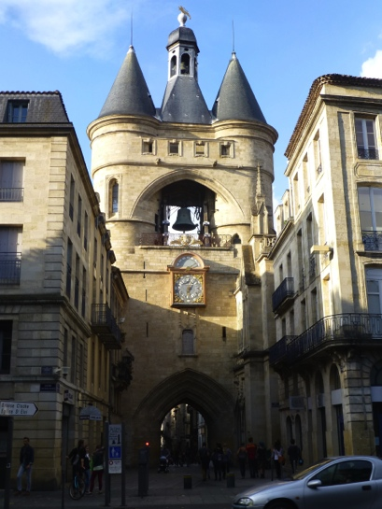
Bordeaux
Thursday 25 June [Bordeaux]
Explore the surrounds of Bordeaux: its wineries and chateaux, and St Emilion. Visit the historic pottery of Gradignan and its contemporary sculpture exhibition. http://www.poterie-gradignan.org

Friday 26 June [Sarlat] 5 nights
Drive to Sarlat [2 1/2hours]. Explore villages on the way, lunch at Bergerac. We will be based at Sarlat for the next 5 days.
Stay at the Ferme Croix D’Allon for 5 nights. A farm with lots of room to spread out. A kitchen at our disposal and a swimming pool. 2kms from the centre of Sarlat. [Dinner included]

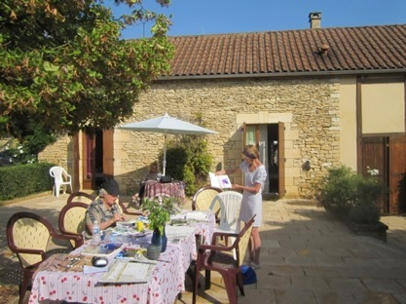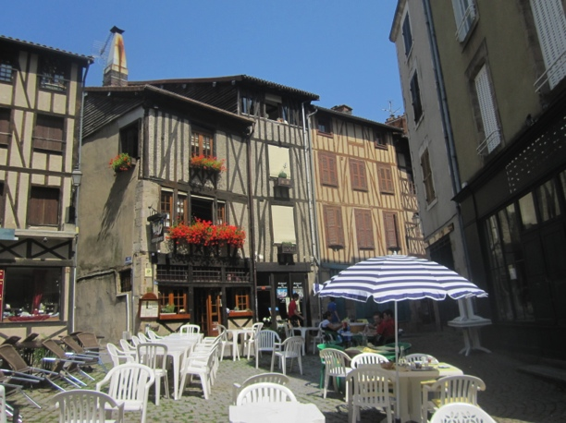
La Ferme Croix D’Allon Sarlat

Saturday 27June Sarlat
Local morning market in Sarlat
Visit the village of Beynac. Take a gabarre, a boat down the Dordogne.
Visit La Roque Gageac and Domme with spectacular views down the Dordogne Valley.

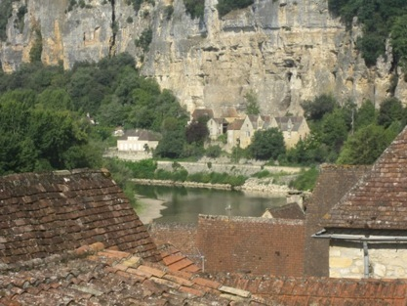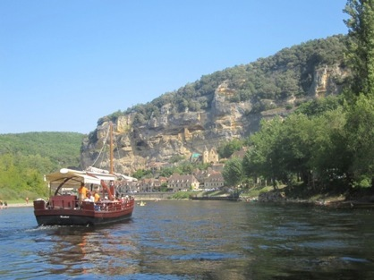
Beynac a Gabarre on the Dordogne

Sunday 28 June Sarlat
Explore the Vezere Valley and its underground prehistoric caves, where Cro-Magnon man painted, drew and sculpted. Lascaux 11 and Grotte de Rouffignac .
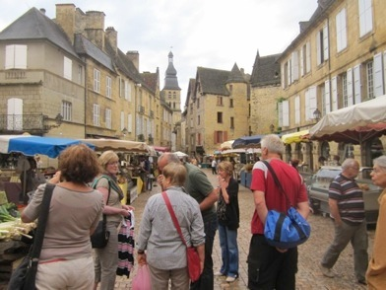 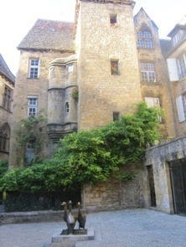 Sarlat
Monday 29 June Sarlat
Visit the chateaux of the Dordogne and Rocamadour.
[Dinner included]
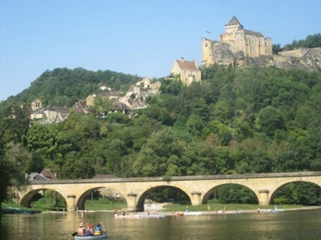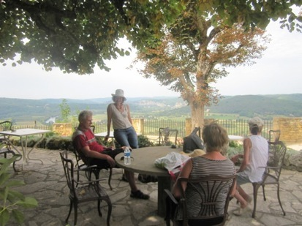
Drinks at Domme
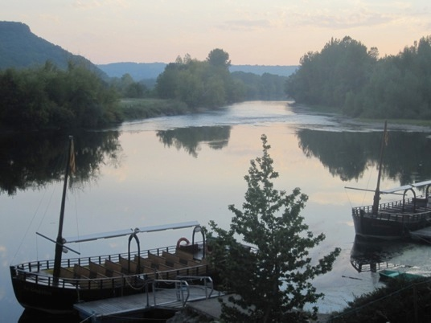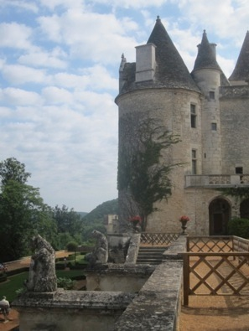
The Dordogne Chateau Milandes

Tuesday 30 June [Sarlat]
Chateau of Milandes where Josephine Baker lived. Beautiful gardens. Explore local galleries and studios.

Wednesday 1 July [Eymet] 3 nights
Morning market at Sarlat before heading south-west to Eymet via Monpazier. Afternoon in Monpazier.
Stay at a local chambre d’hote: [dinner included]
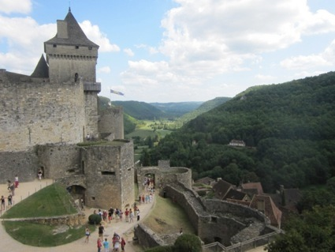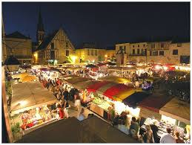
Chateau Biron Eymet night market

Thursday 2 July [Eymet]
Visit La Capelle Biron, and Saint Avit and the birth place and gallery of Bernard Palissy. [05 53 40 98 22] Exhibition of contemporary ceramics “Jaune”. Visit Chateau Biron and its sculpture exhibition. Eymet market. A market that has been running since 1270.
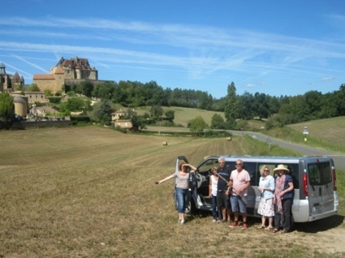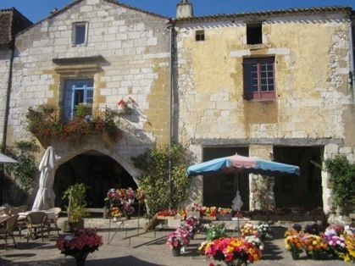
Our bus in front of Chateau Biron Market at Monpazier

Friday 3 July [Eymet]
Explore the walled bastide towns of Villereal, Montflanquin. Dicover the Pigeonniers, Pigeon houses and lavoirs of the region.
Evening market La Capelle Biron

Saturday 4 July [La Borne]
We head north first to Chateauroux for lunch [3 1/2 hour drive]
and then to the 17th century convent, which houses the 17th Biennale of contemporary ceramics 2-4 pm. http://aaar.fr/agenda/17eme-biennale-internationale-ceramique-chateauroux In the car to Nancay to the fabulous Galerie Capazza paintings/sculpture/ceramics [1hour drive] visit 5-7pm. www.galerie-capazza.com Drive to la Borne for dinner [30 mins]
[Dinner included]

Sunday 5 July [La Borne]
Spend the day at La Borne. Visit the artists’ studios and galleries. Enjoy wines of Sancerre.

Monday 6 July [Paris]
Back to Paris, stay the night in the Latin Quarter. Gallery visits, [maybe the Louvre/Pompidou?] and a restaurant.
For those who would like to participate in an afternoon drawing class at the famous La Grande Chaumiere, today is the day. http://www.grande-chaumiere.fr/en/
[Dinner included]

Tuesday 7 July. The tour finishes in Paris.
The Picasso Museum has just reopened. Opens from11.30am
Musee D’Orsay open from 9.30am.

Contact: Jane Annois
jane@zestefrenchtours.com
www.zestefrenchtours.com
03 98442337 /0422942216

Included in Tour:
- All travel in France for 14 days Bordeaux to Paris
- Accommodation and breakfasts
- 6 dinners
- All museum and gallery entries
- All boat trips and other activities associated with the tour.
- Interpreting and travel assistance
- Some art materials

Not included:
- Airfares,
- Travel insurance
- Personal items
- Your favourite art materials

