Zeste French Tours
Pottery Tour to the South of France

2-16 September 2015 Aix en Provence to Lyon $3,900

A trip for potters and those interested in ceramics. Meet the French potters and discover the South of France.
Starting from the Mediterranean, we wind our way through France’s major pottery centres, towards Lyon, meeting the artists, visiting their studios ad participating in workshops. We spend time at France’s biggest Potters market, where you will meet some of the finest ceramic artists in France and around Europe.

Wednesday 2 September: Aix en Provence
Meet at Aix en Provence [train station/hotel or place to be arranged]
Lunch and visit Gallery Granet. Late afternoon visit to Cezanne’s studio.

Thursday 3 September : Aix en Provence
Early morning market then visit the potters north of Aix, including Christine Zablocki and Eric Desplanches. Explore the beautiful Lac St Croix.

Friday 4 September : Cassis.
Take a boat trip to les Calanques, Cassis and swim at the beach, explore the port.

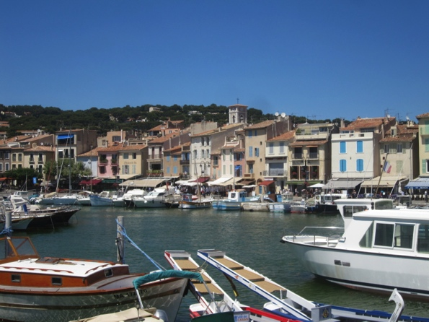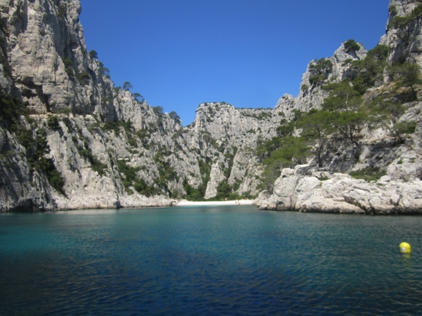
The port at Cassis The Calanques
Saturday 5 September. [Cassis] Cassis Potters Market. Meet the potters at the annual Potters market at Cassis.

Sunday 6 [Luberon Valley] Visit Chateau La Coste its gallery, walk through the extensive grounds to see the site specific sculptures by artists such as Andy Goldsworthy, Frank Gehry, Calder, Bourgeois and many more. Lunch and winetasting at the La Coste. Stay in the Luberon Valley of Provence: Visit local potters at Bonnieux.
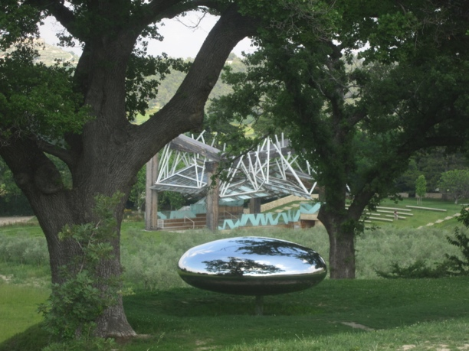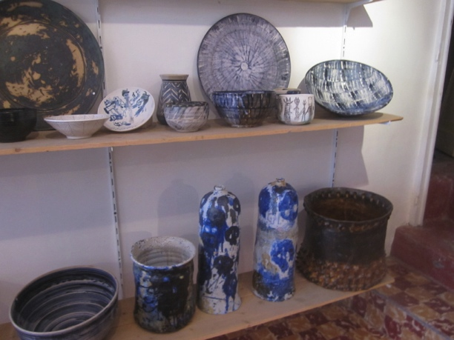
Chateau La Coste Poterie at Bonnieux

Monday 7 September Luberon Valley: visit local potters, the village of Roussillon and Gordes. Lunch with potters at their studio in the Luberon Valley.

Tuesday 8 September St Quentin la Poterie
Visit the town of Usez, enjoy lunch in the arcades surrounding the town square. Spend the afternoon at St Quentin la Poterie, visiting artists’ studios and Gallery Terra Viva. Meet the potters. Demonstration.

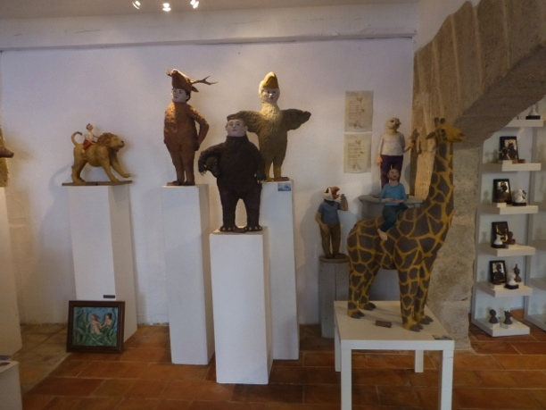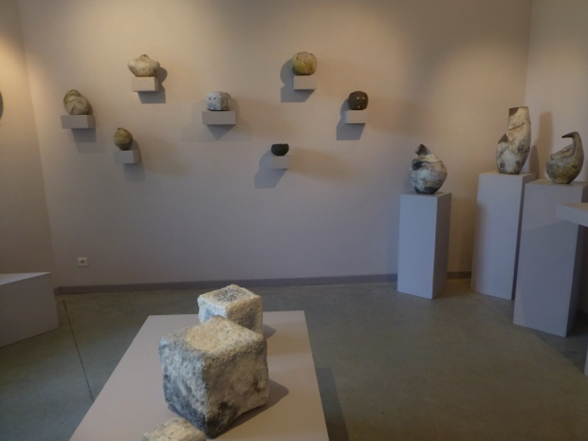
Studios at St Quentin la Poterie

Wednesday 9 Dieulefit:
Wednesday morning market in Usez. Visit La Maison de la Ceramique at Dieulefit and its exhibitions and pottery school.
Visit the Ceramic Gallery Nadia B, artist studios.

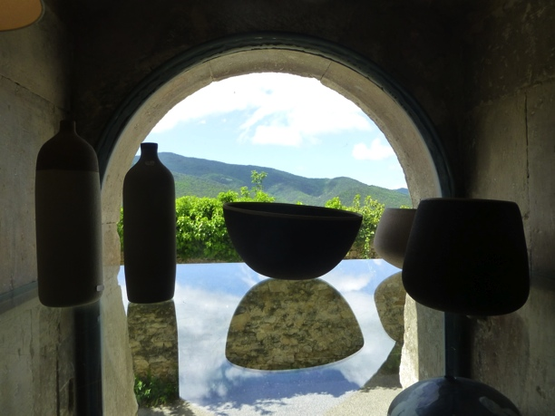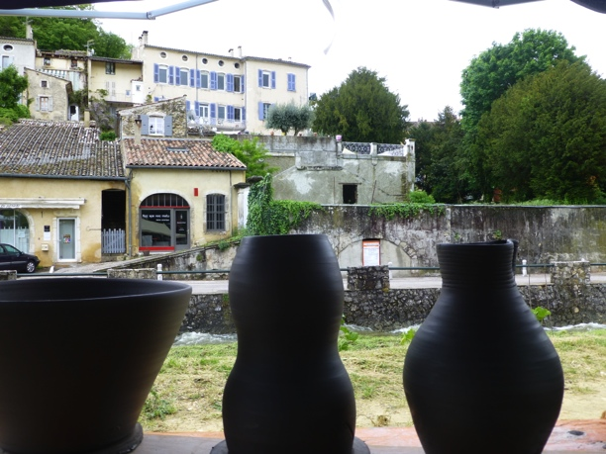
Dieulefit

Thursday 10 September: Dieulefit:
Visit potters studios and galleries, Hands on ceramic workshop. Visit Maryse Tavernier.

Friday 11 September: la Cote St Andre.
Workshop: making pieces for raku firing, at the studio of Jean Marc Plantier. Demonstrations and Making.

Saturday 12 September: Lyon
Les Tupiniers Potters Market at Lyon. Stay in Lyon

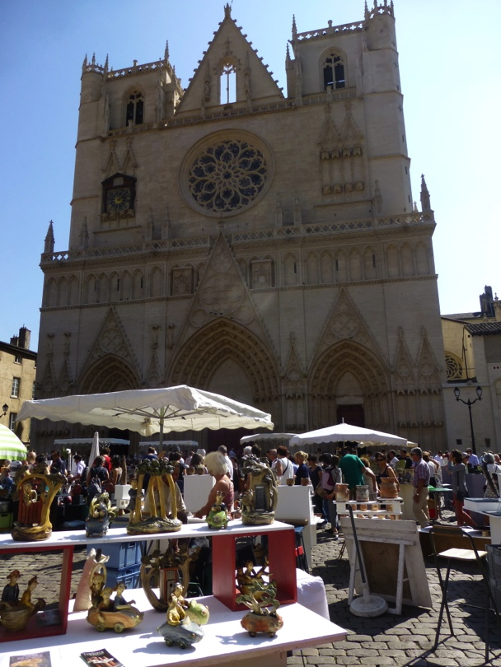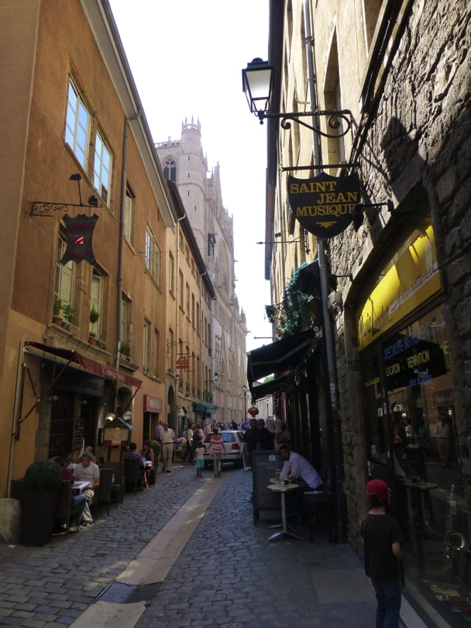

Sunday 13: Lyon during the day. Return to La Cote St Andre in the evening.
Les Tupiniers Potters Market. Explore the old town of Lyon. Take the funicular railway to see the Roman ruins and La Fourviere, basilica.

Monday 14: La Cote St Andre
Hands on workshop at Yves Gaget’s studio .
The art of Terre Vernissee.

Tuesday 15 La Cote St Andre.
Raku firing day at Jean Marc Plantier’s and last night party with the potters.
Fire your pieces made the previous Friday.

Wednesday 16 La Cote St Andre
Final day, head back to train/airport.
[Pick up fired pieces from Yves Gaget on the way to the airport]

Included:
All travel Lyon to Lyon.
All breakfasts
6 dinners
Pottery workshops
Entries to museum/ galleries / activities

Not Included:
Airfares Other meals
Travel insurance

