Zeste French Tours
Pottery, Music, Art, hilltop villages…

Pottery and Music Tour

20 June –4 July 2018

For those who love pottery and art, studio and gallery visits; jazz, blues and world music; hilltop villages, rural landscapes lavender and sunflowers, fine food and wine. Take part in ceramic workshops at 3 pottery studios, demonstrations at 3 other studios.
Lyon – Paris $4,600
Wednesday 20 June. [La Cote St Andre] 3 nights
Arrive at airport/TGV station at Lyon, St Exupery Airport. [Aim for 11am]. Pick up van, lunch at Jean Marc Plantier’s house. In the afternoon, make pieces for raku firing at Jean Marc Plantier’s studio towards the end of the tour. Decorate pieces ready for bisque. Dinner at Jean Marc’s house.

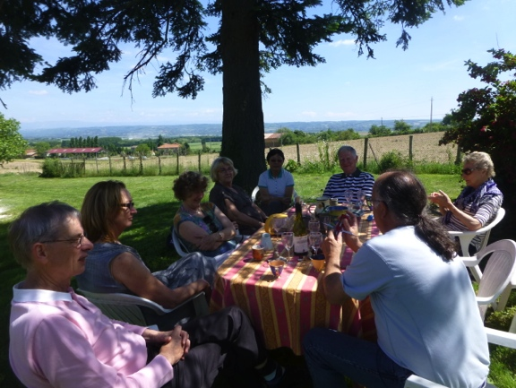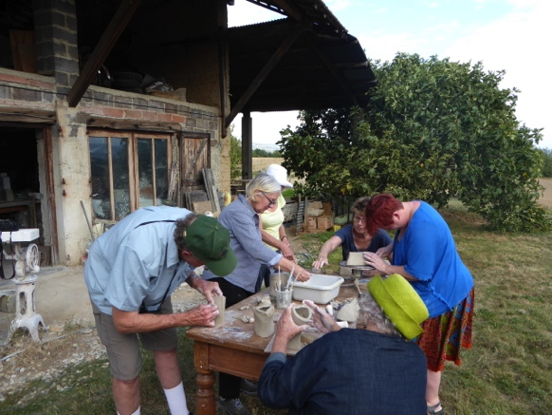
lunch at Jean Marc’s house making pots for raku firing

Thursday 21 June [La Cote St Andre]
La Fete de la Musique, annual music festival
Visit Lac Paladru for a picnic lunch, swim if hot. In the afternoon, visit the ceramic exhibition at La Grange Dimiere at Charavines, in a medieval grain store near Lac Paladru. Visit the studio of Yves Gaget.
Celebrate la fete de la musique at Bourgoin Jailleu in the evening.
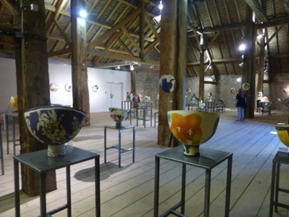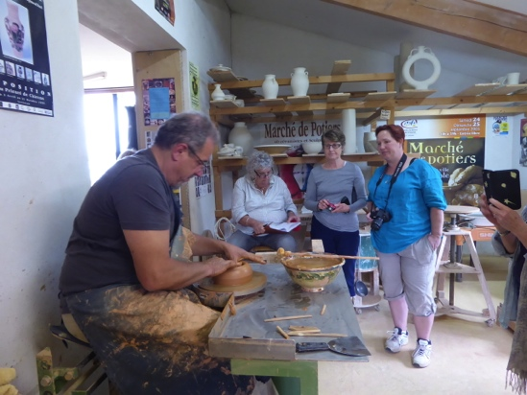
Exhibition at La Grange Dimiere Yves Gaget’s studio

Friday 22 June [La Cote St Andre]
Raku fire pieces made on Wednesday. Late visit to Le Facteur Cheval at Hauterives, enjoy Dinner at le Clos, [0475688913] then a Concert at Le Facteur Cheval in the evening

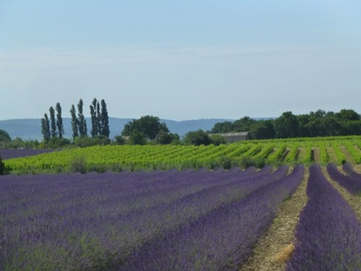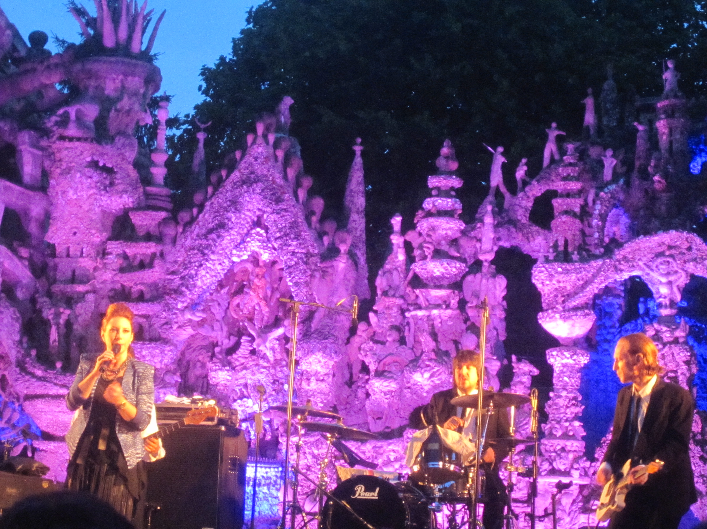
Lavender near Dieulefit Le Palais Ideal de Facteur Cheval

Saturday 23 June [Dieulefit] 2 nights
In the morning, visit Chateau de Virieu in the morning for the biannual artisans’ festival: ceramics, glass, wood, textiles and more.
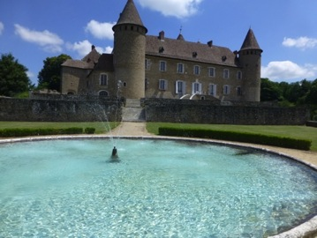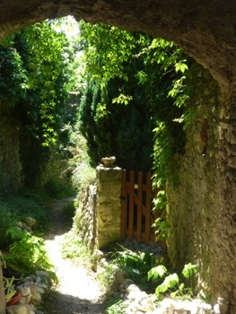
Chateau Virieu Cliousclat
Head south towards Provence. Spend the early afternoon at Mirmande and Cliousclat; artist and pottery villages in the Drome region.
Stay in a chambre d’hote amongst the lavender fields, near Dieulefit. Visit Dieulefit and galleries. Lavender and sunflowers. Enjoy the swimming pool at our accommodation..
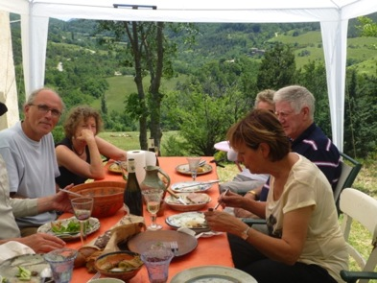 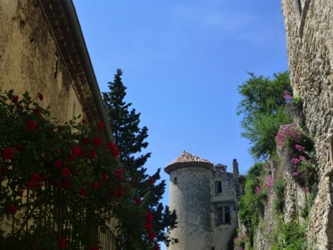 ,Lunch with Maryse and Claude Le Poet Laval

Sunday 24 June [Dieulefit]

At Dieulefit, visit La Maison de la Ceramique, school and exhibition space in the morning. Nadia B Ceramics Gallery in the afternoon and the village Le Poet Laval.

Visit Maryse Tavernier and Claude Wolf and their studio.

Dinner at our chambre d’hote, ‘Fontlargias’.
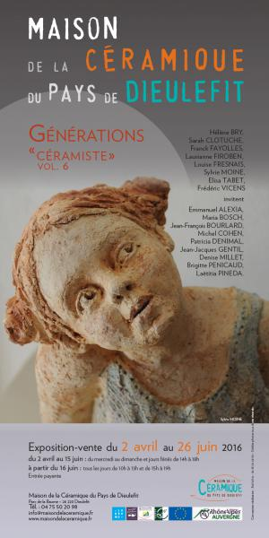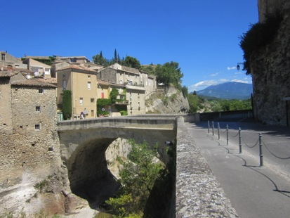
Vaison la Romaine
Monday 25 June [Buoux- Provence] 4 nights
Head south to Provence, visiting Vaison la Romaine on the way.
Stay at a chambre d’hote at Buoux, with swimming pool, local walks. Visit local pottery studios.Visit villages of Roussillon and Gordes, Dinner at Auberge de la Loube, Buoux. Phone:+33 4 90 74 19 58

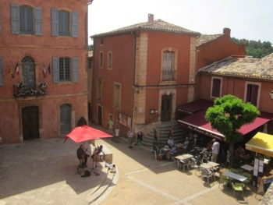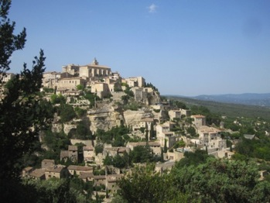
Roussillon Gordes

Tuesday 26 June [Buoux-Provence]
Explore villages of the Luberon:
Visit ceramics studios in Bonnieux. Visit the studio of Olivia Tregaut and Denis Bouniard at Oppede le Vieux.
Dinner included. Le Petit Café 33490767401
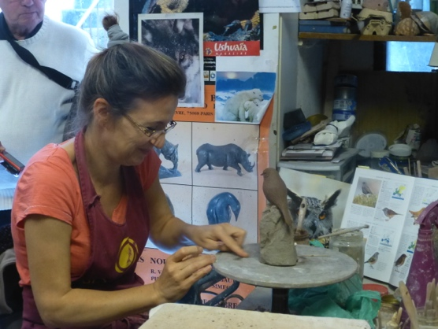 Olivia

Wednesday 27 June [Provence]
A day on the Mediterranean. Lunch at the port of Cassis. Explore les Calanques by boat, coves in limestone bays in the National Park. Swim at the beach in the Mediterranean.
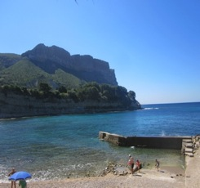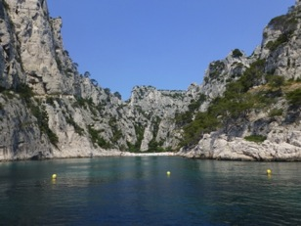
Cassis

Thursday 28 June [Provence]
Visit Chateau La Coste –lunch and sculpture park, winery. An amazing sculpture park with artist such as Andy Goldsworthy, Richard Serra, Frank Ghery, Louise Bourgeois and many more.
A highlight- as is the lunch 12.30pm and winery. 04 42 61 92 92
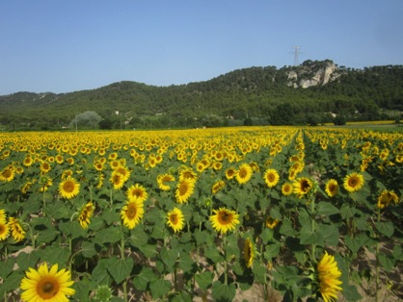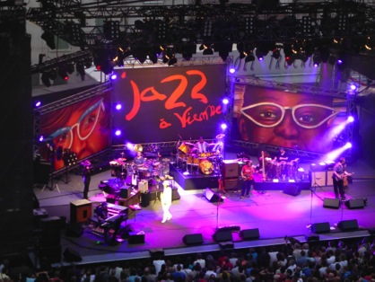

Friday 29 June [St Quentin la Poterie] 1 night
A visit to St Quentin la Poterie, a pottery village near Avignon. Discover the many studios and artists in this village of potters. Meet the potters. Visit the Gallery Terra Viva.

Saturday 30 June [La Cote St Andre] 1 night
Drive back through the vineyards to Vienne. Arrive early afternoon to explore the Roman city and soak up the ambience of the international jazz festival. Concert in the Roman Amphitheatre in the evening.

Sunday 1 July [Paris] [Hotel La Studia, 51 Boulevard St Germain] 4 nights
Take the TVG, very fast train from Lyon Part Dieu station at 11.30am to Paris.[2hrs] Arrive in the afternoon to see the annual Potters market at St Sulpice in Paris.
Dinner near St Sulpice at La Boussole ,12 rue Guisarde 0156248220

Monday 2 July [Paris]
Explore Paris- Fondation Louis Vuitton/ Orangerie / Le Grand Palais/ Marmottan
Evening Opera ‘Don Pasquale’ at the Palais Garnier Opera house.
Tuesday 3 July [Paris]
Continue to explore Paris, galleries of le Marais, and the 6th arrondissement.
To choose while in Paris.
Evening Jazz at Duc des Lombards

Wednesday 4 July
Tour finishes in Paris

Costs: Lyon to Paris $4,600
Included:
- Bed and all breakfasts
- 6 dinners
- Gallery and museum entries
- Music concert tickets
- Pottery workshops
- All travel during the 2-week tour, including train Lyon to Paris.

At the Jazz Festival we either take a picnic or buy take away on site.
The chambres d’hotes are homes where we stay and breakfast is included.
6 dinners are included, when we go to restaurants you will pay for your own.
Our big lash out extravaganza will be La Pyramide at Vienne at 64 Euros. It is worth the special occasion at an excellent French restaurant.
Being a small group we can make some changes to the itinerary to suit the weather, the best music and festival options.

Lunches: we can have a picnic or buy a sandwich or find a little restaurant, to be decided on how we feel at the time.

Please bring a mobile phone. It will be invaluable when we need to meet up, or if someone gets lost. Make sure it has international roaming. SMS is cheap and could save us a lot of anxiety. Alternatively you can buy a French SIM card when in France.

The jazz festival program can be found at www.jazzavienne.com

I can guarantee an insightful trip, as knowing the area and the local French people for 18 years has allowed me openings to places and people you would not otherwise find. The language is invaluable too! We will have a lot of fun.
Jane
Arrival at Lyon St Exupery airport between 10am and 12 noon, by plane or train [TGV], where I will pick you up. Departure from Paris, we can discuss, and I can help you make arrangements to your next destination.

Jane Annois
03 98442337/0422942216 jane@zestefrenchtours.com www.zestefrenchtours.com

