Pontormo’s Florence explores the life and work of the artist Jacopo Pontormo in Florence and locations close to Florence in the north of Tuscany.

Pontormo, in the words of a leading scholar of 16th century Italian art, was the key figure of ‘the new style that ended the Renaissance.’ More than any other artist of the time, he led the new revolutionary movement with his innovative and engaging art.

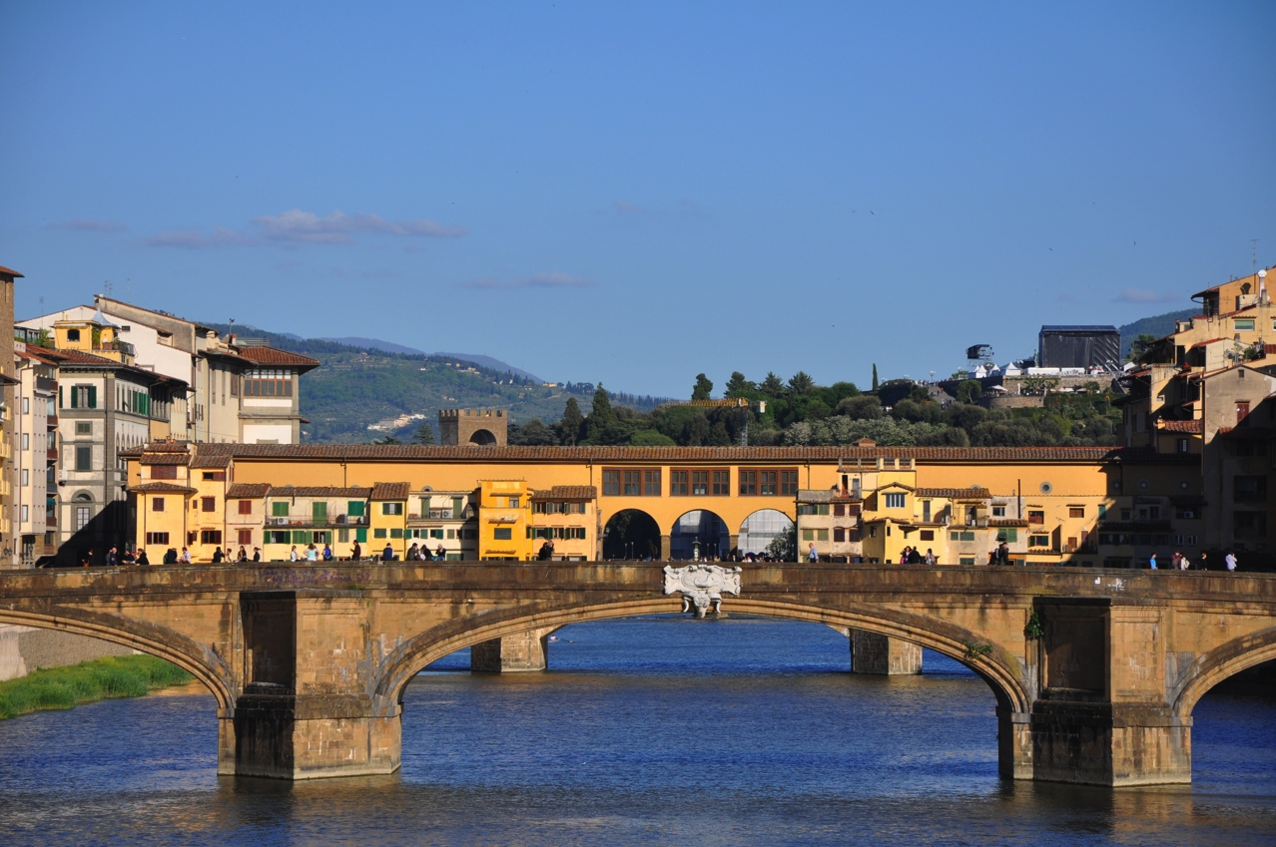
This tour, Pontormo’s Florence, follows his career working for the church and the ruling Medici as well as a range of private patrons in Florence and northern Tuscany. Every major work and many other panel and fresco paintings are included in the tour. Many are still in their original locations, while others are now in the collections of the major art museums in Florence, including the Uffizi Gallery, the Galleria dell’Accademia and the Gallery Palatina in Palazzo Pitti.

Pontormo’s Florence 19-30 May 2017

Itinerary

The tour also provides a context for the 50 years Pontormo lived in Florence, the period which spans his entire career, and offers glimpses of life in Florence during this time. We explore Pontormo’s neighbourhood in Florence, and the nearby organisations with which he was associated.

Outside Florence we visit Pontormo’s family home near Empoli, now a museum. Several relevant Italian villas, with their art collections and gardens, are also included on the tour itinerary.

Pontormo’s Florence, while focused on Pontormo’s life and work, also includes an overview of the artistic achievements in Florence during this quite extraordinary time, and the viewing of the work of his friends and contemporaries including Michelangelo and Raphael, Andrea del Sarto and
Rosso Fiorentino, and his most important pupil and closest friend Agnolo Bronzino.

Itinerary

Friday 19 May – day 1 Orientation
Arrive at the Hotel in Florence by 12.00pm. Following check-in, all tour participants meet for a welcome lunch at a nearby restaurant. In the afternoon we commence the tour with an orientation walk through Florence, identifying the major Renaissance palazzi and public buildings, as well as the sculptures located in the piazzas and streets. This walk-the-town introduction includes a visit to Piazzale Michelangelo and the Church of San Miniato al Monte, from which the most spectacular views of Florence and many of her major landmarks can be seen.

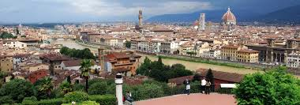
Saturday 20 May – day 2 Santissima Annunziata precinct
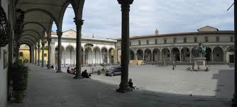
Today we explore Pontormo’s neighbourhood and his earliest extant masterpieces, which are mostly in their original sites. The Basilica of Santissima Annunziata, a church closely associated with the Medici, is the home of Pontormo’s first important commission, and of his early High Renaissance masterpiece in fresco. It is also the church in which Pontormo was buried, twice. The church faces one of Florence’s most beautiful large piazzas of the same name, which features Brunelleschi’s Foundling Hospital. We then view Pontormo’s house and those of his high-profile neighbours including Benvenuto Cellini and Andrea del Sarto.
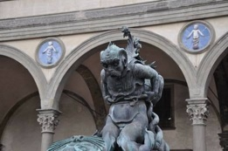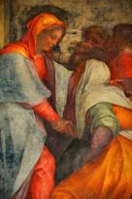
Brunelleschi’s Foundling Hospital and Pietro Tacca’s Pontormo: Visitation fountain [detail] alterpiece [detail]

Lunch
After lunch we visit the Church of San Michele Visdomini, the home of Pontormo’s Pala Pucci, the altarpiece commissioned by Francesco Pucci for his family chapel. Dated 1518, this work is generally considered to be the first major work which flagged the break from the style of the Florentine High Renaissance.
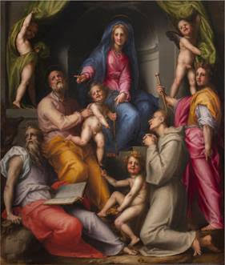
Pontormo: Visdomini Palla Pucci

Sunday 21 May – day 3 Uffizi, Bardini Museum and gardens
The Uffizi Gallery is one of the great art museums in the world, and its collections include in particular a wealth of Renaissance paintings. Pontormo is well represented here both with paintings and drawings. We spend the morning exploring his works, as well as those of his contemporaries and teachers, including those who influenced him. Paintings by Pontormo exhibited include Supper at Emmaus, Ten thousand martyrs, and several important portraits. The highlight is the Portrait of Cosimo the Elder, Lorenzo de’ Medici’s grandfather, described by F M Clapp as ‘One of the great imaginative creations of Florentine portraiture’. Time is also available for tour participants to explore particular interests in the Uffizi at their leisure.

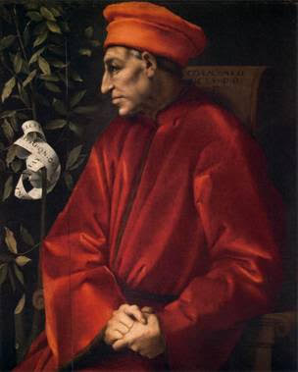
Pontormo: Portrait of Cosimo the Elder Uffizi Gallery

Late lunch at Uffizi Gallery
In the afternoon we visit the Bardini Museum, established by the 19th century antiquarian Stefano Bardini with his own extensive collection of Italian paintings and Renaissance sculpture. This is followed by the very short walk to the Bardini villa and gardens, and more wonderful views of Florence.
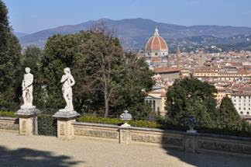
Florence from Bardini Gardens

Monday 22 May – day 4 Davanzati / Orsanmichele precinct
Today we explore the historic precinct that embraces the Piazza della Repubblica and Piazza Mercato Nuovo, which hosts a copy of Pietro Tacca’s famous bronze Porcellino (original in the Bardini Museum – see day 3). We tour the 14th century Palazzo Davanzati, a beautiful early Florentine home and now museum which includes a Pontormo birth tray painted in oil.
Lunch
After lunch we visit the ancient church of Orsanmichele, which commenced its life as a granary. It now also houses a gallery of Florence’s most important sculptors from the 14th through to the 16th century, originally commissioned for the external niches of the church. Artists commissioned by Florentine guilds include Andrea Pisano, Donatello, Ghiberti, Verrocchio and Giambologna.
Opposite Orsanmichele is the Accademia Arti del Disegno, which has strong links to Pontormo and now houses Pontormo’s large Baldrone tabernacle Crucifixion. Our final destination today is Palazzo Strozzi, one of the most substantial in Florence built during Pontormo’s lifetime.

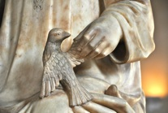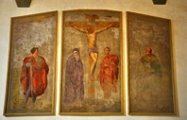
Orsanmichele Pontormo: Crucifixion
Accademia Arti del Disegno

Tuesday 23 May – day 5 Empoli, Carmignano and Poggio a Caiano
Jacopo Pontormo was born in the village of Pontorme on the outskirts of Empoli in 1494. His original family home, now completely renovated as a museum following the 500th anniversary of his birth, includes a facsimile copy of his Diario (Diary). We also visit the Church of San Michele in Pontorme to view another of his important early anti-classical paintings.
Lunch: Empoli
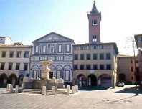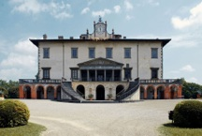
Empoli Villa Medici at Poggia a Caiano

Leaving Empoli we travel to Carmignano and view another major Visitation by Pontormo, and one of his greatest and most intriguing masterpieces. Recently completely restored for an exceptional exhibition of the works of Pontormo and Rosso in Florence in 2014, it has never looked so good! After a quick coffee at the Café Pontormo, we visit the Medicean villa at Poggio a Caiano, a short drive from Carmignano. Pontormo was commissioned, together with del Sarto and Franciabigio, to paint in fresco the Grand Sala in this breathtaking Tuscan villa and garden. Pontomo’s large Vertunno e Pomona in the lunette of the Sala has been highly praised over the centuries, even by Pontormo’s detractors.

Wednesday 24 May – day 6 Palazzo Pitti, Bobili Gardens and Santa Felicita
The Pitti Palace boasts important Renaissance art collections including several important paintings by Pontormo and his contemporaries. We explore the Palace’s extensive galleries before taking a stroll in its Boboli Gardens. This magnificent Italian garden, originally built for the Medici, contains many fountains, antique and Renaissance sculptures, and yet another panorama of Florence.
Lunch
Santa Felicita is an ancient church, rather modest by Florentine standards, and almost hidden in its own piazza a few metres from the Ponte Vecchio. Here we examine what is perhaps Pontormo’s most recognised painting and greatest masterpiece – the Deposition – which occupies the main wall of the Brunelleschi-designed Capponi Chapel. Also in this chapel is his Annunciation, in fresco, on the western wall.
A special Dinner is planned for this evening.
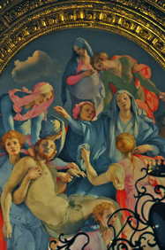
Santa Felicita Deposition [detail]
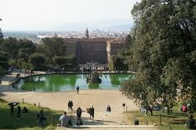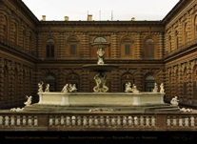
Palazzo Pitti and the Boboli Gardens

Thursday 25 May – day 7 Piazza and Palazzo Signoria, and the Bargello
The Bargello Museum – Florence’s major sculpture museum – is housed in a beautiful 13th century building, which is well worth a visit in its own right. Work by all major Renaissance sculptors is exhibited, including Michelangelo, Cellini, the della Robbia family, Giambologna, Brunelleschi and Ghiberti, as well as Donatello’s marble St George and bronze David. The Bargello is one of the real gems of Renaissance Florence.
Lunch
A short walk takes us to the Piazza della Signoria, which together with the Loggia dei Lanzi is Florence’s most important outdoor sculpture ‘gallery’, and includes both originals and copies of works by Donatello, Michelangelo, Cellini, Giambologna and others.
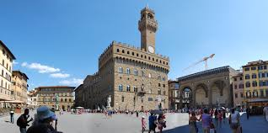
Palazza della Signoria

From the piazza we enter the Palazzo Vecchio, to view the treasure trove of Renaissance paintings, sculpture and frescoed ceilings by Donatello, Verrocchio, Bronzino, Michelangelo and Vasari.

The magnificent Basilica of Santa Croce is the burial place for many great Tuscans, and includes works by Giotto, Taddeo Gaddi, Donatello – as well as Bronzino’s The Descent of Christ into Limbo and Filippo Brunelleschi’s Pazzi Chapel.

Friday 26 May – day 8 I Tatti, Castello Villa and Certosa at Galluzzo
Today we visit a monastery and two villas with splendid gardens on the outskirts of Florence.
When the plague returned to Florence in 1522 Pontormo, with his student Bronzino, fled from Florence and worked for a few years at the Certosa at Galluzzo, where he painted a series of frescoes on Christ’s Passion, and the Supper at Emmaus, now in the Uffizi, and perhaps other works now lost or destroyed.
The Villa di Castello is one of the many Medici villas near Florence, and one which was particularly influential in the development of Renaissance gardens in Tuscany. It is one of two Medici villas near Florence for which Cosimo I de’ Medici commissioned Pontormo to execute major fresco projects, both now destroyed, during the 1530s.
Lunch
In the afternoon we visit the villa I Tatti in the hills outside Florence , the former home of art historian Bernard Berenson and his wife Mary. Now owned and managed by Harvard University, we immerse ourselves in a guided tour of this beautiful property, including the villa and its collection of paintings, and its outstanding garden.
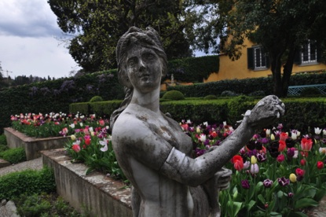
I Tatti

Saturday 27 May – day 9 San Lorenzo, and Santa Maria Novella
The Church of San Lorenzo and its chapels, closely associated with the Medici, is also the site of Pontormo’s last and perhaps his most significant commission, and painting of the church choir, tragically destroyed in the 18th century. We visit the Medici chapels with Michelangelo’s sculptures of the allegories of Day and Night, and Dawn and Dusk, and other works by Michelangelo and his contemporaries.
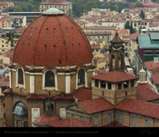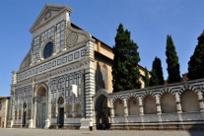
The church of San Lorenzo Santa Maria Novella
Lunch
After lunch we visit Santa Maria Novella, including the convent occupied for the last century by the Carabinieri as a school, which contains frescoes by Pontormo in the Pope’s Chapel, decorated for the first visit to Florence of the Medici Pope Leo X. This special access viewing is followed by a visit to the Farmacia di Santa Maria Novella, an exquisite historic pharmacy with origins going back to Renaissance Florence.

Sunday 28 May – day 10 Galleria dell’Accademia, and San Marco
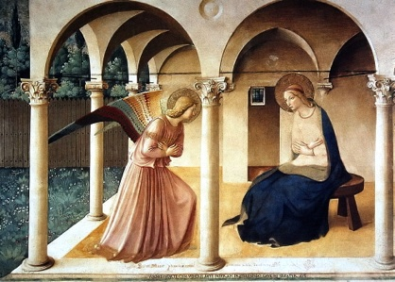
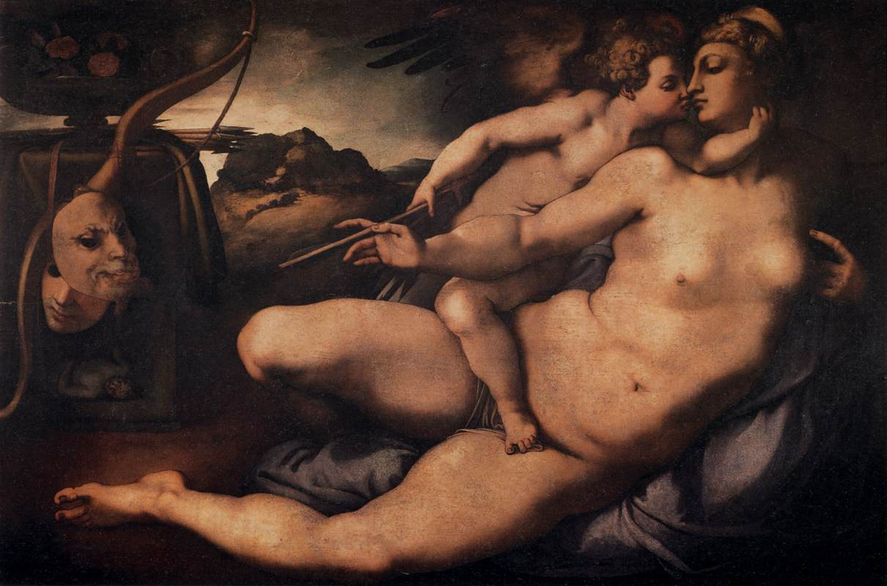
Today we visit the Galleria dell’Accademia, host of a large collection of paintings and sculptures from the 15th and 16th centuries. The Gallery includes Michelangelo’s [original] David. The renowned Venus and Cupid by Pontormo is displayed near Michelangelo’s marble Slaves: it was painted in oil from a cartoon by Michelangelo at the latter’s request. Also by Pontormo is a small fresco titled Hospital of San Matteo.
Fra Angelico: Annunciation San Marco

Pontormo: Venus and Cupid Galleria dell’Accademia

Lunch
In the afternoon we visit the Museum of San Marco, the former monastery, and view its extensive art collections including Domenico Ghirlandaio’s
Last Supper and a large collection of works by Fra Angelico. We also visit the cells of the monks, many of which are decorated by Fra Angelico. San Marco is closely associated with the renowned monk Girolamo Savanarola, who was hung with two of his fellow monks in Piazza della Signoria in 1498.

Monday 29 May - day 11 Duomo precinct, Duomo Museum, and San Salvi
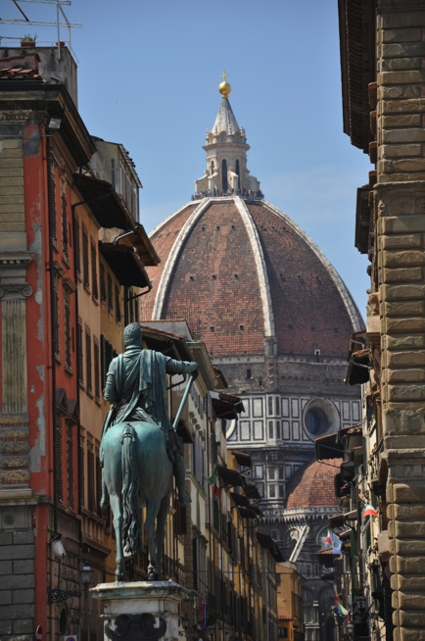
Andrea del Sarto was Pontormo’s most important teacher, and his great masterpiece is the Last Supper in the Cenacolo (Refectory) of San Salvi on the eastern edge of modern Florence. We visit this fascinating boutique museum to view this work in-situ, as well as works by Pontormo collected from other sources, including the much degraded original of his very early Faith and Charity from the portico of Santissima Annunziata.
We then return to the spiritual heart of Florence, the Duomo precinct,
and explore its major elements. The Cathedral and its great Brunelleschi dome, together with its ‘rival’ the Ponte Vecchio, projects Florence’s enduring image. For those so inclined, to understand something of the architecture and engineering of the Dome, we recommend the climb to the top!
Lunch
We then visit the Museum of the works from the Duomo, treasures retrieved from the Cathedral and preserved in this museum, including Ghiberti’s so-called Gates of Paradise from the Baptistery. This Duomo Museum reopened in late 2015 following extensive refurbishment by the Spanish architect Santiago Calatrava.
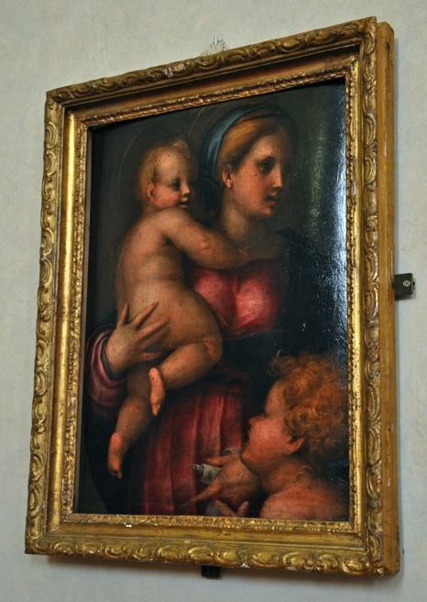

Brunelleschi’s dome, Pontormo: Madonna and Child, Cathedral in Florence Cenacolo di San Salvi
Tuesday 30 May day 12 Departure from Florence
Your guides:
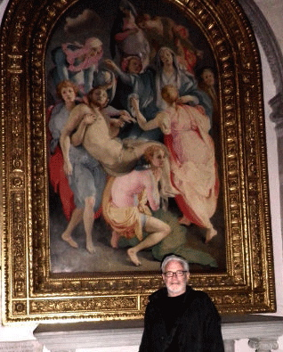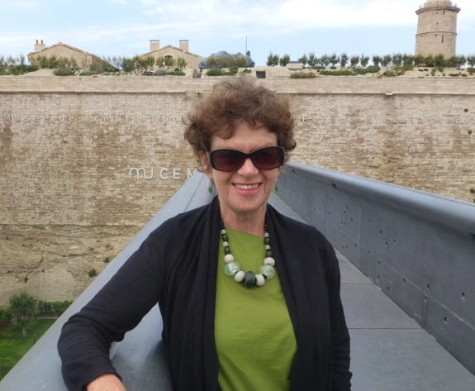
Jonah Jones Jane Annois
Led by Jonah Jones, a specialist in Pontormo’s life and work. Jonah has been fascinated by Jacopo Pontormo for several decades and since 2012 has immersed himself in researching Pontormo’s contribution to the history of Italian art.
Jonah has been involved in the visual arts in Australia and internationally for many years. He was Founding Director of the Melbourne Art Fair, the Moët and Chandon Australian Art Foundation and the Araluen Arts Centre. He was also Director of the Sydney 2000 Olympics Cultural Festivals for two years.
In addition Jonah developed and toured exhibitions to North America, Asia, Europe and the Pacific for the Christensen Fund, and the Australian Government, for two decades.

Jane Annois has been leading Zeste French Tours for 12 years. Although specializing in small group tours to France she is taking Zeste further to Italy to explore Renaissance art in Florence and Northern Tuscany. Jane has a background in ceramics and French art, culture and history. She is concerned with providing her clients with a rich cultural experience. This will be a very special, personalized tour, catering to your interests and needs and offering ‘behind the scenes’ experiences. Our accommodation will be comfortable renovated apartments in the heart of Florence; we will enjoy fine Italian food and wines and participate in the important café culture of Florence and fine restaurants. Our central accommodation enables us to walk to most of our destinations, galleries and restaurants. We will be taking a minibus to explore villages outside Florence.
For bookings and enquiries:
Jane Annois
jane@zestefrenchtours.com
www.zestefrenchtours.com
0422942216
03 98442337
Tour includes:
11 days accommodation and breakfasts
5 dinners
All transport during 11 days
All entries to museums and galleries
max 12 people Cost:
$5,500 [Florence to Florence]

