Newsletter May 2016 Zeste French Tours

Bonjour,
I’m off to France on Tuesday to begin this year’s Zeste French Tours. Spring has arrived in France with wildflowers and blue skies for our walks in the Chartreuse Mountains as our first adventure.
Our walking tour will take us to four very different landscapes in France, from the Chartreuse mountains near Grenoble, to the Luberon Valley and then the Calanques, limestone bays in the National park near Cassis, followed by the Hautes Alpes de Provence and Route Napoleon back towards Lyon.
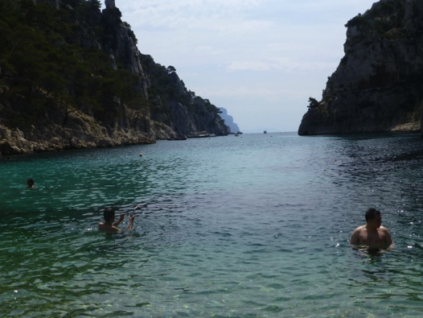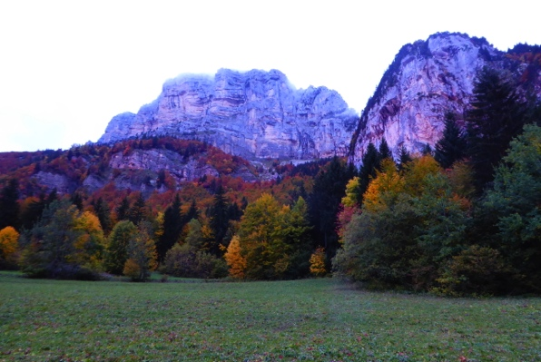

The second tour from Avignon/Uzes/St Quentin la Poterie, follows the Roman route to the Pont du Gard, Nimes and Aigues Mortes. We explore the Camargue and its music, jazz manouche. Heading west along the coast via Sete, until Collioure, a day in Spain following Dali, then through the mountains, Cathar country its fortresses, valleys and wonderful wines to Carcassonne.
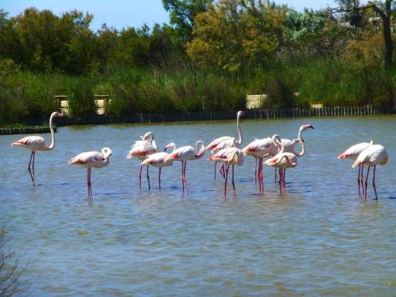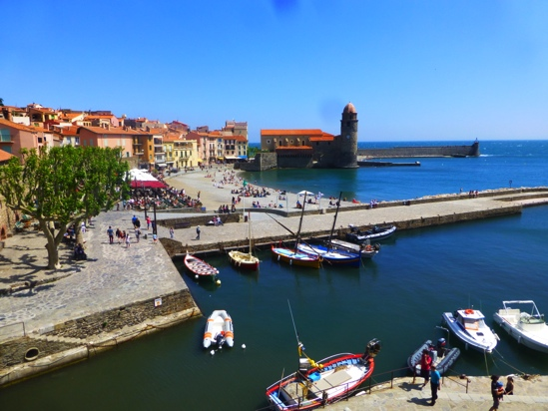

The third tour in June/July is the Pottery and Music tour, visiting all our French friends, taking part in workshops in the studio and enjoying their hospitality in their homes. We wind our way through the Rhone Alpes, the Drome and Provence to some of the most picturesque parts of France, with fabulous music performances throughout the trip. We finish in Paris with a grand finale at the Potters market at St Sulpice and the Paris Opera.
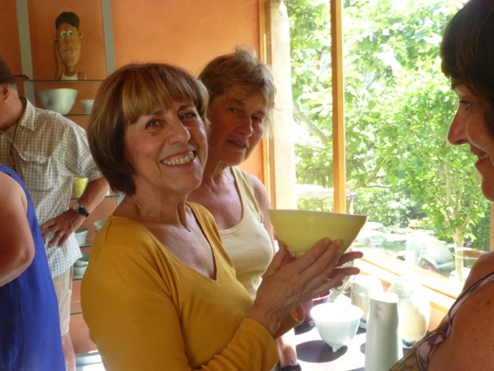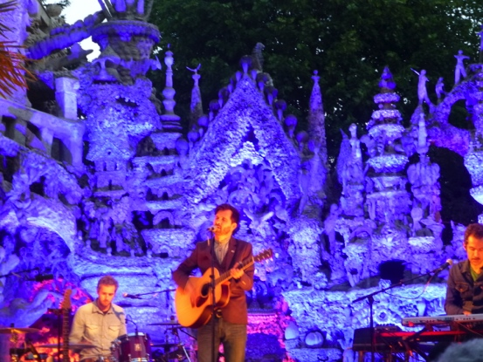
After the Pottery tour, in early July, it will be the middle of the summer festival season. I am making the most of my time in France by going to several! Starting with les Nuits de la Fourviere in Lyon for a ‘soul night’ in the Roman Amphitheatre, then fulfilling my long held dream of going to Montreux Jazz Festival on Lac Leman to see none other than Patti Smith and Van Morrison. I mean really- I have been waiting years and years for an opportunity like that. Following it by Musilac on the lake at Aix les Bains.

Home again in mid July until late August, when I take a private tour from Bordeaux through the Dordogne – yes I take requests!
I am then looking forward to taking a group of keen photographers to Brittany. They will be in heaven. We go off the beaten track to some stunning beaches, with amazing rock formations, weathered boats and usually just us, on the pristine beach. We follow the coast to the furthest western point in France, and discover the Celtic past in the forests with 6000-year-old standing stones.

The last tour for the year is from Bordeaux to Bilbao, in late September [during our school holidays]. This is a new tour, where I had a lot of fun doing the reccy!
We visit some of the finest wineries France has to offer and enjoy Bordeaux – a beautiful city on the River Gironde. We follow the Atlantic coast down from Arcachon to Biarritz [surfing capital of France with a bit if ‘ritz’] and into the Basque country, cross the border into Spain and into San Sebastian. It is suddenly very different, the Pyrenees as a backdrop and fabulous tapas bars. Eventually we arrive at Bibao, and the Guggenheim Museum, a mecca for those interested in architecture and the arts. We return to Bordeaux through the mountains and an inland route.
There are still a few places on the Bordeaux to Bilbao trip and the itinerary is available online at http://www.zestefrenchtours.com/tours-2016.html

While you are online, the tours for 2017 are listed including a new exciting tour, to Florence, exploring the life and art of 16th century artist Pontormo, with art expert Jonah Jones. The tours are booking up, but there are still a few places left in each of them.
I hope to hear from you, best wishes
Jane Annois jane@zestefrenchtours.com

Bordeaux to Bilbao:
