Zeste French Tours

Corsica

20 September – 4 October 2018 Bastia – Bastia $4,600

Take a journey around the island, exploring its Genoese past, its culture and traditions, food and wine, from its beautiful turquoise beaches to the craggy rocks and mountains of the interior. There will be swimming, walks and wonderful discoveries.

Thursday 20 September [Patrimonio]
Meet at the airport in Bastia.
Spend the day in the city of Bastia, exploring the old city and port. Drive to the hill top town of Patrimonio, known for its vineyards and excellent wines. Wine tasting and visit to a local vineyard.
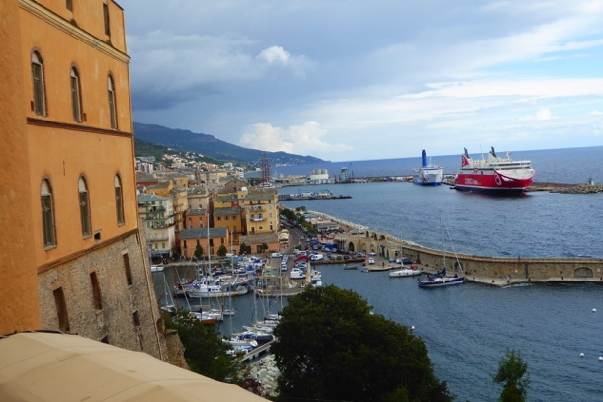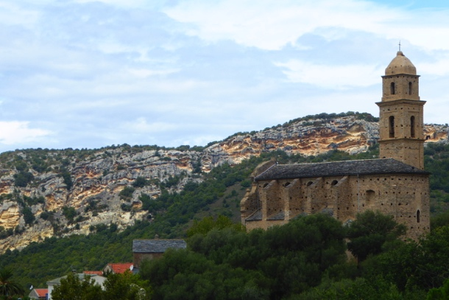
Bastia Patrimonio
Friday 21 September [Pigna]
Down the mountain to the west coast of Corsica to the beautiful bay at St Florent. Take a boat trip to the beautiful white sandy beach of ‘La Plage de Loto’ [every 30mins].
Through the desert des Agrates, to visit L’Ile Rousse and then into the countryside to the artists’ village of Pigna.

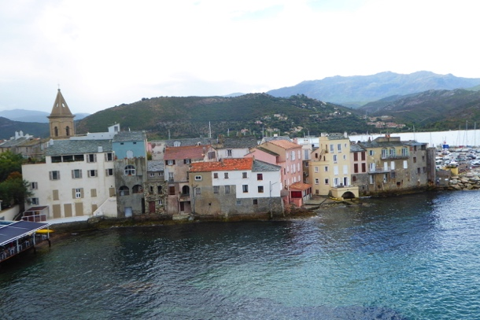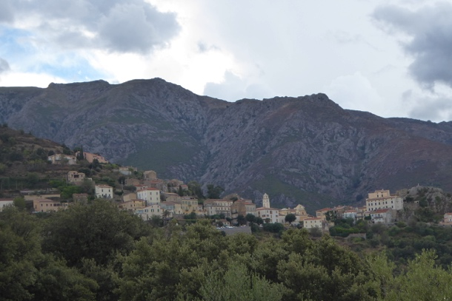
St Florent Pigna
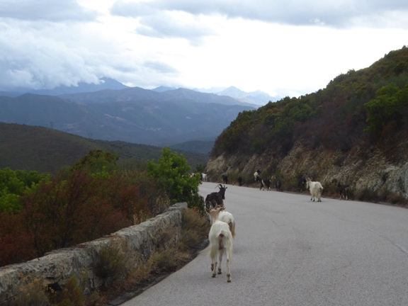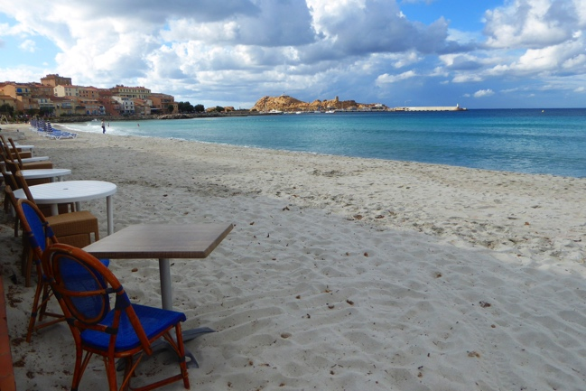
The road in the Balagne L’Ile Rousse
Saturday 22 September [Calvi]
Spend the day in the Balagne the region noted for its Artist villages, ‘Strada l’Artigiani’, traditional handcrafts and music. Also the Baroque and Romanesque churches perched in the mountains.

Sunday 23 September [Calvi]
A day to explore Calvi, the capital of the Balagne, a beautiful seaside resort with its towering Genoese citadelle, the birthplace of Christopher Columbus.

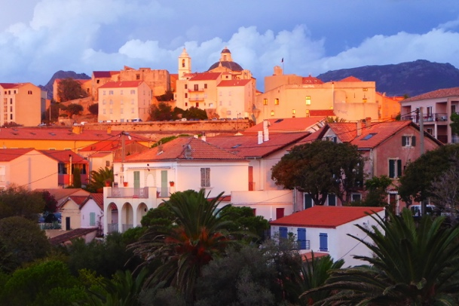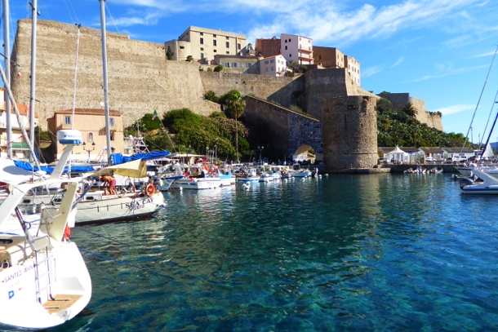
Calvi Calvi

Monday 24 [Piana]
From Calvi, follow the spectacular coast road through rocky out crops, mountains and breathtaking views across the bay to Porto where we enjoy a beautiful lunch at the port. Explore the history of Porto before heading into the hills to Piana [one of the ‘most beautiful villages in France’]. A Corsican hill top village of white houses and granite rock formations, which has privileged views across the bay.
The area is known for its traditional handcrafts, national parks and walking paths.
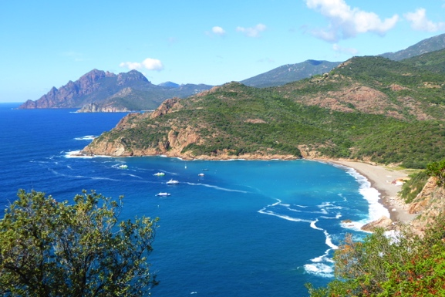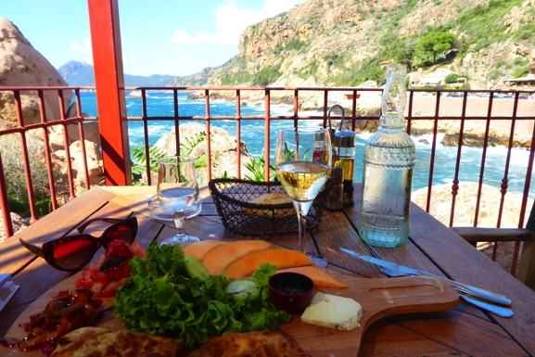
Porto lunch at Porto
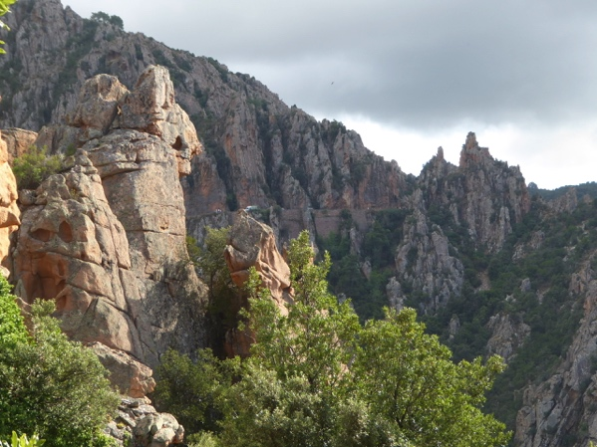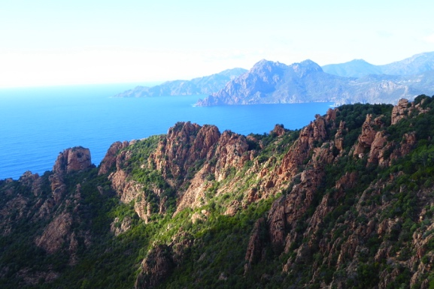
the Calanques de Piana

Tuesday 25 [Sartene]
Visit Sagone in the morning and then the bustling city of Ajaccio, to see La Maison Napoleon, the port, museum.
We move on to Sartene, in the mountains for two nights.
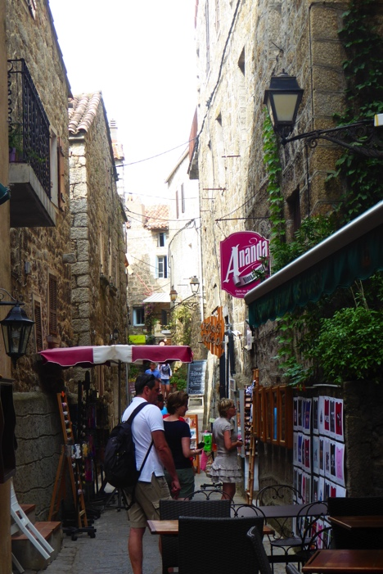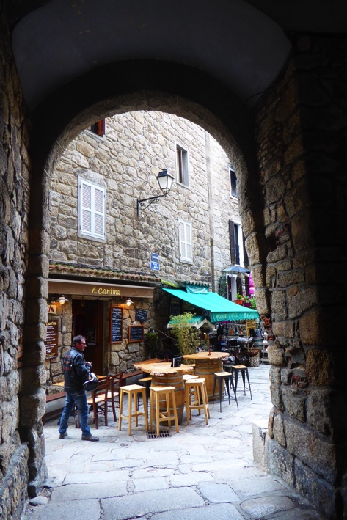
Sartene

Wed 26 [Sartene]
Spend the day in Sartene, a hilltop town of winding alleys and coloured houses, with an interesting museum of Corsican archeology and pre history.
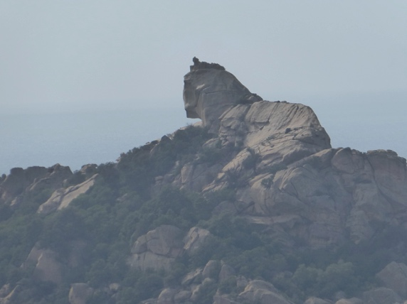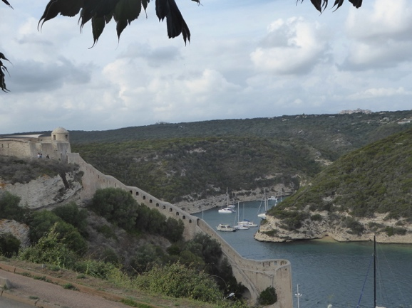
Le Lion de Roccapina the harbour at Bonifacio

Thurs 27 - Sunday 30 [Cala Rossa] [5 nights]
From Sartene we go to the Pointe de Roccapina, the pink granite rock promontory and its prehistoric sights, before arriving in Bonifacio for lunch. We visit the old city at the top of the promontory perching over the city and its protected harbor. See the ‘Escalier du Roi D’Aragon’ and views of the cliffs looking towards Sardinia.
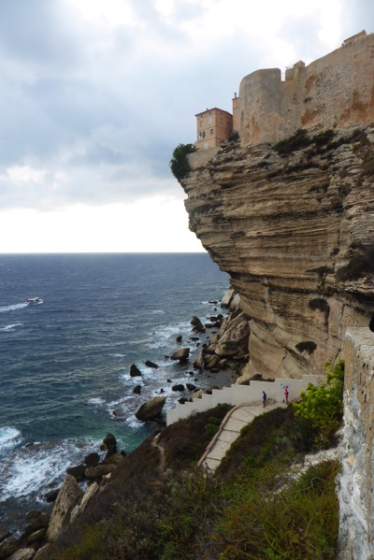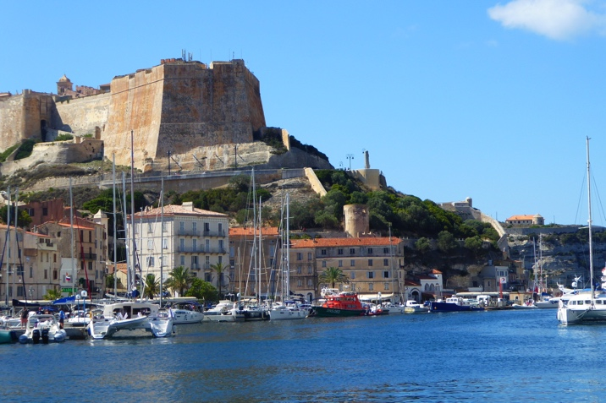
Bonifacio
Drive to our home on the east Coast for 5 nights at Cala Rossa.

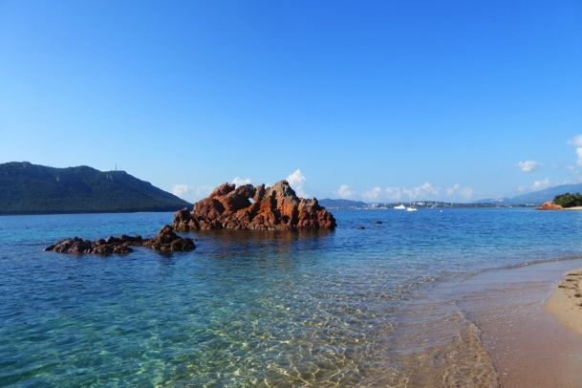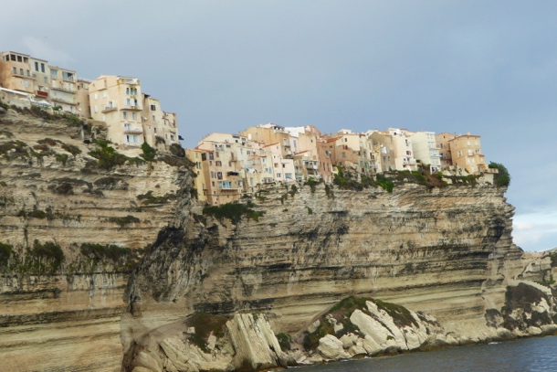
Cala Rossa Bonifacio
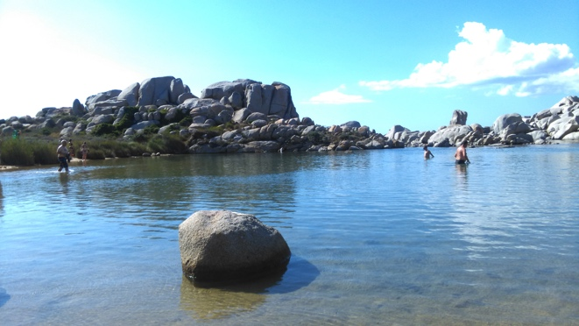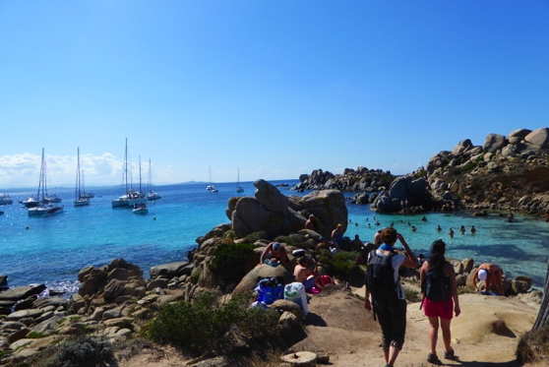
the Iles de Lavezzi
Fri 28 [Cala Rossa ]:
Rest and recreation: beaches, cafes on the sand, walks- the pool.

Sat 29 [Bonifacio]
From Cala Rossa as our base we explore neighbouring towns, beaches and inland villages.
Return to Bonifacio for the day to take a boat trip to the Iles de Lavezzi: clear turquoise water, protected bays and beaches, extraordinary rock formations, and a sailor’s haven.
Take a picnic, spend the day. Walk around the island.

Sun 30 [Cala Rossa]
Another perfect beach! Plage de Polombaggia.
In the afternoon, head inland to explore the village of Zonza.

Mon 1 October [Cala Rossa]
Spend time at the beach, the pool and visit the town of Porto-Vecchio.

Tues 2 October [Corte]
From Cala Rossa, head north along the East Coast to Solenzara for lunch at the beach, before heading inland and high into the mountains. A change of climate and scenery at Corte with narrow laneways and arches, galleries, bars and bistros.
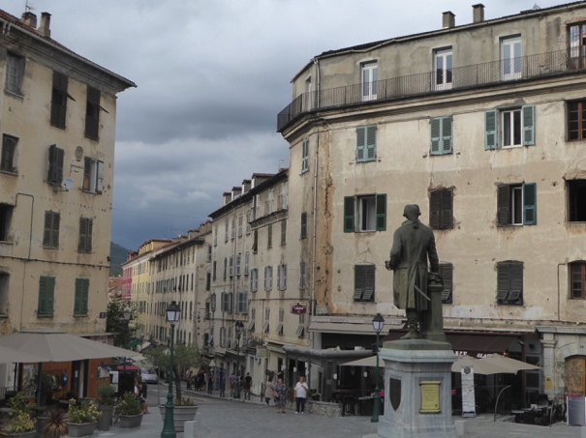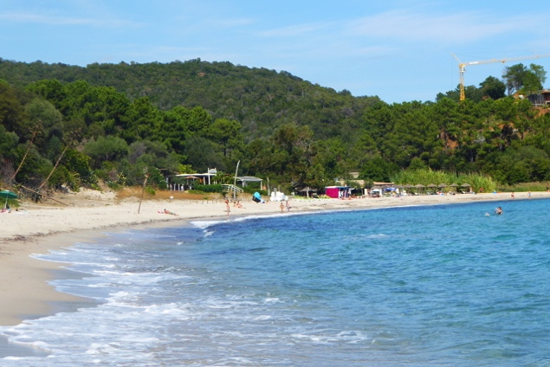
Corte Solenzara

Wed 3 Bastia
Continue north east to Bastia, via the city of Aleria and its Roman history. Spend the afternoon and evening in Bastia, its Citadelle and old port. Our last night.

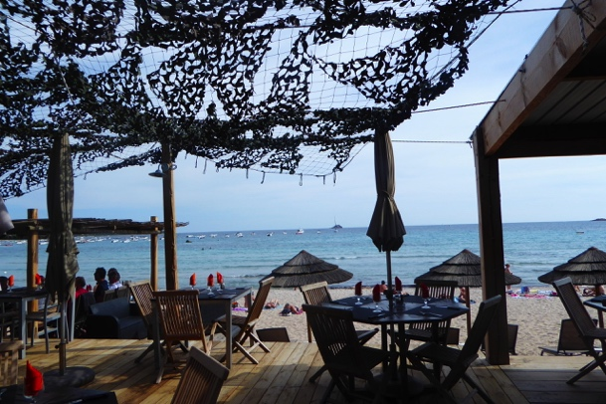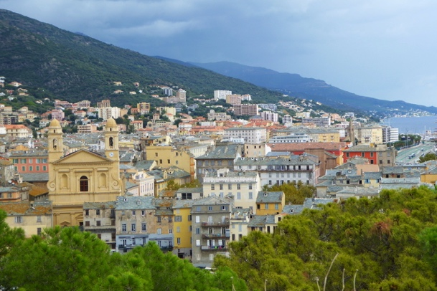
our beach at Cala Rossa Bastia

Thursday 4 October:
Departure, Back to Bastia airport.

Cost $4,600
Included:
Not included:
- Airfares
- Travel insurance
- Other meals

- all travel in Corsica by minibus
- boat trips
- all entries to museums and
- other activities
- accommodation and breakfasts
- 6 dinners Corsica
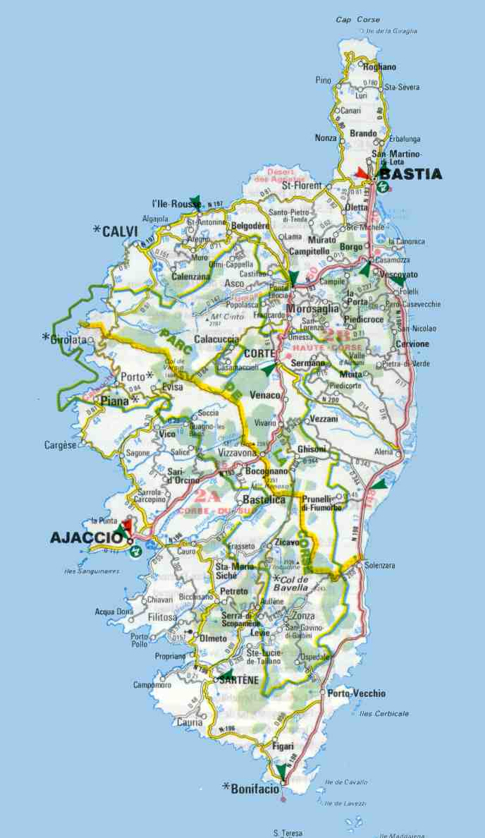
www.zestefrenchtours.com
jane@zestefrenchtours.com
Jane 0422942216

There are flights to Bastia from Paris, Lyon, Nice or Marseille. Please discuss your travel plans before booking.

