Zeste French Tours
La Camargue
15-29 May 2015 Avignon to Avignon $3,900

Follow the Roman Route from Avignon to Usez, the Pont du Gard, Nimes, Arles to the wetlands of the Camargue. Explore the coastline from Aigues Mortes to the Bay of Collioure, through the mountains to Cathar territory and Carcassonne, before returning to Avignon. Immerse yourself in the rich history

Friday 15 May [Uzes] Les Pins de Jol, St Quentin la Poterie
Pick up from Avignon train station / airport
Lunch in Avignon and visit le Palais des Papes
Drive to Uzes, stay the night at St Quentin la Poterie. Dinner.

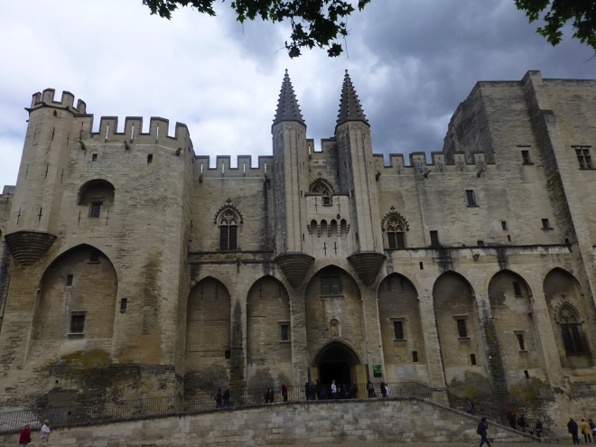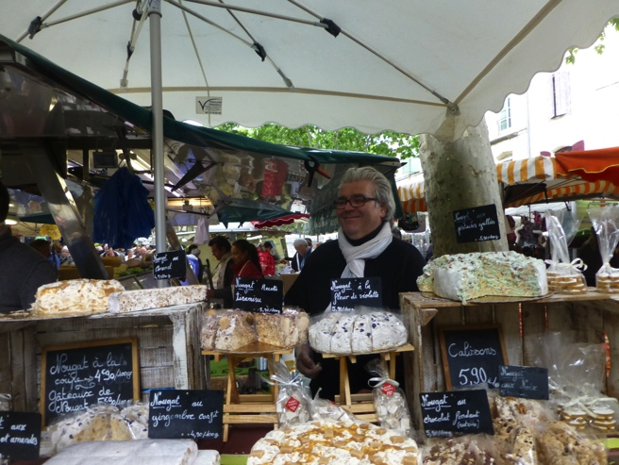
Palais des Papes, Avignon Uzes market

Saturday 16 May [Uzes]
The Uzes market! Spend the morning at the market; enjoy the music and ambience and food. Afternoon at St Quentin la Poterie, its pottery studios and galleries.

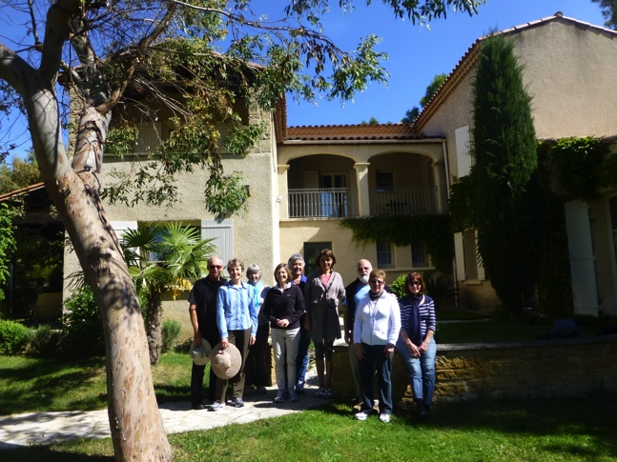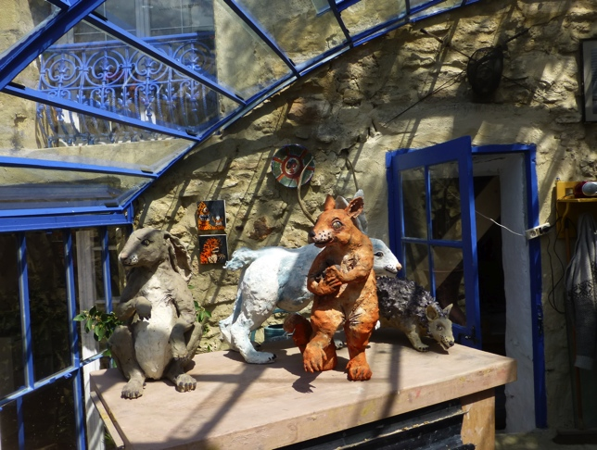
Les Pins de Jols Studio at St Quentin la Poterie

Sunday 17 May [Uzes]
Visit le Pont du Gard, Roman aqueduct and museum. Spend the day near the water. Evening back at St Quentin/ Uzes.
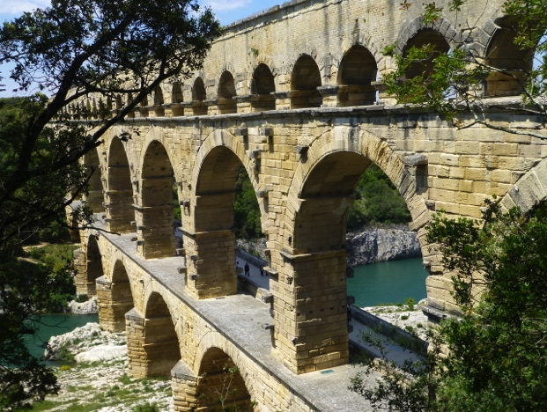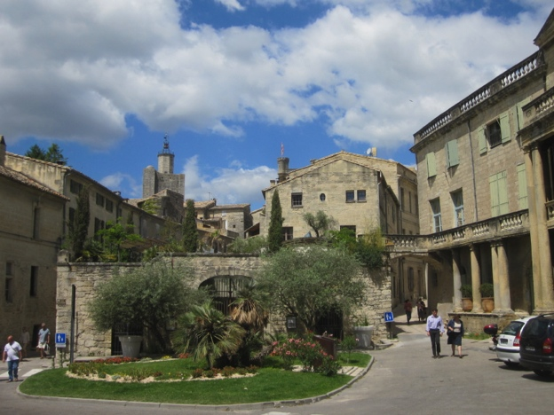
Le Pont du Gard Usez

Monday 18 May [Aigues Mortes]
Drive to Aigues Mortes via Nimes. Visit Nimes and its Roman past: La Maison Carree, the Amphitheatre [Arenes] and the Temple of Diana and the Musee d’Art Contemporain. Lunch at Nimes. Dinner in the square inside the walled city.
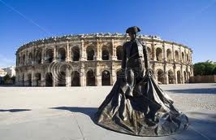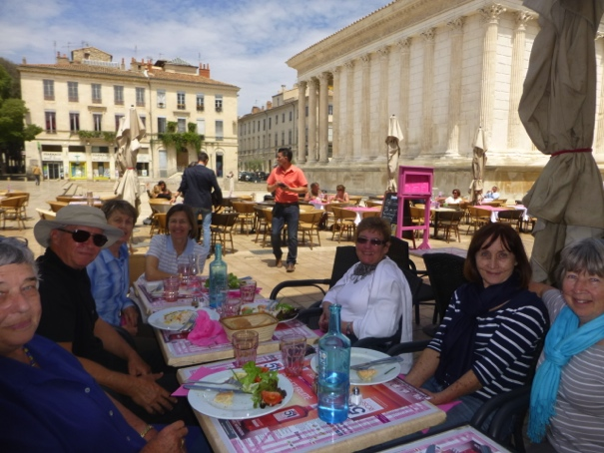
Les Arenes de Nimes La Maison Carree at Nimes

Tuesday 19 May [Aigues Mortes]
Aigues Mortes established in 13th century, a walled city and port: our base for exploring the wetlands of the Camargue. Take a boat trip in the morning along the canal du Midi to see the wetlands, black bulls and white horses. Spend the afternoon at the Ornithological Park and wetlands. Don’t forget your camera or sketchbook.

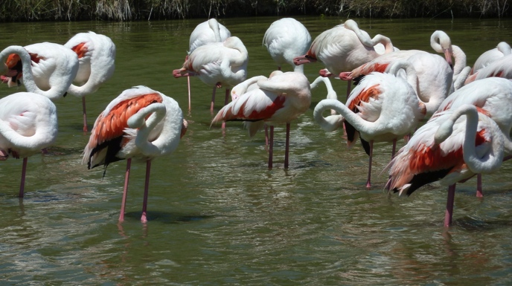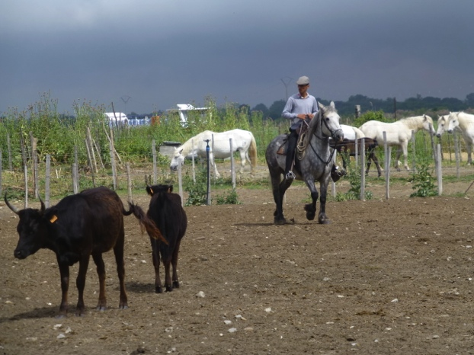
Flamingoes at the Camargue Rounding up the black bulls

Wed 20 May [Aigues Mortes]
Visit Arles and the Fondation Vincent van Gogh, the gallery where contemporary artists have paid homage to Van Gogh. Walk the Van Gogh trail through the city. Visit Arles’ magnificent Roman amphitheater and antique theatre. Arles Jazz Festival.

Thurs 21 May [Aigues Mortes]
Spend the morning at Aigues Mortes and surrounds and the afternoon at Saintes Maries de la Mer at the edge of the Camargue. A fortified town on the coast of 13th Century, with a history of the Templars and Crusades. Known for its history as a place of pilgrimage to the three Saint Marys and meeting place for gypsies.
Enjoy Jazz Manouche, gypsy guitar music from the region at a local restaurant in the evening.

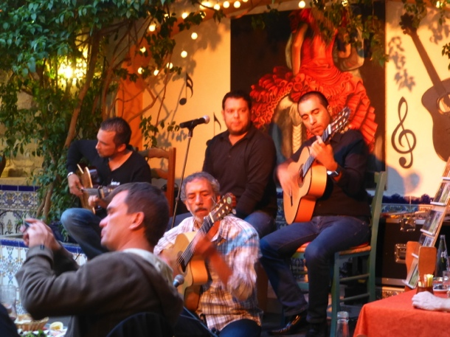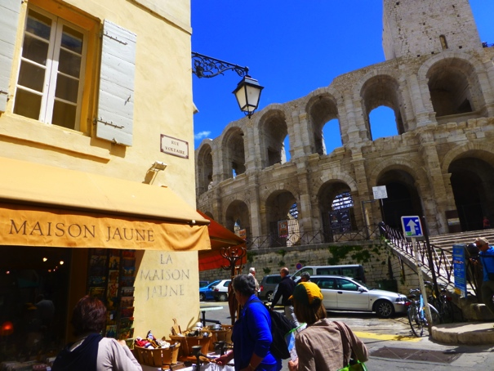
Music at Les Saintes Maries de La Mer Arles

Friday 22 May [Sete] Hotel les Tritons [8 Blvd Joliot-Curie]
Visit Montpellier on the way to Sete. Montpellier is the old capital of Languedoc, now an exciting university city. See its galleries, medieval architecture, and charming old quarter. Sete, where we will stay the night, is a large fishing port established by Louis XIV, with waterways, canals, beaches and shoals of fish and seafood restaurants. Take a boat trip at Sete.
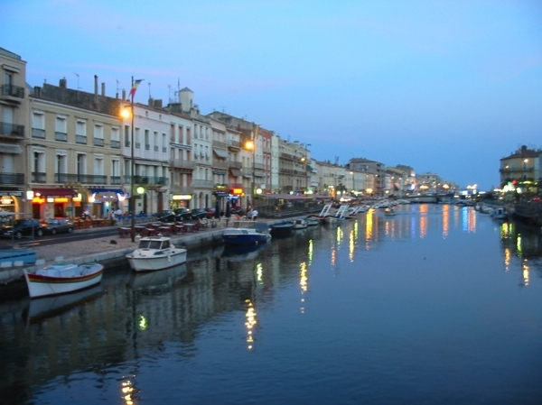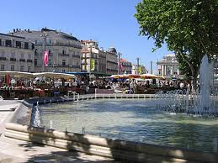
Sete Montpellier

Sat 23 May [Collioure] Le Triton
From Sete we follow the coast through Narbonne and Perpignan to Collioure:

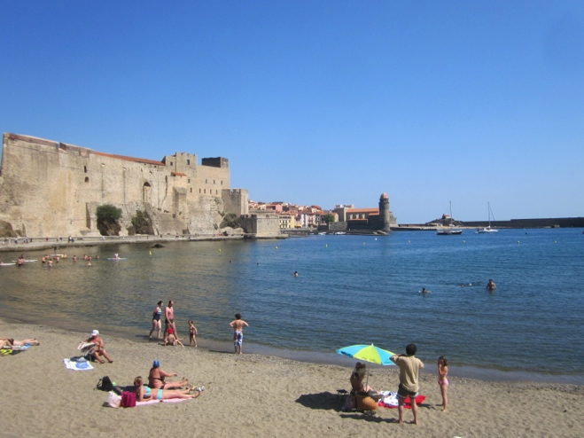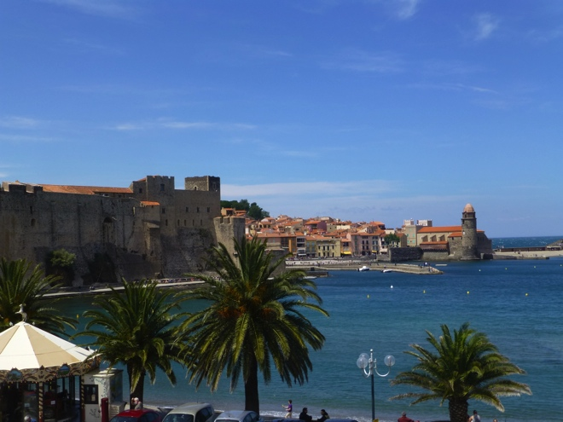

Sunday 24 May[Collioure]
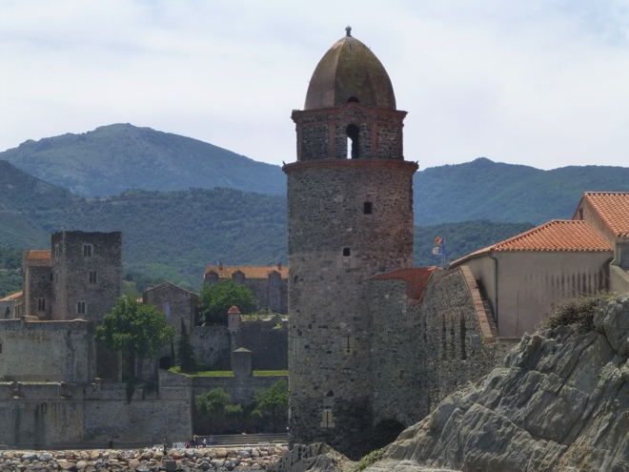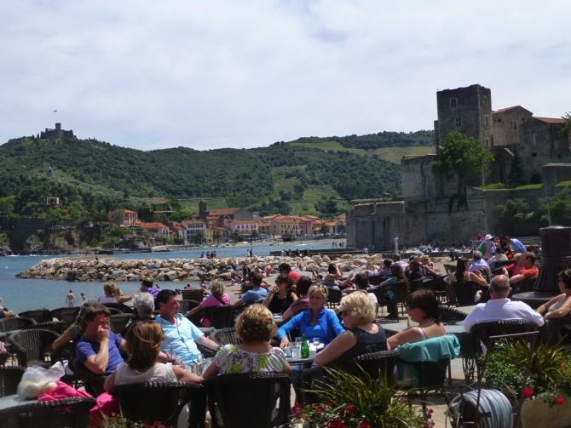
Collioure
Spend the morning exploring Collioure and the afternoon in Spain! Drive over the mountain into Spain to Figueres to visit the Dali Museum.

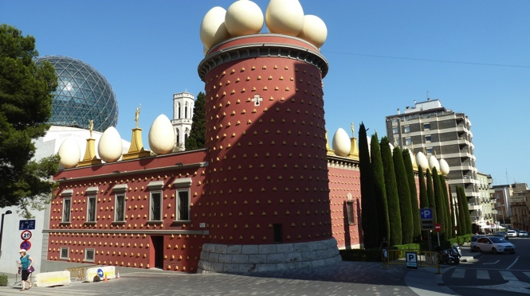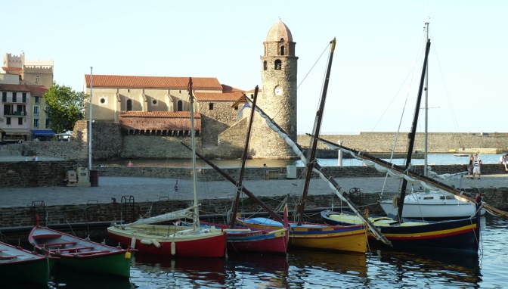
Dali Museum, Figueres, Spain Collioure

Monday 25 May [Collioure]
Enjoy the beautiful coastal town of Collioure, its fishing port, beaches and cafes.
Collioure is a picturesque port made famous by the artists Matisse, Derain, Picasso and Braque who all painted here. Walk the Fauvism trail around Collioure and visit the many galleries, try the local wine. Swim.

Tuesday 26 May [Carcassonne]
From Collioure drive north into the mountains to Carcassonne, via Perpignan, Rennes-le Chateau, Arques, and Limoux. This is the land of the Cathars, chateaux on mountain tops and dramatic landscapes. Stay at the chambre d’hote les Palmiers de la Cite at the foot of the chateau.
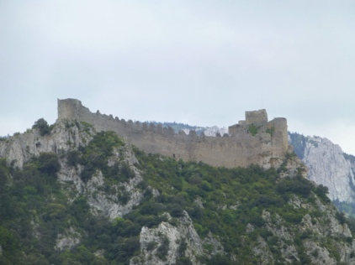 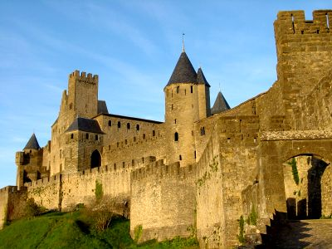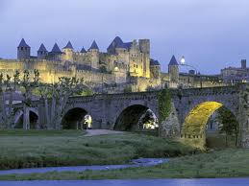 Carcassonne

Wed 27 May [Carcassonne] les Palmiers de la Cite
Spend the day at Carcassonne, exploring the chateau and village.
Dinner in the village around the chateau.

Thurs 28 May [Avignon] Hotel Boquier
Drive from Carcassonne through Beziers to Avignon, exploring local region.
Stay in Avignon the night

Friday 29 May depart.
Make our way to the Avignon airport or train station.

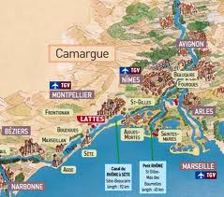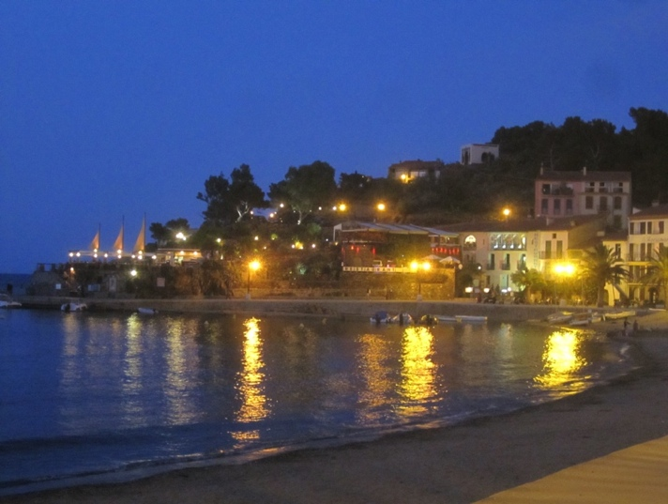
Collioure in the evening. That is our hotel on the right of the photo, right on the beach.

For more information and bookings:
Jane Annois 03 98442337 / 0422942216
jane@zestefrenchtours.com
www.zestefrenchtours.com

Cost: $3,900 Included:
14 nights and 15 days
Pick up and drop off in Avignon
All travel in France in between
All breakfasts and accommodation
6 dinners
All entries, museums, galleries and activities.
Boat trips at Sete and Aigues Mortes
Interpreting, introductions to artists and studios.

