Zeste French Tours

Bordeaux to Bilbao

3 – 17 September 2018
Bordeaux to Bordeaux 14 days $4,600

Starting and finishing at Bordeaux, we explore its famous vineyards before heading south along the coast. First to Arcachon and its nature reserves, sand dunes and beaches, then down to Biarritz the surfing capital of France. Spend time at the jewels of the Basque coast: Bayonne, Biarritz and St Jean de Luz before crossing into Spain to visit San Sebastian and Bilbao. Enjoy the tapas bars and the flavours of Spain and the exceptional Guggenheim Museum at Bilbao. Enjoy fine cuisine and wines.

Monday 3 September Bordeaux [4 nights]
Meet at Bordeaux [airport/train or hotel TBA]. Explore the city of Bordeaux, its highlights and promenade along the Garonne River.
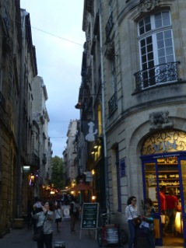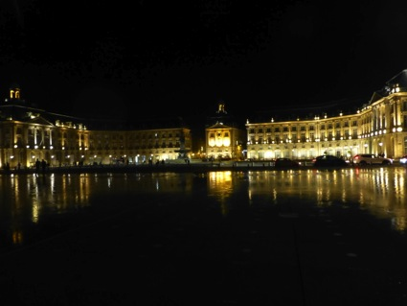
Bordeaux

Tuesday 4 September [Bordeaux]
Visit the famous vineyards on the outskirts of Bordeaux, in the Medoc and along the Gironde River. Chateaux and wine.
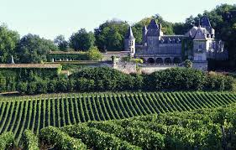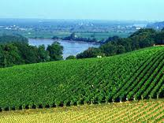
Wednesday 5 [Bordeaux]
Spend the day exploring the countryside between Bordeaux and St Emilion on the Dordogne River. Visit the chateaux, wine tastings.
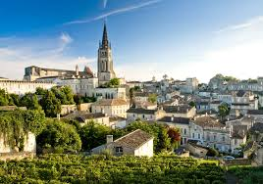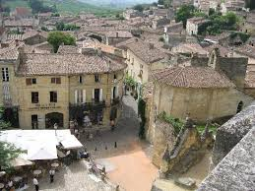
St Emilion

Thursday 6 Bordeaux
A day in Bordeaux, to experience the city. A lively city with a busy shopping district, markets , galleries, museums, parks and walks along the river.

Friday 7 [Arcachon]
Drive to Arcachon to take a boat trip in the Arcachon Basin. View the birds and wildlife in this nature reserve. Roll down the famous sand dunes at the renowned Dunes de Pilat.
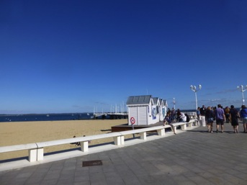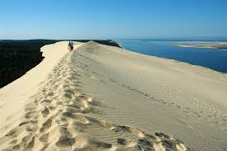
Arcachon, the pier The Dune du Pilat

Sat 8 Biarritz [3 nights]
Follow the coast south through the Landes region, past the lakes, stopping at several small historic villages. Spend the late afternoon at Bayonne before arriving in Biarritz. Spend the next 3 nights at Biarritz, the surfing capital of France.
Watch the sunset over the beach as the surfers catch the big waves. A beautiful city of beaches: the ‘grande plage’ with its famous Casino, the port, sheltered swimming beaches and of course, the surf beach. Museums, galleries, restaurants, walks, excursions.

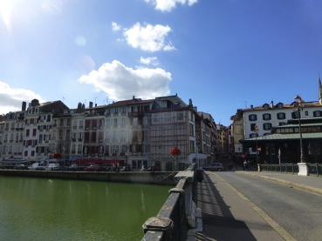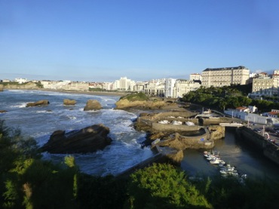
Bayonne Biarritz

Sunday 9 [Biarritz]
Spend time at Biarritz, walk the beaches, swim if hot. Explore the town and the port.
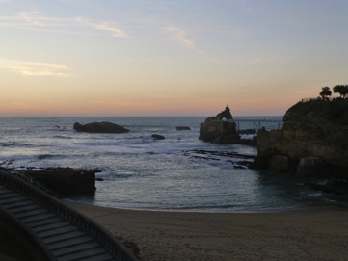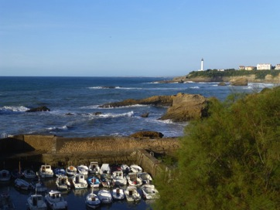

Monday 10 [Biarritz]
Visit the nearby town of St Jean de Luz, picnic and walks.
Take a train trip up to the mountain “La Rhune”. Spectacular views across the Pyrenees. [Depart from St Jean de Luz]
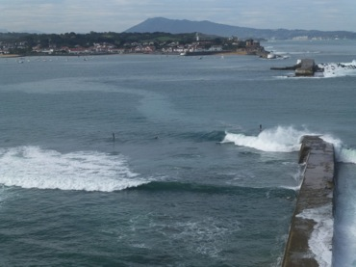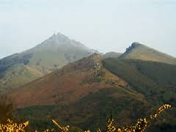
St Jean de Luz La Rhune Mountain

Tuesday 11 San Sebastian [2 nights]
Over the Spanish border and into San Sebastian.
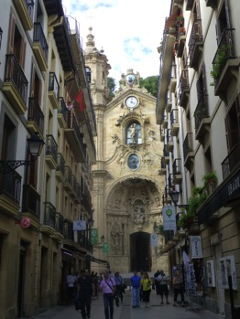 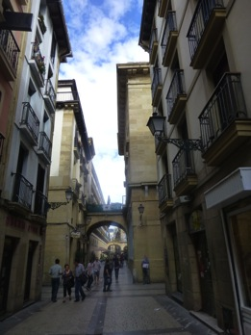San Sebastian
Walk along the promenade, along one of the most beautiful beaches of Europe.
Visit the old town and the buildings of la Belle Epoque.

Wednesday 12 [San Sebastian]
Discover the winding streets, the tapas bars, the promenade along the beach.
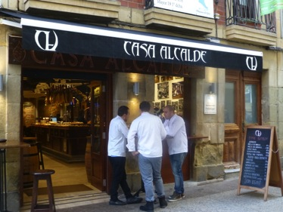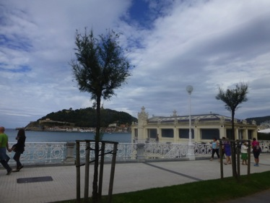
San Sebastian

Thursday 13 Bilbao [3 nights]
Arrive in Bilbao late afternoon; discover the Guggenheim and surrounds in the evening and local tapas bars.

Friday 14 Bilbao
Spend the day at The Guggenheim Museum.
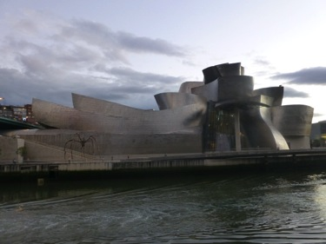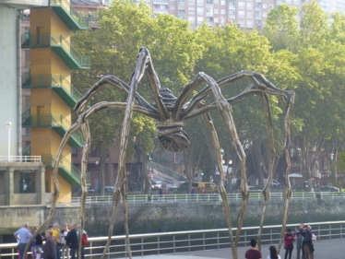

Saturday 15 [Bilbao]
Explore the city of Bilbao, its architecture and history. Visit Bilbao’s other museums, music in the evening.

Sunday 16 [Dax]
Drive to Dax, an inland town famous for its curative spa and gallo-roman history.

Monday 17 September [Bordeaux]
Last day, drive from Dax to the airport at Bordeaux.

Included:
All travel in minibus, boat and train trips.
6 dinners
All breakfasts All entries to museums and galleries.

Not included:
Airfares
Travel insurance
Other meals

Accommodation [twin share]

