Bonne Annee Part 2
The French tours continued in September 2013,
beginning with the Art Tour to Paris and Brittany with artist Emmy Mavroidis, followed by the Gourmet tour to the Loire Valley with chef Younes Khazour

Art in Paris and Brittany 2- 16 September 2013
We all met in Paris, staying in the 6th arrondissement surrounded by art galleries and restaurants. We spent 5 days visiting galleries and exhibitions, walking, sketching, taking a life drawing session ... and seeing Bryan Ferry at la Villette.
We visited Monet’s garden at Giverny and then followed the coastline of Brittany from Mont St Michel around to Concarneau with some very beautiful bays, in between.
Here is the story in pictures:
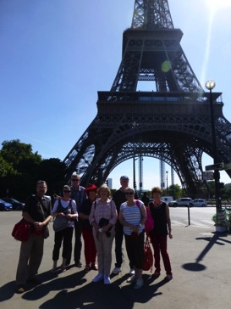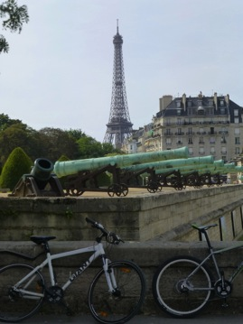
The team in Paris
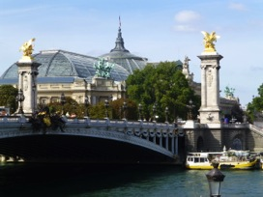
Bryan Ferry
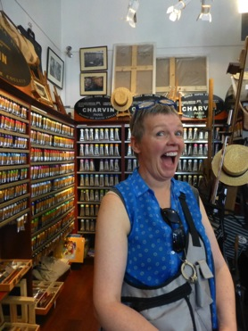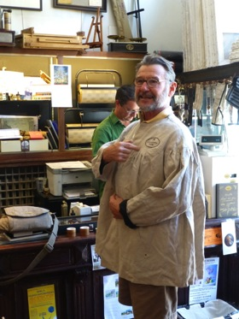
At the fabulous art supplies shop in Paris, very happy.
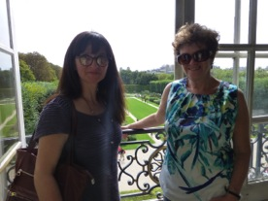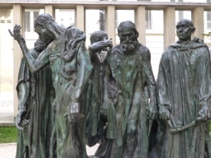
Emmy and me at the Rodin museum
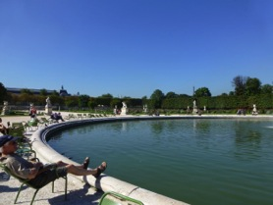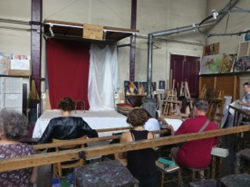
Peter relaxing in the Luxembourg Gardens Our life drawing session at la Grande Chaumiere in the 14th.
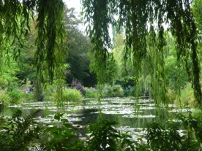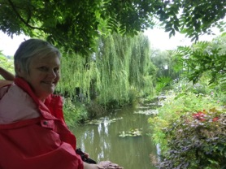
Suzanne at Monet’s Garden at Giverny
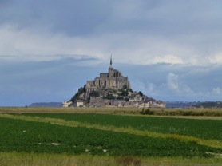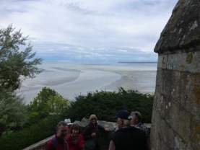
Mont St Michel
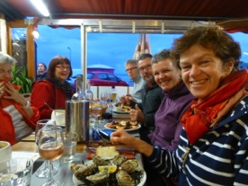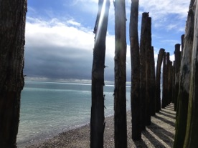
Eating oysters at Cancale
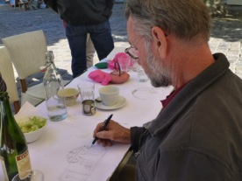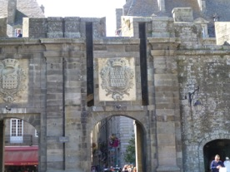
Garry sketching at St Malo
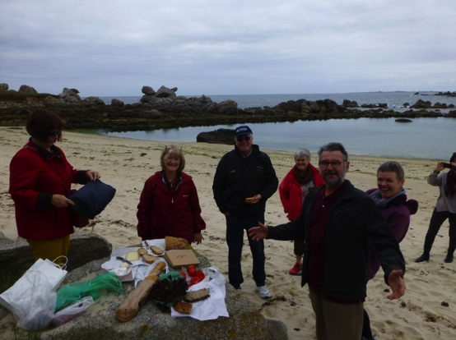
Picnic lunch at Amiets Beach near Roscoff
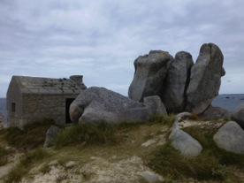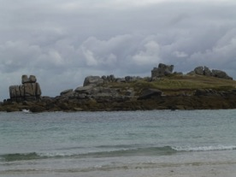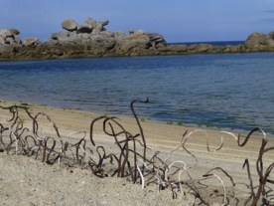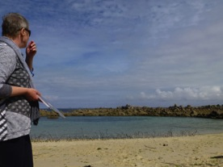
Terrianne’s installation at the beach
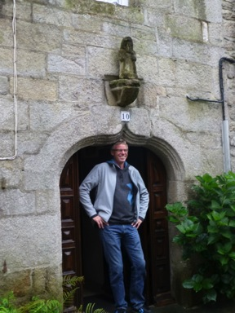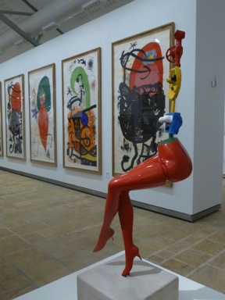
Duncan at Roscoff Miro exhibition at Landernau
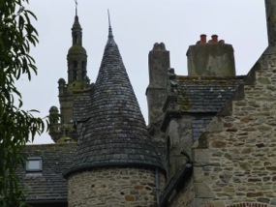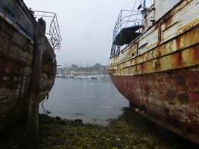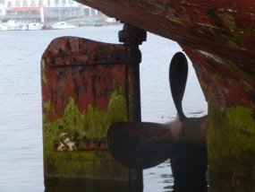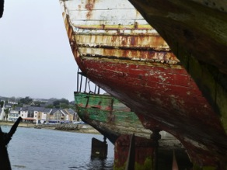
Boats at Camaret sur Mer – fabulous colours and textures
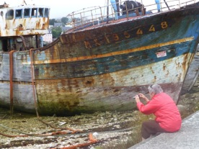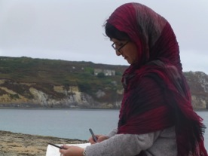
Suzanne and Emmy at Camaret sur Mer
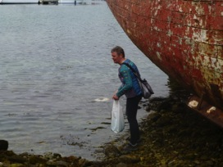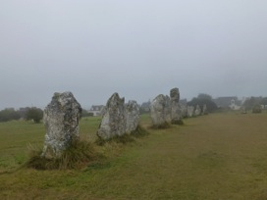
Collecting treasures at Camaret the alignements, Camaret
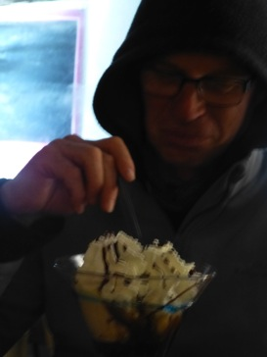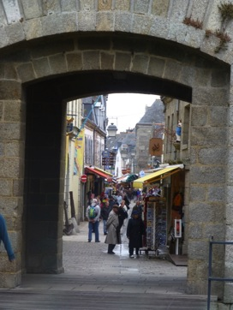
Concarneau

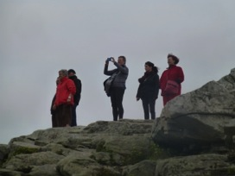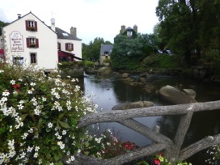
Pointe du Raz Pont Aven
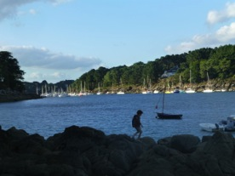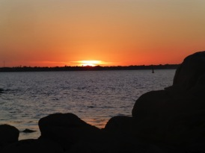
Beaches near Concarneau
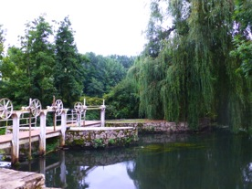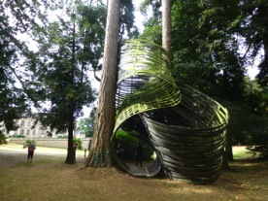
Our chambre d’hote at Chartres Sculpture park and chateau
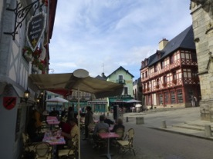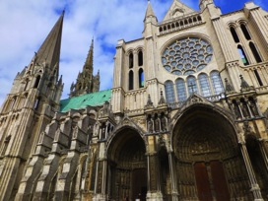
Crepes at Josselin Chartres Cathedral
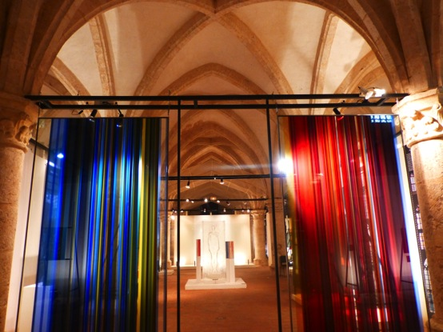
Stained glass centre and museum at Chartres

Brittany was full of hidden surprises. We stayed at Cancale famous for its seafood, especially the oysters, but we indulged in crayfish and other shellfish we did not recognize. The beach at Amiets was extraordinary. The rock formations created natural sculptures of immense proportions. No one was there there except us. Terrianne created a wonderful installation along the beachfront using found materials. The artist we met at Pont Aven suggested the chateau and sculpture park and gallery near Josselin. A spontaneous visit was rewarded with walks through the gardens discovering internationally recognized sculptures and some French artists who made quite an impact. We photographed, sketched, painted and installed our way around Brittany and drew many ideas for the next ceramics projects.
Our last night on the tour was at Chartres at one of my favourite chambre d’hotes with our hosts Jean Yves and Edith. It is a 17th mill with stunning gardens and a river running through the property, before returning to Paris.

I will be taking a tour to Brittany again this year on 2-16 September. It is not an art tour, however there will always be opportunities for sketching or painting if the heart desires. It is a photographer’s delight. It is also a delight for those who enjoy seafood, crepes, apple cider, beaches, boats, secluded coves, Celtic history, and France.
The Brittany tour for 2-16 Sept 2014 is $3,900 from Paris to Paris.

The Gourmet Tour to the Loire Valley with chef Younes Khazour
19 September – 3 October 2013
14 days of visiting local producers, wine tasting, picking fresh vegetables, cooking up a storm, experiencing some of the best restaurants, visiting chateaux, learning even more about French history and looking at some of the wonders of the world. We stayed on the Cher and the Loire Rivers in the middle of France.
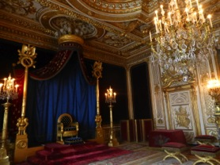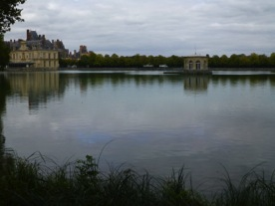
Fontainebleau
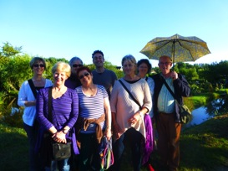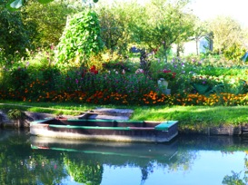
Le Marais at Bourges, tracks and canals through the vegetable gardens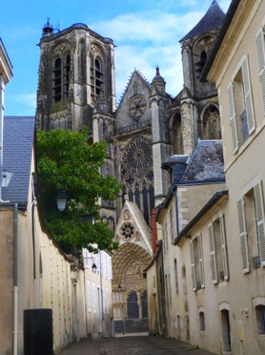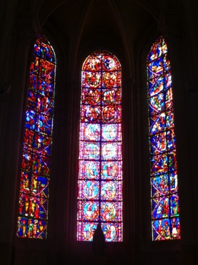
Bourges Cathedral
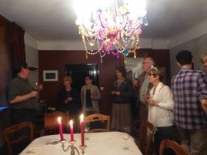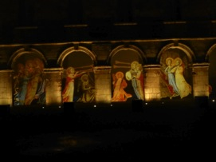
Wine tasting at our chambre d’hote les Illuminations de Bourges
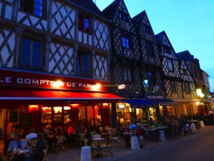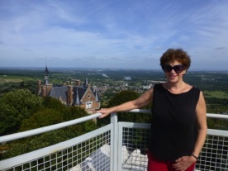
Dinner in Bourges At Sancerre on top of the world
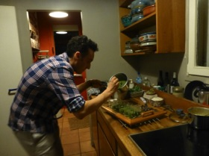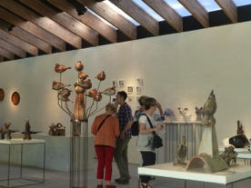
Younes preparing entrée at the Ceramic gallery in La Borne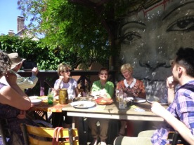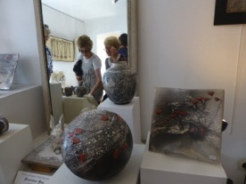
Lunch at La Borne Visiting studios in La Borne
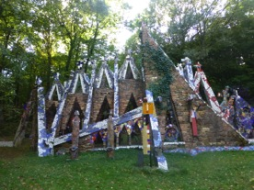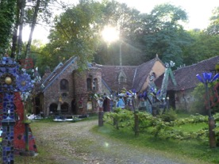
the amazing ‘cathedral’ of Jean Linard
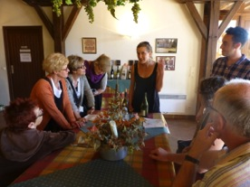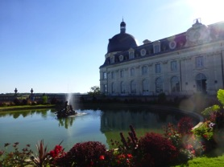
wine tasting at Quince Chateau Valencay
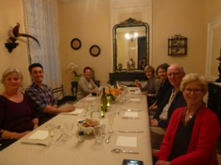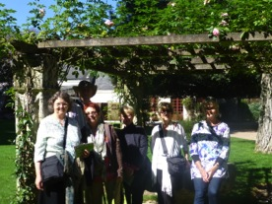
Dinner at our manor house at Montrichard outside l”Orangerie at Chenonceau
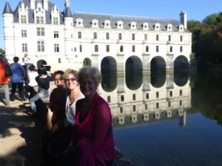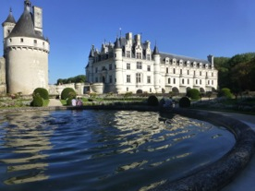
At Chenonceau
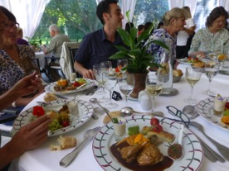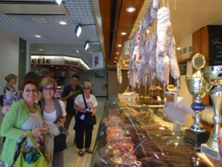
Lunch at the Orangerie at Chenonceau Shopping for delicacies in Tours
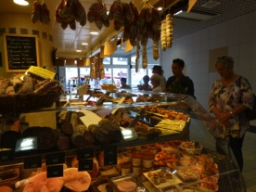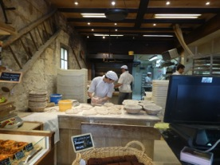
More shopping in Tours the bakery
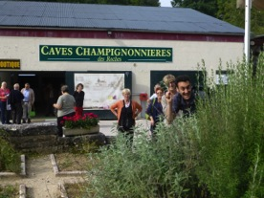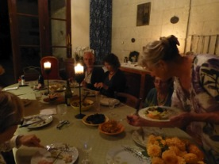
Troglodyte caves full of mushrooms near Montrichard . Cooking at Montrichard
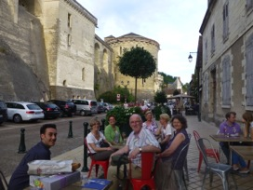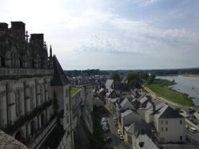
Drinks at Amboise Amboise on the Loire
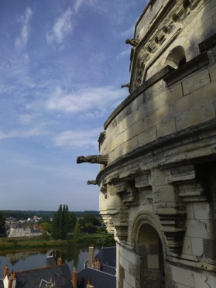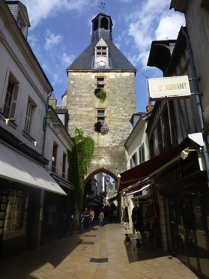
Amboise
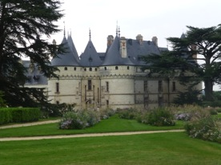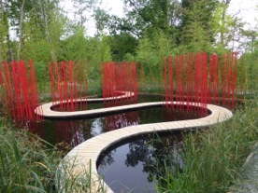
Chaumont sur Loire and the Garden Festival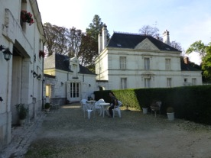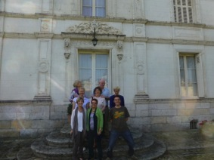
Our manor House / chambre d’hote at Montrichard
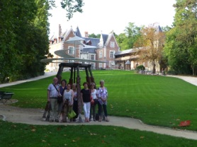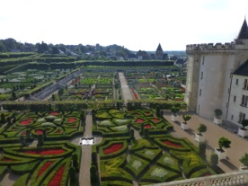
At Leonardo di Vinci’s house at Amboise Villandry chateau and gardens
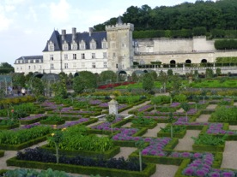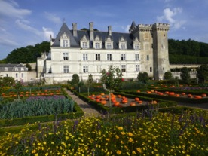
Villandry
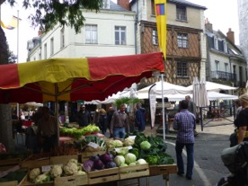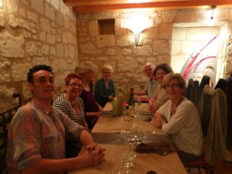
The market at Saumur Dinner at troglodyte restaurant at Turquant
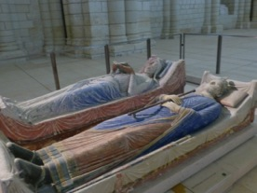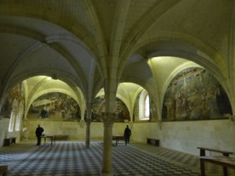
Eleanor of Aquitaine and Henry II at Fontvraud Abbey
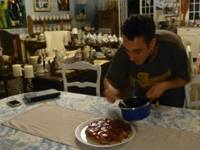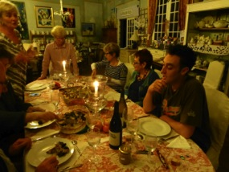
Younes making final touches to his tarte tatin Another fabulous dinner
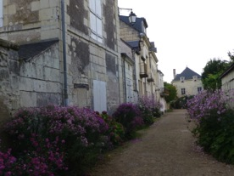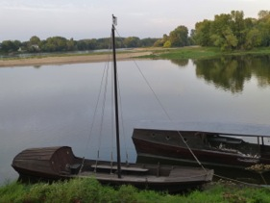
Candes St Martin
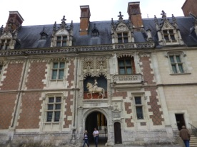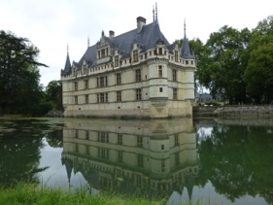
chateau at Blois Azay le Rideau
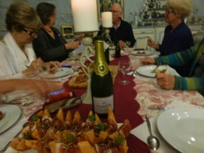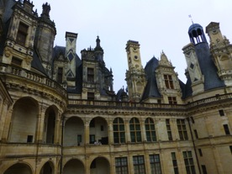
the last feast Chateau Chambord
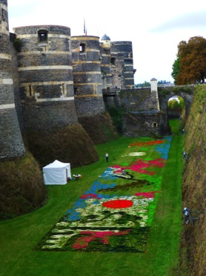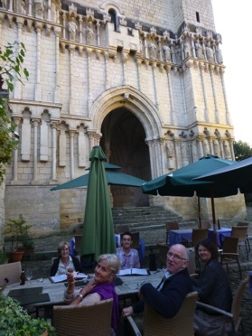
Chateau Angers Dinner at Candes St Martin
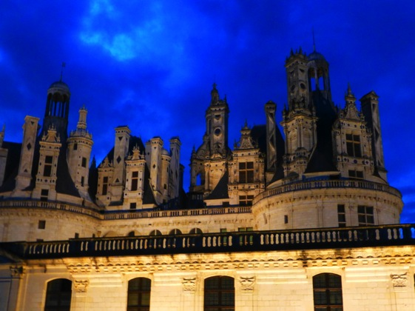
Chambord at night: we were the only ones there and could hear the “Brame du cerf” the mating calls of the deer in the surrounding forest.

Younes is coming back to France this year to take another Gourmet tour in the Loire Valley- where he was born, bred and trained as a chef. His expert knowledge is invaluable, and between the two of us we can take you to some very special places to experience a holiday of culinary delights, in the Valley of the Kings.
Gourmet tour, the Loire Valley 19 September – 3 October, Paris to Paris, $4,500

