Bonne Annee 2014 from Jane from Zeste French Tours.

2013 was quite a year! After the Warrandyte Pottery Expo in February, where we welcomed 7 French Potters as our guests and spent a very French few weeks with them, a group of 8 Australian Potters were invited as guests of the biannual Dieulefit Potters Market to exhibit and give demonstrations in May. We were welcomed by local potters and friends Maryse Tavernier and Claude Wolf for a week in the Drome region, where we explored and enjoyed the hospitality of many in this gorgeous part of the world. From there I met up with the first group for the year in Avignon for the tour to the Camargue.
Dieulefit Potters Market May 2013
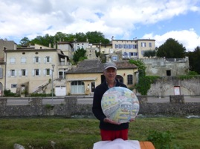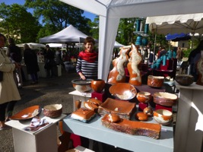
Chris Pittard at Dieulefit At my stand at the potters market
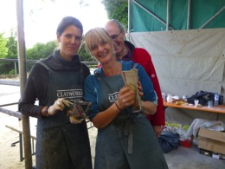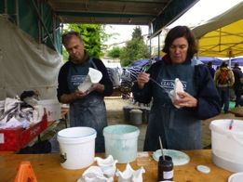
Bridget Bodenham and Angela Nagel Mary Lou and Chris Pittard
with Claude Wolfe
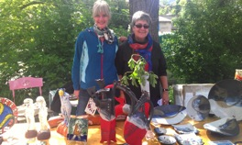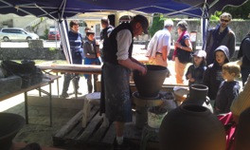
Angela Nagel and Judy Pierce Rob Barron demonstrating

More information from www.zestefrenchtours.com
Jane at jane@zestefrenchtours.com or 0422942216

The Camargue 24 May – 7 June 2013
However it was not only the Camargue. We spent the first few days in Usez, a duchy full of history and magnificent buildings, lively with colourful markets and music in the streets. It is not far from St Quentin la Poterie, where the original tiles for the Popes Palace in Avignon were made, now a maze of winding streets and laneways of contemporary ceramic artists. We followed the Roman route to the Pont du Gard, Nimes and Arles before staying at Aigues Mortes in the heart of the Camargue, famed for its pink flamingoes, white horses and black bulls. Onwards to Sete a town of boats, seafood and waterways before a very favourite place to stay for a while, Collioure. No wonder the impressionists and fauvists painted here. Our hotel was right on the beach- our balconies looked out over the beautiful bay to the chateau and fortress on the other side, with the twinkling lights of the bars and restaurants in the evening.
Just over the mountain is Spain, so a trip to the Dali Museum in Figueres was a fascinating adventure. Then through the mountains of the Cathars and Templars to explore ancient chateaux and fortresses on the way to a few days at Carcassonne. Our chambre d’hote was in easy walking distance to both the chateau and the old city, so we were able to explore both. Then finally back to Avignon.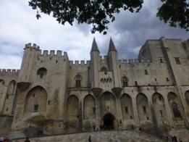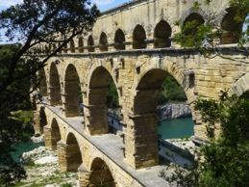
Avignon, the Popes Palace The Pont du Gard
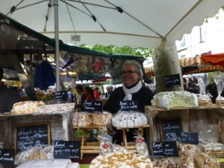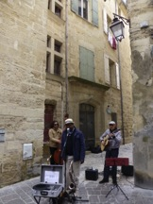Usez market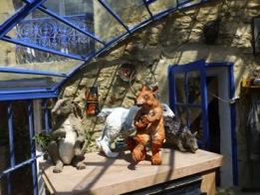 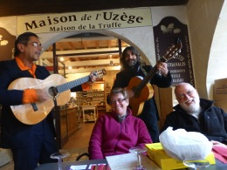
St Quentin la Poterie serenaded at Usez
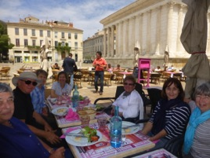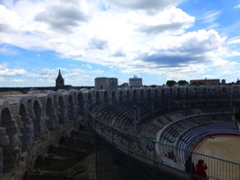
Lunch at Nimes Roman Arena at Arles
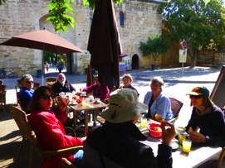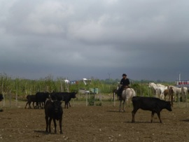
Breakfast at Aigues Mortes Rounding up the bulls in the Camargue
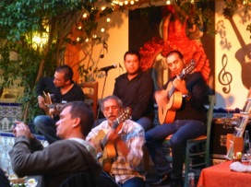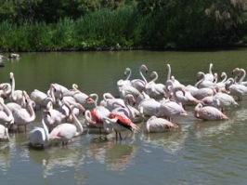
Jazz Manouche at les Stes Maries de la Mer Flamingoes in the Camargue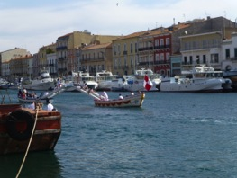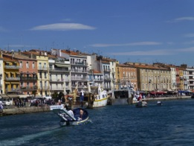
Sete

Collioure
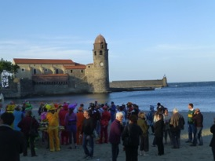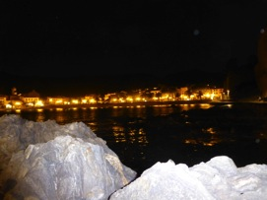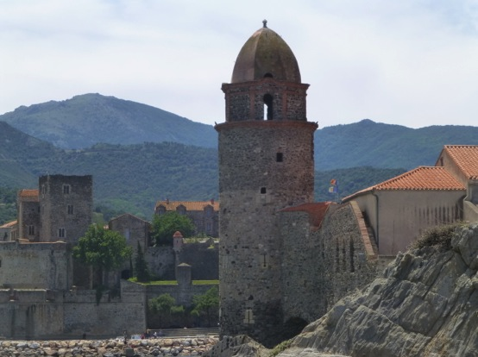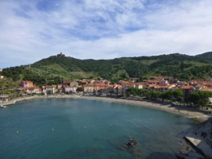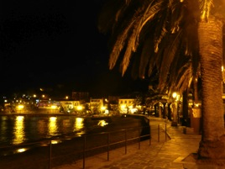

Collioure:
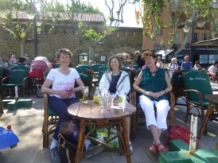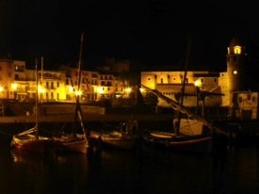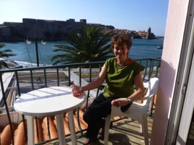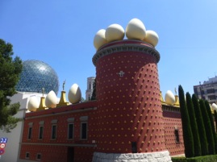
From the balcony at Collioure Dali Museum, Figueres, Spain
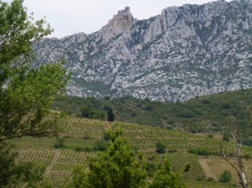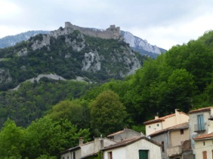
Mountains near Limoux
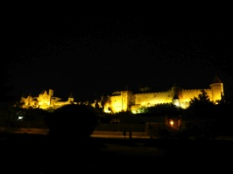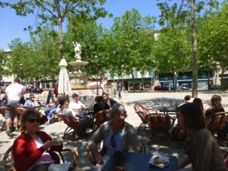
Carcassonne
I can’t wait to go back to this stunning part of the world in June 2015.
I will be taking a tour 6-20 June 2015, beginning and ending in Avignon $3,900.

The Language Tour 12 -26 June 2013
Practising our French for 2 weeks in rural France seemed to involve quite a lot of eating and drinking! It would start by discussing how to make apricot jam over the breakfast table to the history of a chateau dating from 12th Century including members of its family having fought in both the Crusades and the Resistance. We would have dinner with French friends, a party one night with the French potters, long summer lunches, chatting at Provencal markets and visiting artists in their studios. We learnt colloquial phrases, local slang and used everyday French in everyday settings. We would check vocab and grammar to explain language choices, but conversation was the focus. And it was so much fun.
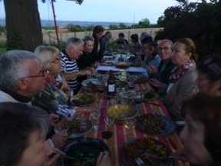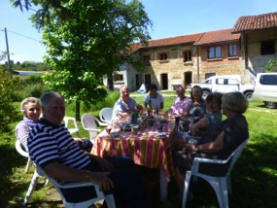
Party time with the Fench potters St Antoine L’Abbaye
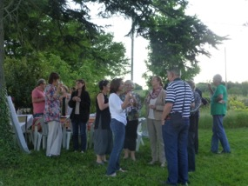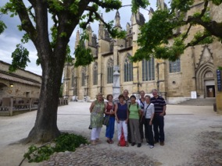
Pont en Royans Chateau Virieu
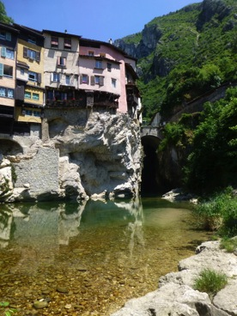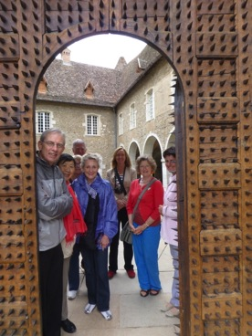
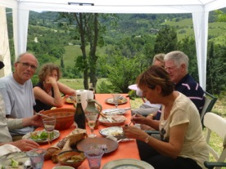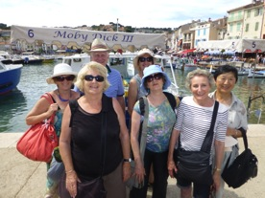
chez Maryse Tavernier and Claude Wolfe At Cassis
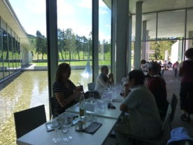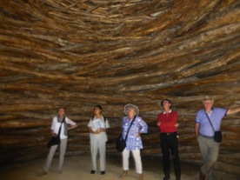
at Chateau La Coste restaurant and sculpture park
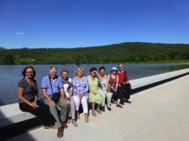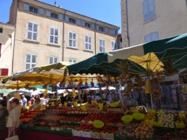
At La Coste Apt market

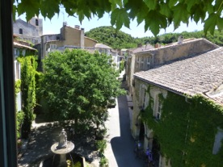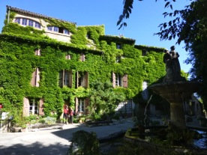
Our chambre d’hote at Saignon
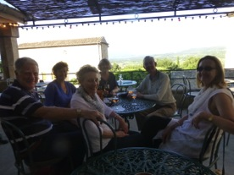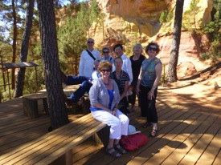
Drinks at Lacoste in the Luberon At Roussillon
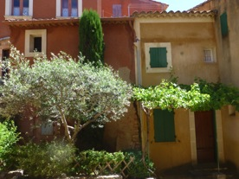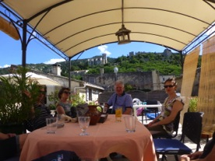
Roussillon with Olivia Tregaut at Oppede le Vieux
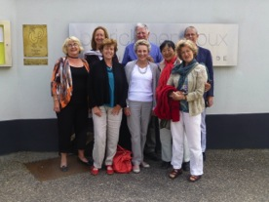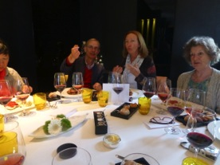
Lunch at La Pyramide in Vienne
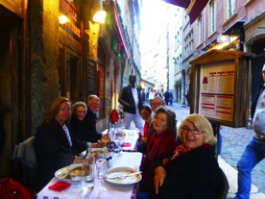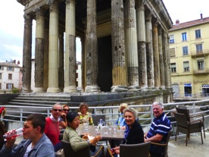
Last night in Lyon Drinks at the Forum in Vienne

The Language tour took us through the Rhone Alpes, the Drome and Provence.
I will be taking this tour again next year 30 May – 12 June 2014 and again 20 May -3 June 2015. The tour from Lyon to Lyon is $3,900.

The Music Tour 29 June – 13 July 2013
Just a small group for the music tour this time, we packed so much in and could be flexible. We picked the 7 concerts we wanted to see from the 15 nights available and travelled to the Drome and Provence, around those dates. Fabulous weather, wonderful times.
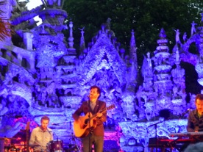
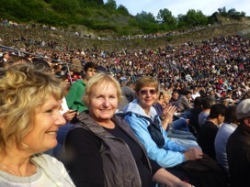
Hugh Coltman at the Facteur Cheval at Jazz at Vienne
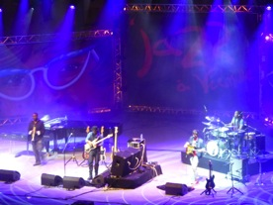 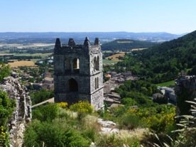
Marcus Miller at Jazz at Vienne driving through theDrome
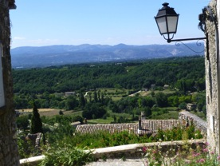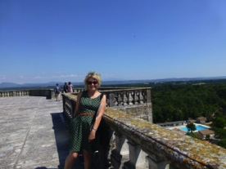
Mirmande Chateau Grignan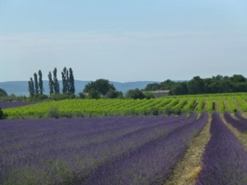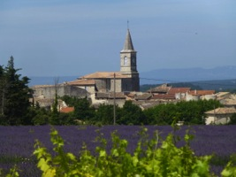
Lavender near Taulignan in the Drome
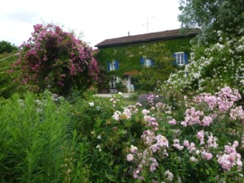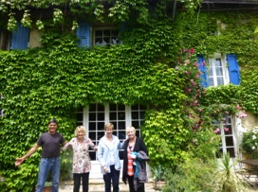
Our gite with Bernard
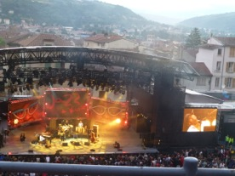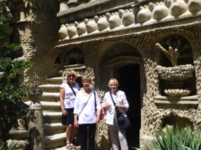
Jazz at Vienne at le Facteur Cheval
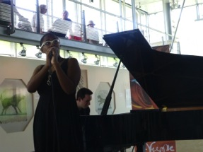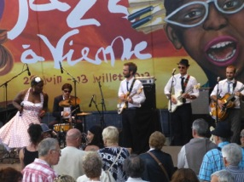
Cecile McLorin Savant in the Gallo Roman museum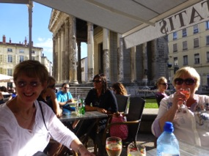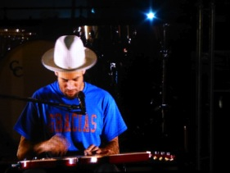
Outside the forum at Vienne Ben Harper
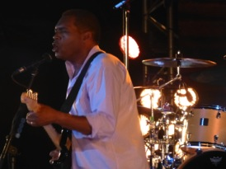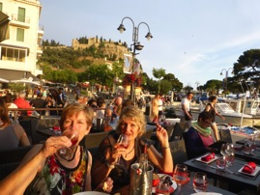
Robert Cray at Cassis
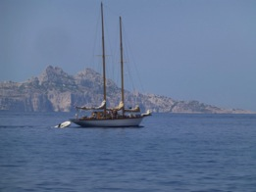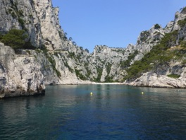
At Cassis
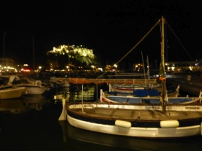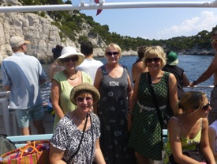
Cassis by night on the boat in the Calanques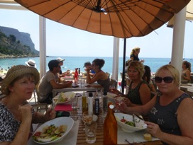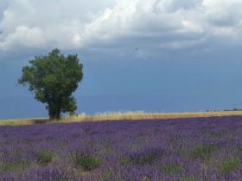
lunch at the beach at Cassis the lavender plateau of Valensole
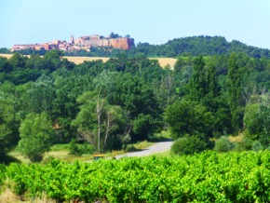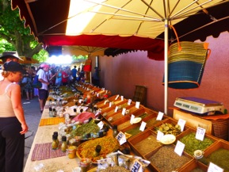
Roussillon Roussillon market
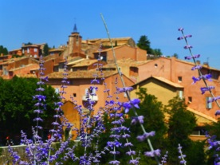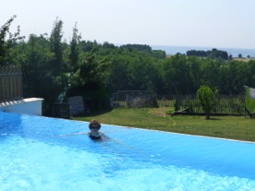
Roussillon A swim before seeing Santana
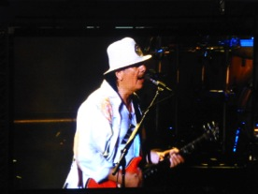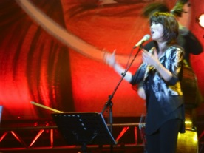
Santana Youn Sun Nah
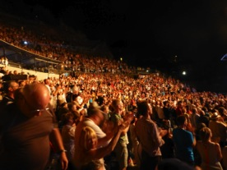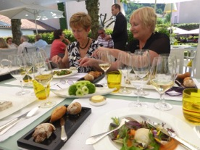
A standing ovation for Youn Sun Nah lunch at la Pyramide, Vienne

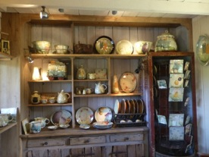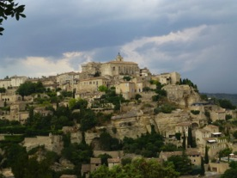
Favourite potters in Provence Gordes
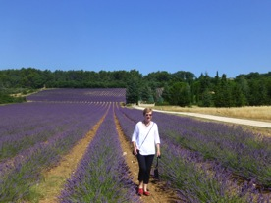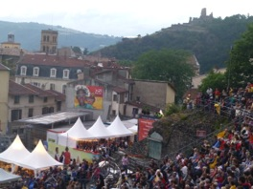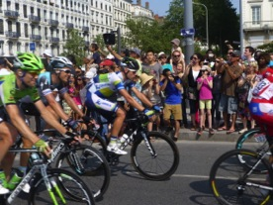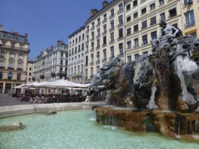
The Tour de France arrives in Lyon Place des Terreaux, Lyon
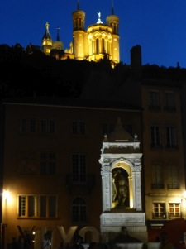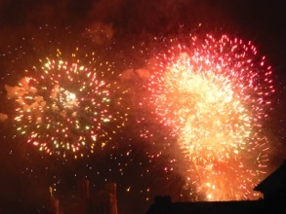
La Fourviere, Lyon Bastille Day Fireworks in Lyon

