**Zeste French Tours**

**Brittany**

**3-18 September 2017**

Paris to Paris $4,600

*Explore the magnificent coastline of Brittany. From Mont St Michel to the secluded bays and fishing villages to the western point of France. Enjoy freshly caught seafood, the oysters of Cancale, where the low tides reveal the treasures of the rock pools and long, long beaches. Explore the Celtic history of the menhirs and dolmens and the magical forests.*

Sunday 3 September

‘Night out in Paris’. Meet up at 6pm at the hotel and enjoy Paris by night, stay at Hotel Studia, 51 Boulevard Saint-Germain 5th arrondissement.

Monday 4 September. [La Roche Guyon]

Breakfast in Paris, let the tour begin.

**Visit Giverny stay at La Roche Guyon**

Leave Paris and drive to Giverny, Monet’s garden. Lunch at Giverny. Spend afternoon at Monet’s garden. Stay in nearby village on the Seine River at Hotel Les Bords de la Seine.’ Visit the chateau of la Roche Guyon. Dinner included.

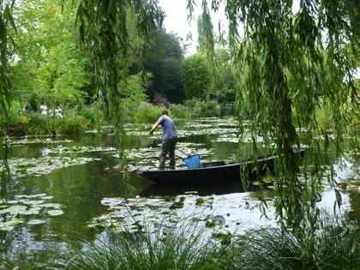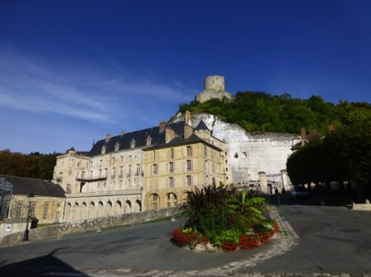

Giverny La Roche Guyon

Tuesday 5 September [Caen]

Drive From la Roche Guyon to **Honfleur** in Normandy. Lunch at Honfleur, explore the port. Drive to Caen where we stay the night [1hr 10mins].

At Caen, visit the ramparts of the chateau and its art gallery.

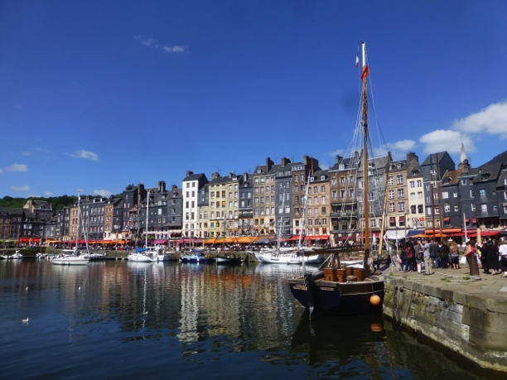 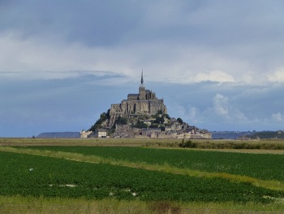 Honfleur Mont St Michel

Wednesday 6 September [Cancale 3 nights]

From Caen, visit the Bayeux Tapestries in the morning before going to Mont St Michel.

Bayeux to Mont St Michel [1hr 25 mins] Spend the day at Mont St Michel. [arrive 12 noon]Enormous tides, the 1km causeway to Mont St Michel. Guided tour of the Abbey.

Night at **Cancale** –[50 mins from Mont St Michel] A sheltered bay and fishing port famous for its oysters, crayfish and shellfish. Stay at Chambre d’hote Cancale-vacances at walking distance to a secluded beach. Dinner included.

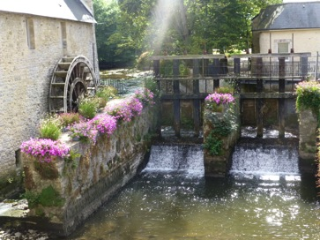 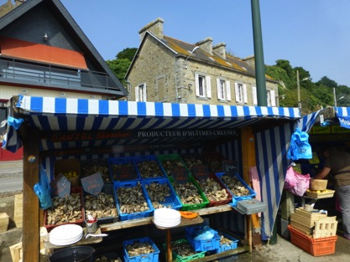

Bayeux Cancale

Thursday 7 [Cancale]

Spend the morning at Cancale exploring its beautiful beaches and rock pools, enjoying the oysters and seafood. In the afternoon, visit St Malo and its 12th century walled city. Fortifications by Vauban

Friday 8 [Cancale]

Visit the beach and artistic town of Dinard, where Hitchock filmed ‘The Birds”.

Explore nearby coast. Walk to one of the many of the unspoilt beaches.

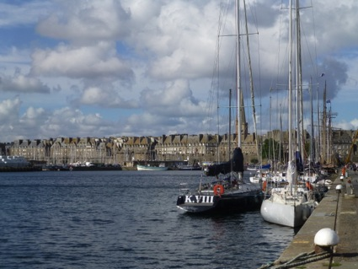 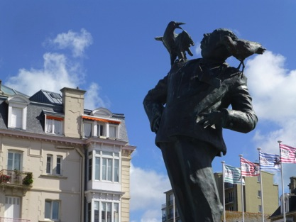

St Malo Hitchcock at Dinard

Sat 9 [Roscoff 3 nights]

Drive from Cancale to Roscoff, exploring villages on the way. **[**2 hours]. Visit the medieval town of Dinan. Take a boat along the river Rance.Stay at local hotel**. Dinner included.**

Sunday 10 [**Roscoff]**

16th century granite houses, pretty port surrounded by farms of vegetables, [particularly onions]. Creperies and seafood. A ferry trip to the Isle de Batz and its luxuriant gardens. A walk around the island. Isolated beaches nearby.

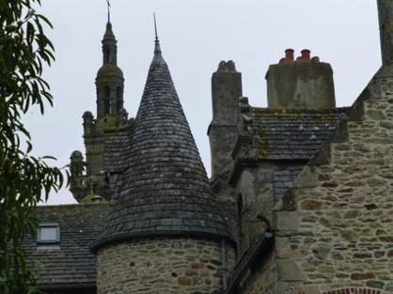 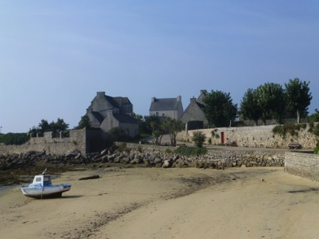

**Roscoff Isle de Batz**

**Monday 11 [Roscoff]**

Explore coast near Roscoff with sculptural rocks, pristine bays and rock pools, stone fishing huts.

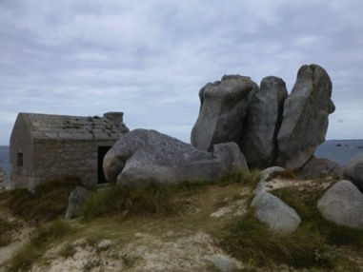 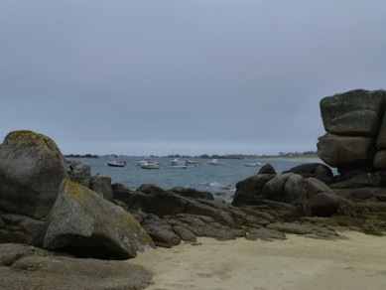 **On the beach near Roscoff**

**Tuesday 12 [Camaret sur Mer] 2 nights**

from Roscoff to Camaret [1 hr 40 mins] Drive through the forest of “Parc Regional d’Armorique”

Stay at HOTEL VAUBAN

4, Quai du Styvel 29570 CAMARET SUR MER Tel : 02 98 27 91 36

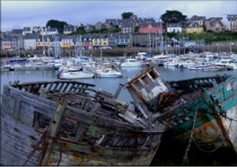 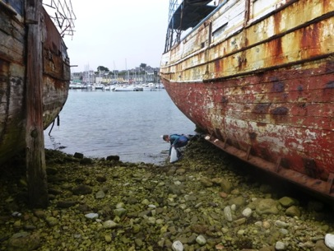

**Camaret sur mer**

A classic fishing village with abandoned fishing boat carcasses in the harbor. A community of art galleries and studios. Visit the town of Landernau on the way for the exhibition at la Fondation Leclerc. Stay at Hotel Vauban, at the harbour.

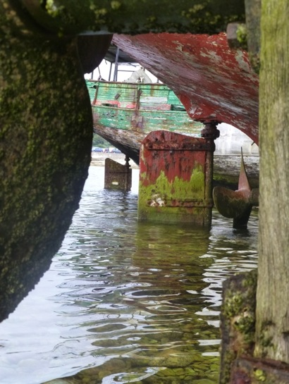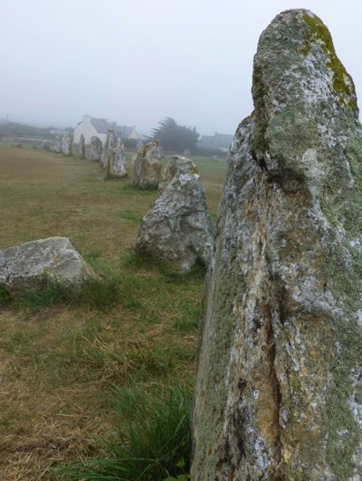

**Boats at Camaret The menhirs of Lagatjar, at Camaret**

**Wednesday 13 September [Camaret sur Mer]**

Explore the village and its port. Visit the standing stones ‘**Les menhirs de Lagatjar’** and the Vauban tour at the port. Unspoilt beaches and rocky cliff walks. Visit the artists’ quarter of Camaret. Dinner included.

**Thursday 14 September [Benodet 1 night]**

Camaret to Locronan [50 mins] and Douarnenez [12 mins] to Benodet.

**Locronan:** granite houses and cobblestone roads. Polanski’s film ‘Tess’ was filmed here. Lunch at Locronan

Douarnenez: sardine town!

La Pointe du Raz: the furthest west in France. On to Benodet and dinner.

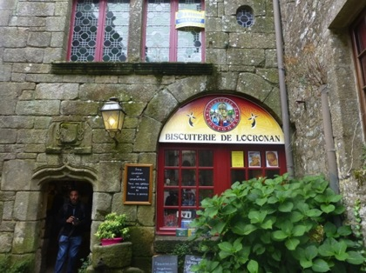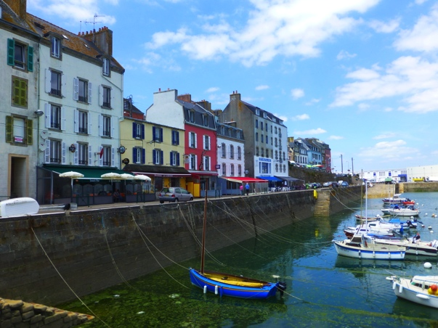

**Locronan Douarnenez**

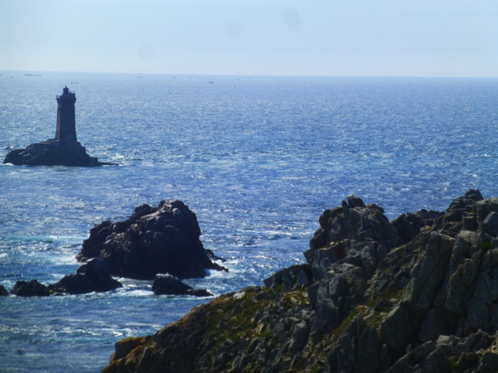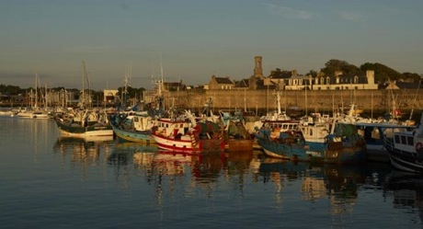

**Pointe du Raz Concarneau**

**Friday 15 September [Vannes 2 nights]**

A short trip to Concarneau where we visit the 14th century Citadelle of Concarneau, fish markets, large fishing port. Visit Pont Aven, known for its connection with Gauguin. The Pont Aven School - artist colony emerging 1850's, led by artist Paul Gauguin developed a style called Synthetism. A very pretty village on the Aven river. Carnac in the afternoon, to see the ancient megaliths and standing stones. Vannes for dinner.

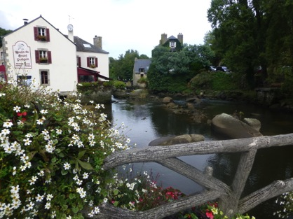 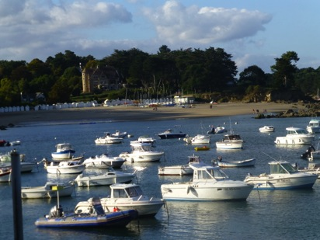

Pont Aven

Saturday 16 September [**Vannes]**

Explore the old village of Vannes. An afternoon boat trip in the Golfe de Morbihan.

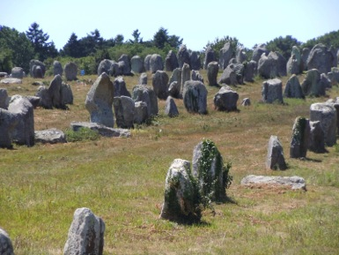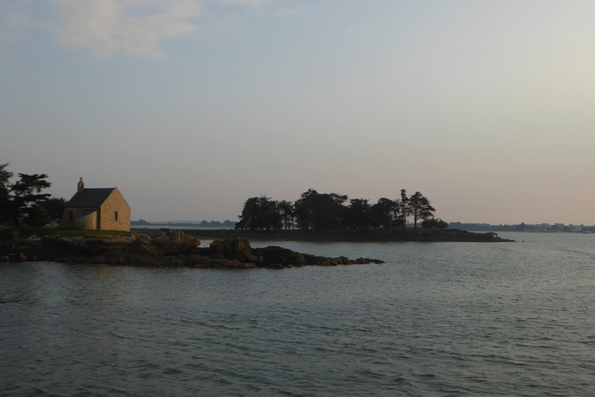

Carnac Golfe de Morbihan

**Sunday 17 September [Chartres**]

Heading back towards Paris via Chartres, spend the morning in Josselin to explore the medieval city and half-timbered houses. Lunch.

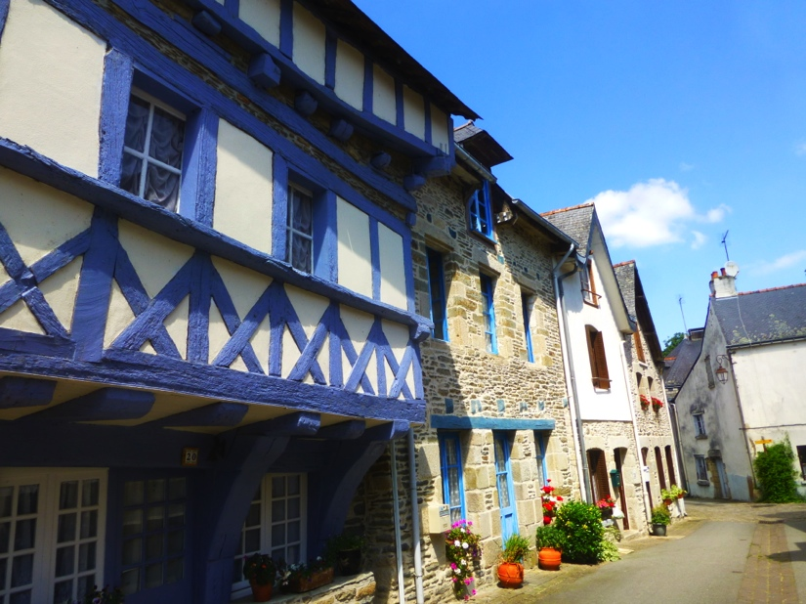

Drive to **Chartres** from Josselin [3 1/2 hours – stop half way]. Stay at 17th century mill chambre d’hote. “Le Moulin de la Forte Maison.” Dinner included.

**Monday 18 September [arrive in Paris]**

Chartres to Paris 1 hr 15 mins

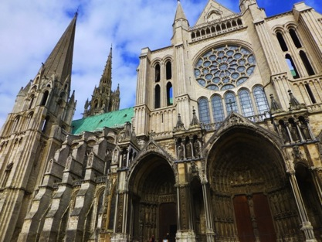

Our mill at Chartres. Chartres cathedral

Visit the cathedral of Chartres in the morning before heading back to Paris. Arrive in Paris early afternoon. Tour finishes. Either stay on in Paris or go to TGV station. To be arranged on individual basis.

Being a small group we can be flexible according to opportunities that arise, such as local markets, exhibitions, weather conditions etc.

**Included**:

Not included:

Mini bus travel Paris to Paris Airfares

Accommodation Travel insurance

All breakfasts Other meals

6 dinners

All entries to chateaux, museums, boat trips etc.

**Contact**: Jane Annois, [jane@zestefrenchtours.com](mailto:jane@zestefrenchtours.com) 03 98442337 / 0422942216

www.zestefrenchtours.com