Zeste French Tours
Music, pottery, art, hilltop villages…

French Tour 29 June – 13 July 2013

For those who love jazz, blues and world music; pottery and art, studio and gallery visits; hilltop villages, rural landscapes lavender and sunflowers, fine food and wine.

The Itinerary

Saturday 29 June [chambre d’hote near Faramans]
Arrive St Exupery Airport, LYON between 10am – 12noon.
I will pick you up from the airport and meet your flight. Drive to our chambre d’hote. Lunch at Jean Marc’s house. Explore local area before heading off to music at Jazz at Vienne. Marcus Miller: the Renaissance Tour
And Keziah Jones

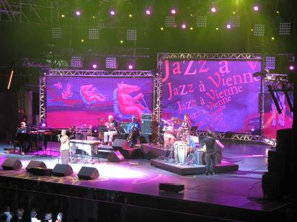
Angelique Kidjo at Jazz at Vienne

Sunday 30 June [chambre d’hote at la Roche St Secret, near Dieulefit.
Head south to the Drome. Visit Mirmande and Cliousclat [picnic] artist villages in the Drome region. Stay at La Lunaire. – on a lavender farm – in full bloom.

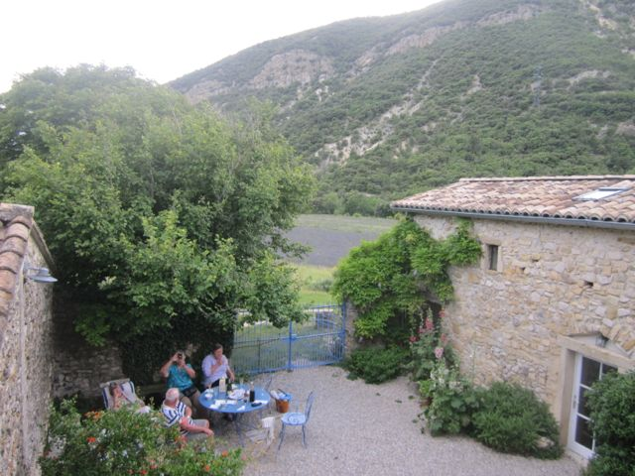
La Lunaire

Monday 1 July [chambre d’hote la Roche St Secret, near Dieulefit].
Visit Maryse and Claude Tavernier
Robert Montaudouin. Visit Nadia B Gallery and hilltop village le Poet Leval with its chateau and “commanderie”.

Tuesday 2 July [chambre d’hote near Faramans]
Drive back to Faramans
Visit St Antoine L’Abbaye, medieval village, abbey and artisans.
Jazz at Vienne: Gypsy music

Wednesday 3 July [chambre d’hote near Faramans]
Visit Jean Jacques Dubernard and la Poterie des Chals and Ann Dangar’s old studio, possible vineyard. To be confirmed
Lunch at Jean Jacques house and studio
Explore local area..
Jazz at Vienne: Cuba

Thursday 4 July Faramans
Visit the Vercors mountain range
Pont en Royans, a perched village in the mountains.
Grottes de Choranche. Exceptional caves inside the mountains
Night off from music !

Friday 5 July Faramans
Visit Lac Paladru and the chateau de Virieu in the afternoon. Visit pottery studio of Yves Gaget; and the exhibition at La Grange Dimiere at Charavines: Ceramic exhibition in a medieval grain store near Lac Paladru. Opening of Gilbert Portanier’s exhibition. Evening at Jazz at Vienne. Ben Harper, Rodriguez

Saturday 6 July [Faramans]
Lunch and petanque game at Jean Marc’s house
Evening music Jazz at Vienne: Blues
Shemekia Copeland, Robert Cray

Sunday 7 July Cassis
Head south to Cassis. Stay at Hotel Cassitel on the waterfront.
Visit Vaison la Romaine on the way.

Evening on a balmy summer evening at the port of Cassis.
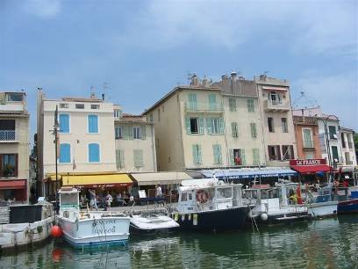

Monday 8 July [Li Poulidetto, Lioux, Provence]:
Boat trip on the Mediterranean, Cassis
Explore les Calanques by boat, coves in limestone bays. A walk along the coastal track.

Head north towards the Luberon Valley
Visit Lourmarin on the way home if time.
Dinner at Moulin de Lavon.

Tuesday 9 July Lioux
Explore villages of the Luberon: Lacoste and Bonnieux. Provencale market at Lacoste in morning. Visit private garden at Bonnieux.
Dinner at Li Poulidetto

Wednesday 10 July Lioux
Visit villages of Roussillon
and Gordes, Abbaye de Senanque.
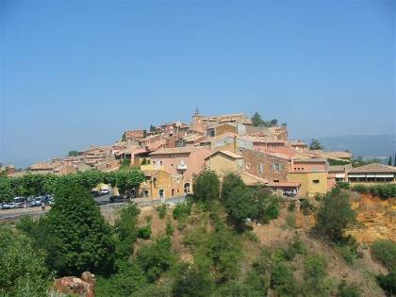
Market at Isle sur la Sorgue.
Dinner at Li Poulidetto

Roussillon

Thursday 11 July [chambre d’hote near Vienne]
Head back towards Vienne. Visit villages of interest on the way.
Jazz festival at Vienne in the evening: Santana

Friday 12 July [chambre d’hote near Vienne]
Lunch at La Pyramide restaurant at Vienne with master chef Patrick Henriroux.
www.lapyramide.com
Explore Vienne, relax under the trees, listening to music. Visit Musee gallo romain at Vienne
Jazz at Vienne: Avisha Cohen

Saturday 13 July [Hotel Elysee, Lyon]
The tour finishes. I will take you into Lyon to the Hotel. The tour de France comes through Lyon today.

Saturday 14 July. Hotel Elysee, Lyon
Bastille Day!!!!

To get to the airport: take a taxi to the railway station PART DIEU. From there take the Rhone Express to the airport [every 20 mins]
Part Dieu Station is also the TGV station for trains to Paris
About 10mins and 10Euros from hotel to Part Dieu.

Food and costs $3,700 Lyon to Lyon
Bed and all breakfasts are covered.
Our first day and night, lunch and dinner are covered.
7 dinners in total included.
At the Jazz Festival we either take a picnic or buy take away on site. [Pay for our own, or with kitty]
The chambres d’hotes are homes where we stay and dinner is provided by the hosts. Your breakfasts and dinners are included in your fee. [6 nights].
Dinner at Jean Marc’s house is included.
Our big lash out extravaganza will be La Pyramide at Vienne at 61 Euros. It is worth the special occasion at an excellent French restaurant.

Lunches: we can have a picnic or buy a sandwich or find a little restaurant, to be decided on how we feel at the time.

The boat trip at Cassis is included in the trip.
Please bring a mobile phone. It will be invaluable when we need to meet up, or if someone gets lost. Make sure it has international roaming. Check with your carrier that it will work in France. SMS is cheap and could save us a lot of anxiety. Alternatively you can buy a French SIM card when in France.

The jazz festival tickets are included.
The jazz festival program can be found at www.jazzavienne.com [the new program comes out in April 2013].
We will be attending up to 7 concerts. We will not know who is performing then until the program comes out. During the festival our hours change. We go to bed late and get up late. We often don’t get home until 1am or so, which means a relaxed morning and brunch at 11am.

Please ring me if you would like to talk about it.
I can guarantee an insightful trip, as knowing the area and the local French people for 16 years has allowed me openings to places and people you would not otherwise find. The language is invaluable too! We will have a lot of fun. Jane

When booking your flights or train please aim to arrive at and depart from Lyon’s St Exupery Airport in the morning between 10am -12noon. Arrangements can be made on an individual basis. I can help.

Jane Annois
03 98442337/0422942216

jane@zestefrenchtours.com
www.zestefrenchtours.com

As a small group we can be flexible and enjoy the pool on hot days, explore the villages, mountains, artists, galleries, shops, markets, cafes, restaurants and hidden treasures when we are not listening to music.

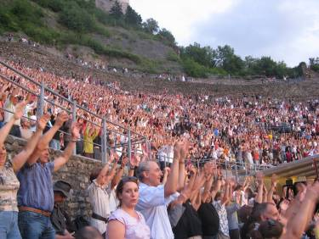
The Roman amphitheatre at Vienne

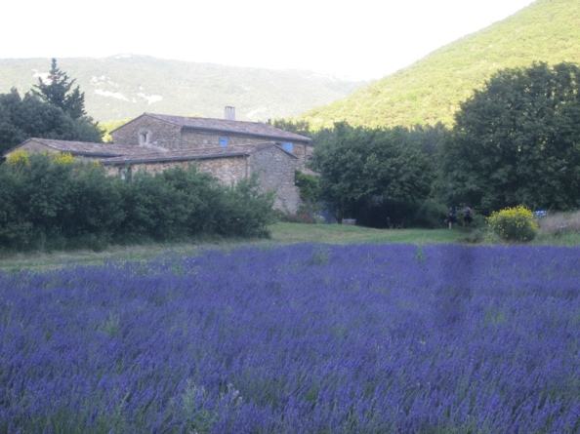
the chambre d’hote at La Roche St Secret, near Dieulefit.

