Zeste French Tours
French Language Tour 29 May -12 June 2014

Lyon, Rhone Alpes, Drome and Provence
Explore South East France while practising, and improving your French. Immerse yourself in French language, culture, history and the countryside.
Meet the locals.
A tour for Francophiles

Contact: Jane Annois jane@zestefrenchtours.com 03 98442337 / 0422942216
Lyon to Lyon $3,900

The Itinerary
Thursday 29 May [Chateau Bonnevaux, near La Cote St Andre, 4 nights]
Arrive at Lyon airport [St Exupery] in the morning. Drive to the village of Faramans, for lunch under the trees with some of the locals. Information session [French] about Le Facteur Cheval followed by a visit in the afternoon [http://www.facteurcheval.com]. Explore local area. Dinner at the chateau included.
Stay at Chateau Bonnevaux at Villeneuve de Marc near la Cote St Andre.

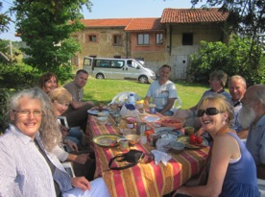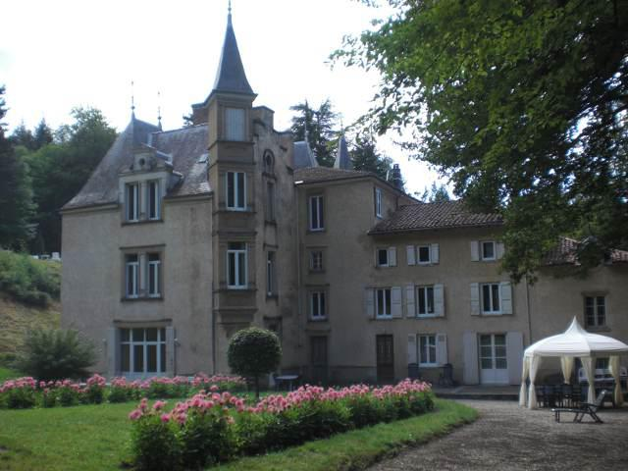
Lunch with locals at Faramans Chateau Bonnevaux

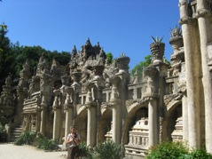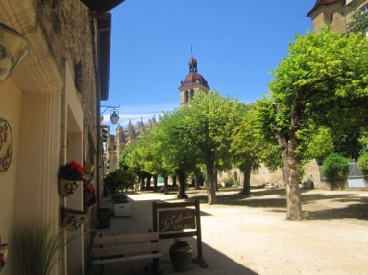
Facteur Cheval St Antoine L’Abbaye

Friday 30 May [Chateau Bonnevaux]
Lunch at ‘La Pyramide’ in Vienne with master chef Patrick Henriroux. www.lapyramide.com.
Morning session discussing Gallo Romain history of the region. After lunch, visit the city of Vienne , explore the roman sites in the city and the Vienne Gallo Romain museum.

Saturday 31 May [Chateau Bonnevaux]
Morning language session about Chateau Virieu and La Grange Dimiere, it’s history and importance as a place of protection for the resistance during WW2. Guided tour en francais at the chateau Virieu
Picnic lunch and swim [if hot] at Lake Paladru.
Late afternoon visit of La Grange Dimiere , medieval grain store, now exhibition space. Dinner at restaurant at Charavines near Lac Paladru.

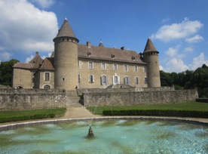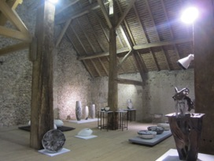
Chateau Virieu Exhibition in La Grange Dimiere

Sunday 1 June [Chateau Bonnevaux]
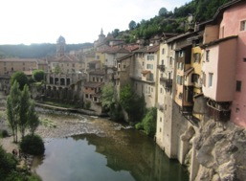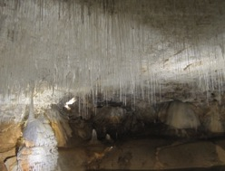
Pont en Royans Grottes de Choranche
Visit the village Pont en Royans, village perched over the river, picnic lunch. Then Les Grottes de Choranche, underground caves in the Vercors mountains.
Dinner included.

Monday 2 June [Gargas, Provence, le Moulin de Lavon]
Drive to the Luberon Valley through Vaison la Romaine , lunch.
Explore Vaison la Romaine and its Roman ruins.
Late afternoon visit to Roussillon.

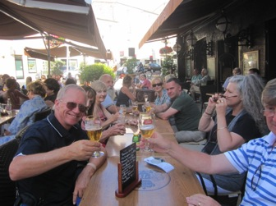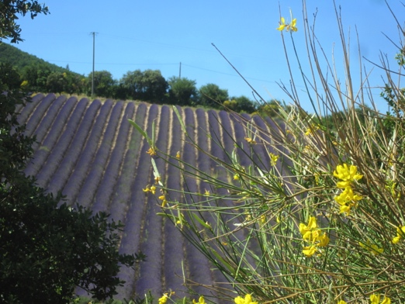
Enjoying Dieulefit Lavender fields in the Drome

Tuesday 3 June [Gargas]
Visit villages of Gordes, Abbe de Senanque and Fontaine de Vaucluse,

Wednesday 4 June [Gargas]
A trip to Cassis on the Mediterranean. Boat trip, swim, lunch, explore.
Visit the ‘Calanques” by boat, the limestone coves with turquoise water.
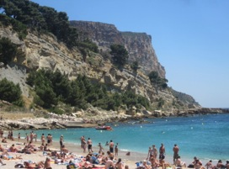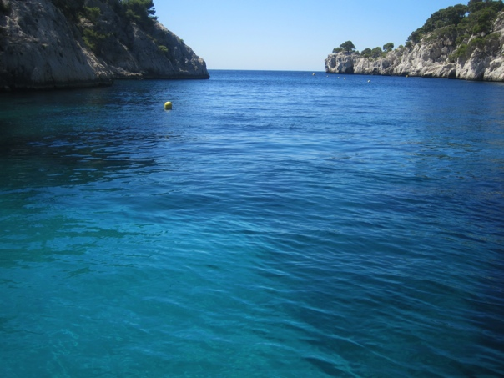
A swim before the boat trip at Cassis

Thursday 5 June [Gargas – Moulin de Lavon]
A.m. Marche de Roussillon. A provencal market in the beautiful town of Roussillon.. Picnic lunch with delicacies from the market. The ochre walk in Roussillon. Villages: which one? Simiane la Rotonde, Banon. Evening drinks at the other Lacoste for pre dinner drinks, the village of the Marquis de Sade, now an artistic village.

Friday 6 June [Gargas]
Am. Visit village of Lourmarin [market]
Drive to Chateau La Coste for lunch and afternoon visit of gallery and sculpture park. http://www.chateau-la-coste.com
Drive back to Cucuron, visit the village and its “etang”.
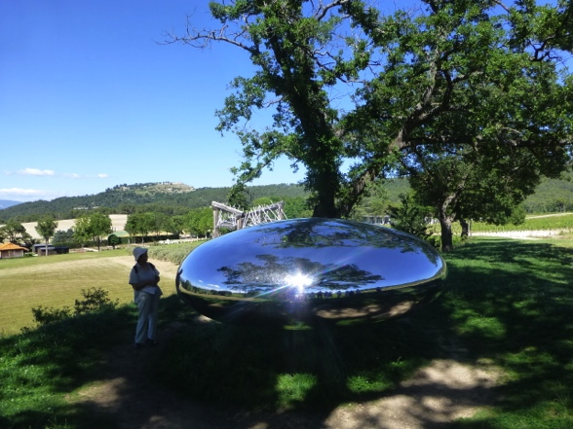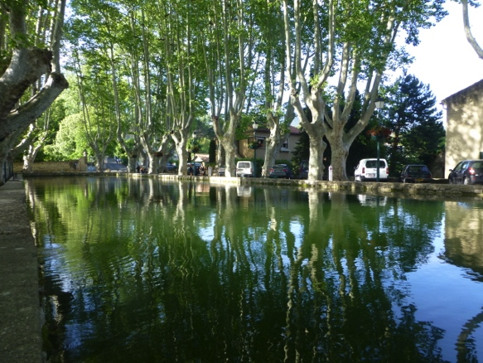
Sculpture park at Chateau La Coste L’Etang at Cucuron

Saturday 7 June [Dieulefit]
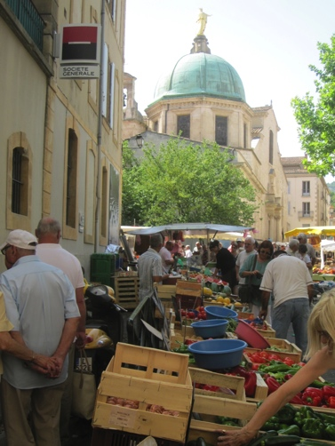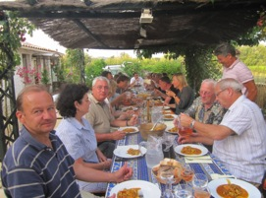
Market day at Apt Practising French at dinner at Gargas

Market day in Apt before heading back to the Drome region to stay at La Tulipe Sauvage at Bourdeaux for the next 3 nights, via the hilltop village of Seguret , near les Dentelles de Montmirail, known for its wines.
The market in Apt is a phenomenon. It winds through all the alleyways, fills the town’s squares and is highlighted with music and coffee shops. Dinner included.

Sunday 8 June [Dieulefit-3 nights]
Time spent in Dieulefit
Visit local artists Maryse Tavernier and Claude Wolfe for French conversation in afternoon. Late afternoon visit the village of the Poet Laval [un des plus beaux villages de France.

Monday 9 June [Dieulefit]
Language session: background to Grignan and Taulignan.
Explore surrounds of Dieulefit. The village of Grignan and its chateau [guided tour in French], made famous by Madame de Sevigne and her writings during the 17th Century. Taulignan and its silk history and museum.

Tuesday 10 June [La Cote St Andre, 2 nights]
Travel back from the Luberon to la Cote St Andre, visiting places of interest on the way. Morning language session about the hilltop villages of Mirmande and Cliousclat. Head north to the Drome region. Visit the artist villages of Mirmande and Cliousclat. Picnic lunch.
Stay at Villa Jeanette.

Wednesday 11 June [La Cote St Andre]
Visit the village of St Antoine L’Abbaye, noted as “un des plus beaux villages de France” and as a place of pilgrimage. Visit its medieval garden, architecture and local artisans. Dinner included.

Thursday 12 June
Tour finishes, back to St Exupery airport, Lyon, between 10-12noon 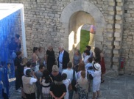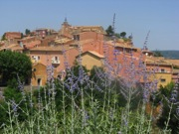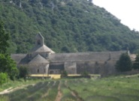
meeting Pierre Cardin in Lacoste Roussillon Abbe de Senanque

Cost $3,900 [Lyon to Lyon]
Included:
- Accommodation and all breakfasts.
- 9 dinners
- The boat trip at Cassis
- All museum/gallery entries

- The other nights when we go to a restaurant, we pay for our own.
- The chambres d’hotes are homes where we stay and dinner is provided by the hosts.
- Lunches we can have a picnic or buy a sandwich or find a little restaurant, to be decided on how we feel at the time.

Airfares are not included.
You are required to have travel insurance.

I can guarantee an insightful trip, as knowing the area and the French friends we will visit for 16 years has allowed me openings to places and people you would not otherwise find. The tour will provide invaluable language opportunities. We will have a lot of fun.

ACCOMMODATION
We will be staying in ‘chambres d’hotes’ or bed and breakfast accommodation with local French families. This will give us opportunities to practise your French language skills at breakfast and dinner. The chambre d’hotes have been chosen for their charm, authenticity, position, and the quality of food and friendliness of our hosts. In most cases they are people and places where I have formed relationships over the last 16 years.

Bookings and enquiries: Contact Jane Annois
jane@zestefrenchtours.com www.zestefrenchtours.com
Aust: 03 98442337/ 0422942216 mobile in France: 0683925102

Please arrange arrival and departure times from St Exupery Airport [TGV train station and airport] for between 10am and 12 noon. It is 50 mins to one hour’s drive to and from the airport. Meeting place is the café “La Brioche Doree” at Terminal 1, near the information counter and post office.
Please bring your mobile phones with international roaming, and have them on at the airport. Text only.

This itinerary may be changed to suit events occurring in France at the time and changes in accommodation beyond my control. You will be kept up to date with any changes.

