ZESTE FRENCH TOURS www.zestefrenchtours.com
Food and wine tour through the Loire Valley
19 September – 3 October 2013: 14 nights, 15 days: Paris to Paris, $4,500
French chef Younes Khazour from the Loire Valley will be our guide exploring the gourmet delights of the Loire Valley. Born and trained in the region he can take us to the kitchens of the chateaux, to wineries and local cheese makers; take cooking classes, degustations, and prepare local delicacies. The tour will be a mix of tastes, colour, chateaux, gardens, cooking and indulgence, all through one of the most beautiful regions of France: the Valley of the Kings.
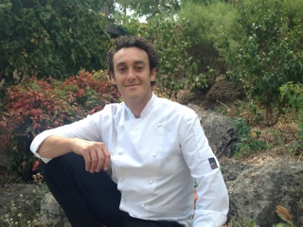

Day 1:Thursday 19 September [Sancerre/Montigny]
Many of us will be in Paris the night before the trip starts. Meet up in the morning at St Sulpice where we pick up the van and head out of Paris [or meeting point to be arranged].
Travel south to Fontainebleau [1 hour] where we visit the chateau and have lunch. In the afternoon drive to Sancerre [1 ½ hrs] where we will stay the night. Stay at chambre d’hote at Montigny near Sancerre.
Dinner at chambre d’hote with our Host Elisabeth Gressin.[ included] www.domainedelareculee.fr

Day 2: Friday 20 September [Sancerre/Montigny]
A day visiting Bourges and surrounding villages: Visit the medieval town and cathedral; Les Forestines de Bourges: the legendary French patisserie.
The Palais Jacques Coeur; (http://palais-jacques-coeur.monuments-nationaux.fr/en/); Les marais gardens 1500metre garden bed.
Les croquets de Charost: visit of artisanal production of specialty biscuits, weekly market day. (30 min drive from Bourges)
An opportunity to see the deer during the mating season. A guided walk through the forest at Mehun Sur Yevre at 6pm. [Sortie Brame du cerf avec guide nature: MEHUN SUR YÈVRE
20 Septembre 2013 à 18h Départ Office de Tourisme. 02.48.57.35.51]

A walk through Bourges in the evening for its sound and light show through the historic quarter:
‘Guidé par le bleu des lanternes, chacun peut flâner à son rythme et s'attarder sur les petits détails qui, de porches en façades, dévoilent toute la richesse architecturale de la ville ancienne. Venez découvrir la magie des lieux historiques de Bourges, dès la tombée de la nuit. Laissez-vous emporter par la lumière, l’image, la musique et l’émotion. La déambulation pédestre vous emporte à travers le temps et l’histoire durant tout l’été.’
Dinner in Bourges.

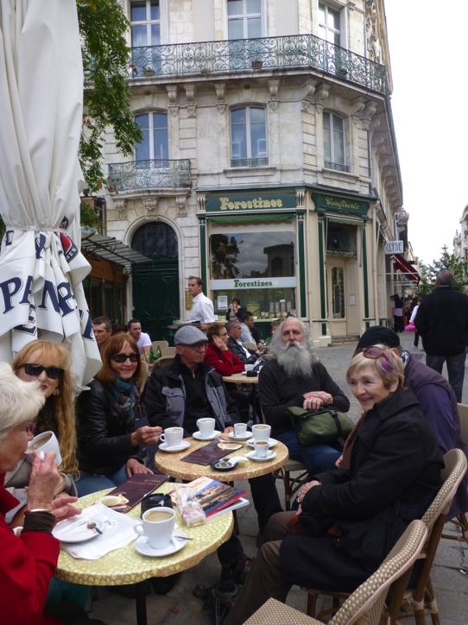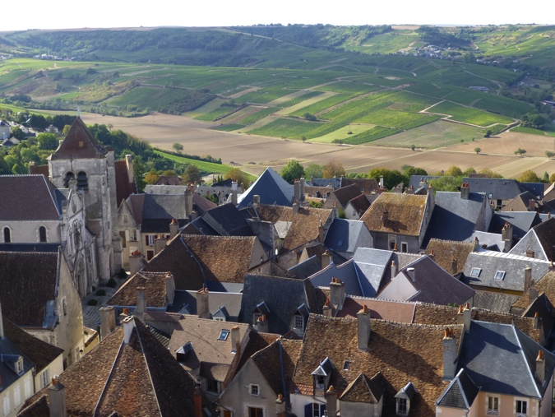
At Bourges enjoying forestines Sancerre

Day 3: Saturday 21 September [Sancerre/Montigny]
Visit Sancerre market in the morning then wine tasting at vineyards. Lunch in the vineyard consisting of charcuterie, crottin Chavignole, and the famous Sancerre Sauvignon. Sancerre museum.
Buy food to prepare at the chambre d’hote in the evening. [Included]

Day 4: Sunday 22 September [Sancerre / Montigny]

Visit Henrichemont and la Borne to visit the local galleries, artists and potters.
Cooking session at Chambre d’hote in evening. [included]

Day 5: Monday 23 September [Montrichard]
Beginning of Les Chateaux de la Loire Vallée

Drive from Sancerre to La Chappelle D’Angillon: Visit the chateau, lunch. Visit the village of Nancay nearby, local biscuit speciality, lavoir and local artists, visiting the Chateau de Valencay on the way.
Visit Producteur de fromage de chevre at Selle sur Cher [Local cheesemaker]
Afternoon market at Montrichard on arrival.
Dinner at the manor house: La Maison Carre. [included]
www.maison-carre.com

Day 6: Tuesday 24 September [Montrichard] Chateau de Chenonceau
Am: Visit the Chateau of Chenonceau
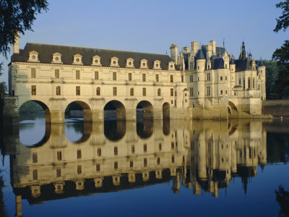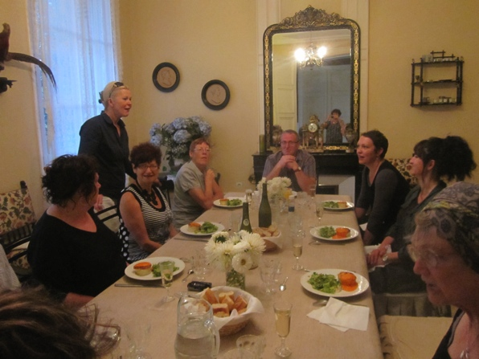

Afternoon visit to La Cave des Roches at Bourre near Montrichard. La Cave Champignonniere. Underground caves where rock was used to build the chateaux of the Loire now extensive series of tunnels growing variety of mushrooms and underground town.
Degustation at our manor house, la maison Carre

Day 7: Wednesday 25 September [Montrichard]
Visit Amboise [chateau] and le Clos Luce where Leonardo di Vinci lived and died. Restaurant.
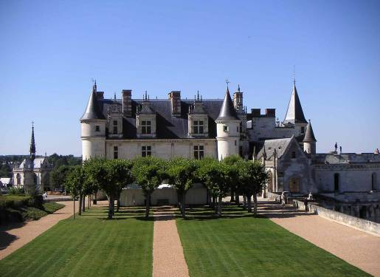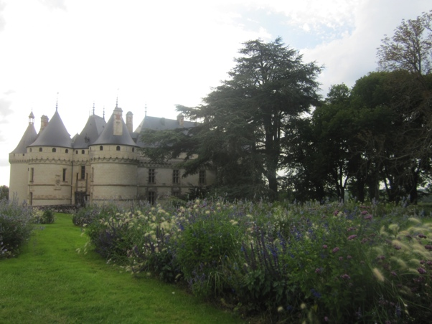
Amboise Chaumont sur Loire
Day 8 Thursday 26 September [Montrichard]
Am Chateau Chaumont sur Loire, its gardens and international garden festival.
Pm Visit the vineyards of Vouvray and taste its famous sparkling white wine.
Discovery of Vouvray vintage
Domaine Huet - L'Echansonne
11 Rue de la Croix Buisée, 37210 Vouvray, France‬‬‬‬‬‬‬‬‬‬‬‬‬‬‬
+33 2 47 52 78 87‬‬‬‬‬‬‬‬‬‬‬‬‬

Domaine Marc Brédif: Vouvray
87 Quai Loire, 37210 Rochecorbon, France‬‬‬‬‬‬‬‬‬‬‬‬‬‬‬
+33 2 47 52 50 07‬‬‬‬‬‬‬‬‬‬‬‬‬

If time also:
Chateau de la Bourdaisiere and
Montlouis sur Loire: Conservatoire de la tomate: 650 varieties of tomatoes.
Contact details:
25, rue de la Bourdaisière
37270 Montlouis-sur-Loire
Tel : 02 47 45 16 31
Fax : 02 47 45 09 11
E-mail: contact@cheateaulabourdaisiere.com
[Dinner included- prepared at our Chambre d’hote]

Day 9: Friday 27 September [Turquant] Saumur

Continue west towards Saumur, visit Chateaux Azay le Rideau and Villandry famous for their gardens, wine tastings, stay at Turquant near Chinon at Le Balcon Bleu. http://lebalconbleuturquant.free.fr 2 rue de Martyrs, Turquant ph: 02 41381031
Dinner at L’helianthe restaurant Turquant
restaurantlhelianthe@orange.fr
Ph: 02 41 51 22 28
Web: www.restaurant-helianthe.fr

Day 10: Saturday 28 September [Turquant]
Les Troglodytes
Visit the village Troglodyte de Rochemenier, Louresse-Rochemenier
Contact details:
Victor LERAY
Rochemenier
Restaurant Genavraie Rochemenier
Ph: 02 41 59 34 22
http://Genevraie.troglodyte.info/

Visit l'Hélice Terrestre de l'Orbière:
Monumental sculpture in a troglodyte village. A contemporary art work by Jacques Warminski. The work is composed of two simultaneous spaces: one entirely dug out from the rock and the other modelled and formed in the open air. The sculptural space allows visitors to move within the thickness of the earth’s crust.

Contact details:
Bernadette ALBERTI
L'Orbière
49350 SAINT-GEORGES-DES-SEPT-VOIES
Tél. 02 41 57 95 92
Fax. 02 41 57 95 12

Le Manoir de la Caillère:
400m2 of galleries, and rooms dug into the white rock of the Loire Valley where Richard Rak has chosen to live and work. He will meet and guide you through his extraordinary gallery where you will see his creations in the serenity of their mineral world.
49320 COUTURES http://www.catp-asso.org/web/sr20-caves_and_cave_dwellings.htm
Tél./fax. 02 41 57 97 97
[Market day at Saumur and Bourgueil]
Cooking session at our chambre d’hote at Turquant [included]

Day 11: Sunday 29 September [Turquant]

Tour of sculptures and Abbey Royale de Fontevraud
Abbaye Royale de Fontevraud
www.abbaye-fontevraud.com
49590 Fontevraud l’Abbaye +33241517352 10h - 17h30

Visit local artists of Fontevraud
Cave aux sculpture Deneze sous Doue
Contact details:
Mairie.deneze-sous-doue@wanadoo.fr
49700Deneze-sous-Doue +33241591540
[Market Montsoreau] Restaurant at Montsoreau

Day 12: Monday 30 September [Turquant]
Explore local area, visit local villages
Cooking session .

Day 13: Tuesday 1 October: Chateau de Chambord [Chambord]
Visit chateau of Blois on the way to Chambord. Stay the night at Chambord.
Visit Chateau Chambord known for its extravagant towers and double helix staircase.

Stay at Hotel ‘Logis de Cygne’, Bracieux at near Chambord.

As a small group we have the luxury of flexibility, and can be as busy or as relaxed as you wish to be.

Day 14: Wednesday 2 October [Paris]
Return to Paris Continue along the Loire on the way to Orleans. Lunch at Orleans. Visit the old town, cathedral and the city of Jeanne d’Arc. Then back to Paris. Stay Hotel Beausejour 71 Ave Parmentier in Paris Wednesday night.
Last night in restaurant at Restaurant ‘Akrame’, 19 rue Lauriston 16th at 8.30pm. [Metro: Kleber,Victor Hugo, Ch de Gaulle-Etoile- or taxi from hotel]
Visits to vineyards, fromageries and kitchens will be made regularly and according to our stamina at the time. .

Day 15: Thursday 3 October
Departure day from Paris
Last day, back to train station and airport. Departure point from our hotel is close to Gare de Lyon for buses to Charles de Gaulle airport and for the TGV train to other parts of France and Europe. Times and arrangements to be organised on individual basis. -or just stay on!
Costs: $4,500
Bookings and Enquiries:
Jane Annois Zeste French Tours
Ph: 03 98442337 / 0422942216
jane@zestefrenchtours
www.zestefrenchtours.com
14 nights/15 days, Includes:
Transport Paris to Paris
Accommodation bed and breakfast
6 dinners
All entries to chateaux and museums
Max 7 people

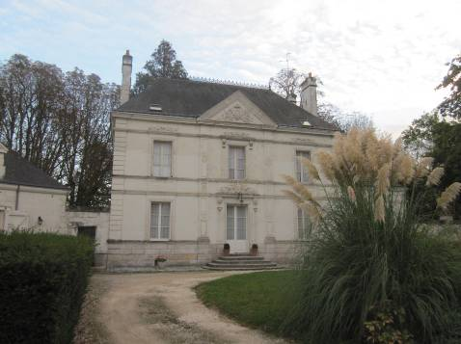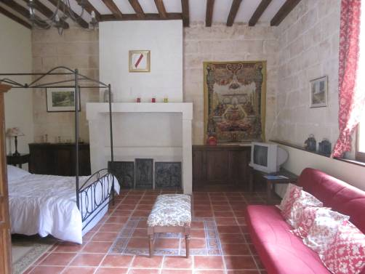
Our house at Montrichard One of our bedrooms at Montrichard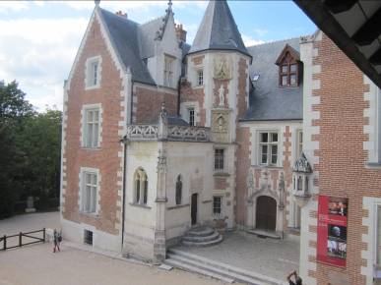 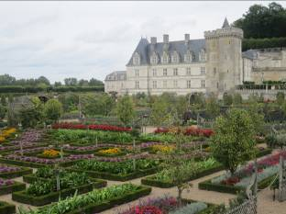
Leonardo di Vinci’s house Villandry Chateau

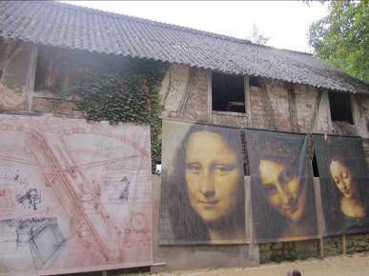 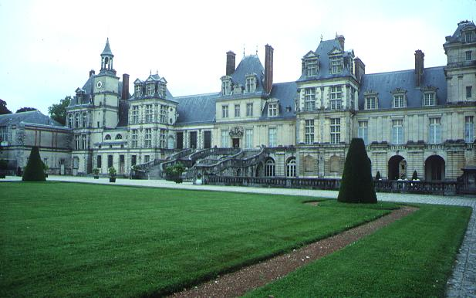 Amboise Fontainbleau

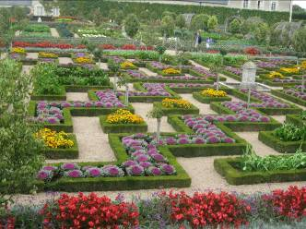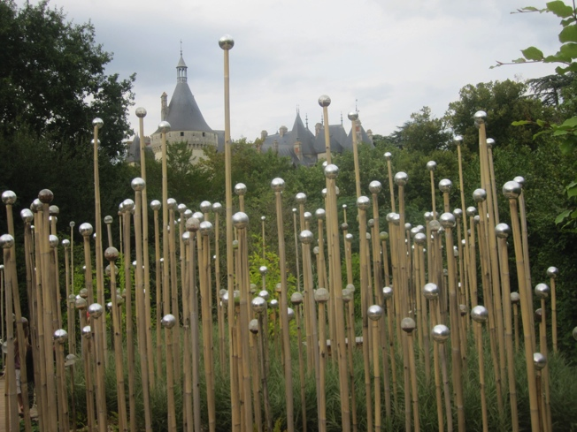
Villandry Chaumont sur Loire garden festival

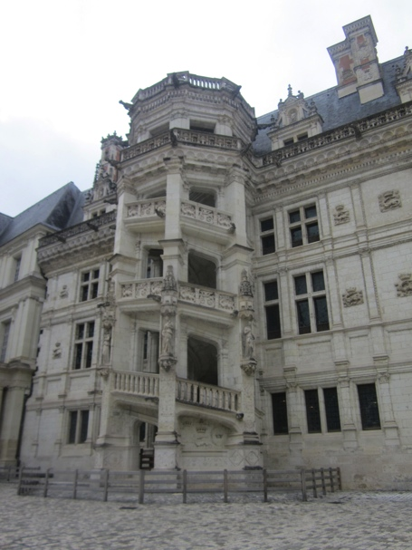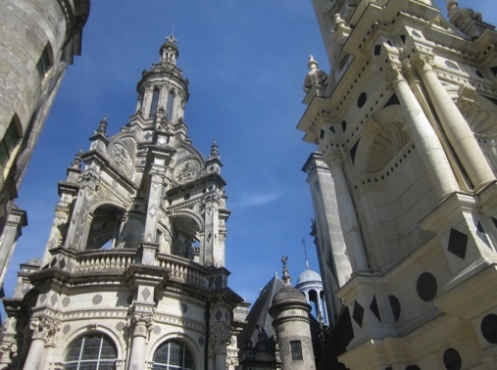
Blois Chambord

